Table of Contents

UNITED STATES
SECURITIES AND EXCHANGE COMMISSION
Washington, DC 20549

SCHEDULE 14A
(Rule 14a-101)

SCHEDULE 14A INFORMATION

Proxy Statement Pursuant to Section 14(a) of the Securities Exchange Act of 1934
(Amendment No. ____)

☒ | Filed by the Registrant
☐ | Filed by a Party other than the Registrant
Check the appropriate box:

☐ | Preliminary Proxy Statement
☐ | Confidential, for Use of the Commission Only (as permitted by Rule 14a-6(e)(2))
☒ | Definitive Proxy Statement
☐ | Definitive Additional Materials
☐ | Soliciting Material under § 240.14a-12

Outset Medical, Inc.
(Name of Registrant as Specified in its Charter)

(Name of Person(s) Filing Proxy Statement, if Other Than the Registrant)

Payment of Filing Fee (Check the appropriate box):

☒ | No fee required.
☐ | Fee paid previously with preliminary materials.
☐ | Fee computed on table in exhibit required by Item 25(b) per Exchange Act Rules 14a-6(i)(1) and 0-11.

Table of Contents



Outset Medical 2026 Proxy Statement AND NOTICE OF ANNUAL MEETING OF STOCKHOLDERS

Table of Contents

Notice of 2026 Annual Meeting of Stockholders

Dear Outset Stockholders:

You are invited to attend Outset Medical, Inc.’s 2026 Annual Meeting of Stockholders (including any adjournments, postponements or continuations thereof, the “Annual Meeting”).

When |  | Where |  | Record Date
June 4, 2026 (Thursday)  At 1:30 p.m. Pacific Time |  | Via live audio webcast: www.virtualshareholdermeeting.com/OM2026 |  | Close of business on  April 9, 2026

At the Annual Meeting, stockholders will be asked to vote on the following matters:
Items of Business* |  |  | Board Recommendation
Proposal One: | To elect the two (2) Class III directors named in this proxy statement to hold office until the 2029 annual meeting of stockholders |  | ü | FOR each nominee
Proposal Two: | To hold a non-binding advisory vote to approve the 2025 compensation of our named executive officers as disclosed in this proxy statement |  | ü | FOR
Proposal Three: | To ratify the appointment of KPMG LLP as our independent registered public accounting firm for 2026 |  | ü | FOR

*We will also conduct any other business properly brought before the meeting.

Attending the Annual Meeting |  | Voting
Stockholders of record at the close of business on April 9, 2026 can attend the Annual Meeting online, including to vote and/or submit questions, at www.virtualshareholdermeeting.com/OM2026.  See page 5 of the accompanying proxy statement for additional information regarding participation in the virtual meeting. |  | Your vote is very important to us. Whether or not you plan to attend the virtual Annual Meeting, please ensure your shares are represented by voting promptly. For instructions on how to vote your shares, please refer to the instructions on the Internet Notice you received in the mail, the section entitled “Annual Meeting Information” beginning on page 1 of the accompanying proxy statement or, if you requested to receive printed copies of these materials, your enclosed proxy card.

By order of the Board of Directors, |  | Important Notice Regarding the Internet Availability of Proxy Materials for the Annual Meeting to be Held  on June 4, 2026 at 1:30 p.m. Pacific Time via live audio webcast at www.virtualshareholdermeeting.com/OM2026  This Notice of 2026 Annual Meeting of Stockholders, the accompanying proxy statement and our 2025 annual report on Form 10-K  are available on our website at https://investors.outsetmedical.com/financial-information/annual-reports, as well as at www.proxyvote.com.
/s/ John L. Brottem

John L. Brottem
General Counsel and Secretary
Outset Medical, Inc.
3052 Orchard Drive
San Jose, California 95134
April 24, 2026

Table of Contents

Table of Contents

Annual Meeting Information | 1 |  | Compensation Discussion and Analysis | 31
Board and Corporate Governance  Matters | 9 |  | Compensation Committee Report | 50
Proposal One: Election of Directors | 9 |  | 2025 Summary Compensation Table | 51
Overview of Our Nominees and Continuing  Directors | 10 |  | Grants of Plan-Based Awards in 2025 | 52
Board Structure and Composition | 17 |  | Outstanding Equity Awards at 2025 Year-End | 54
Director Independence | 17 |  | Option Exercises and Stock Vested in 2025 | 55
Board Leadership Structure | 17 |  | Additional Narrative Disclosure | 55
Role of our Board in Risk Oversight | 18 |  | Compensation Risk Assessment | 58
Meetings of our Board | 19 |  | CEO Pay Ratio | 58
Committees of our Board | 19 |  | Pay Versus Performance | 59
Committee Composition and Meetings | 20 |  | Equity Plan Information | 65
Audit Committee | 20 |  | Equity Compensation Plan Information | 65
Compensation Committee | 21 |  | Stock Ownership | 66
Compensation Committee Interlocks and  Insider Participation | 21 |  | Security Ownership of Certain Beneficial  Owners and Management | 66
Nominating and Corporate Governance  Committee | 21 |  | Delinquent Section 16(a) Reports | 68
Director Nomination Process | 22 |  | Audit Matters | 69
Stockholder Engagement | 23 |  | Proposal Three: Ratification of Appointment  of Independent Registered Public Accounting  Firm | 69
Code of Ethics and Business Conduct | 24 |  |  | 69
Corporate Governance Guidelines | 24 |  | Report of the Audit Committee | 70
Stock Ownership Guidelines | 24 |  | Additional Information | 71
Recoupment Policy | 25 |  | Other Matters | 71
Insider Trading Policy | 25 |  | Stockholder Proposals and Nominations for  Next Year’s Annual Meeting of Stockholders | 71
Anti-Hedging and Anti-Pledging Policy | 25 |  |  | 71
Stockholder Communications with our Board | 25 |  | Availability of Annual Report on Form 10-K | 71
Certain Relationships and Related Party  Transactions | 26 |  | APPENDIX A – NON-GAAP RECONCILIATIONS | A-1
Director Compensation | 28
Non-Employee Director Compensation Policy | 28
2025 Director Compensation Table | 29
EXECUTIVE COMPENSATION | 30
Proposal Two: Advisory Vote on Named  Executive Officer Compensation | 30

Table of Contents

Proxy Statement
For the 2026 Annual Meeting of Stockholders
To be held on June 4, 2026

Annual Meeting Information
Our Board of Directors (“Board”) is soliciting your proxy for the 2026 Annual Meeting of Stockholders (including any adjournments, postponements or continuations thereof, the “Annual Meeting”) of Outset Medical, Inc. (“Outset,” the “Company,” “we,” “us” or “our”) for the purposes described in this proxy statement and the accompanying Notice of 2026 Annual Meeting of Stockholders. The Annual Meeting will take place on June 4, 2026 at 1:30 p.m. Pacific Time in a virtual format via live audio webcast. If you held shares of our common stock as of the close of business on the record date, April 9, 2026, you are invited to attend the meeting at www.virtualshareholdermeeting.com/OM2026 and vote on the proposals described in this proxy statement. On or about April 24, 2026, we will be mailing a Notice of Internet Availability of Proxy Materials (the “Internet Notice”) to our stockholders. The Internet Notice will include instructions on how to access the proxy materials over the Internet, including our proxy statement, Notice of 2026 Annual Meeting of Stockholders, proxy card and our 2025 annual report on Form 10-K (the “2025 annual report”). The Internet Notice will also describe how to vote online and, if desired, how to receive a printed set of proxy materials.
What is the proxy statement?
This proxy statement is furnished in connection with the solicitation of proxies by the Board to be voted on at the Annual Meeting to be held in a virtual format via live audio webcast at 1:30 p.m. Pacific Time on June 4, 2026. This proxy statement contains the required information under the rules of the U.S. Securities and Exchange Commission (the “SEC”) and is designed to assist you in voting your shares.
What is the purpose of the Annual Meeting?
At the Annual Meeting, stockholders as of the record date will vote on the items of business outlined in the Internet Notice. In addition, management will respond to any questions from stockholders related to the agenda items or the Company’s business and that otherwise comply with our rules of conduct for the meeting.
When is the record date?
The Board has established April 9, 2026 as the record date for the Annual Meeting (the “record date”).
Why did I receive a Notice of Internet Availability of Proxy Materials in the mail instead of a full set of proxy materials?
Pursuant to the “notice and access” rules adopted by the Securities and Exchange Commission (the “SEC”), we have elected to provide access to our proxy materials over the Internet. Accordingly, we are sending the Internet Notice to our stockholders as of the record date, beginning on or about April 24, 2026. The Internet Notice will instruct you as to how you may access and review the proxy materials on the Internet and, if desired, how to request a printed set of proxy materials. In addition, by following the instructions in the Internet Notice, you may request to receive proxy materials in printed form by mail or electronically by email on an ongoing basis. We believe that these rules allow us to conserve natural resources and reduce our costs of printing and delivering proxy materials, while providing a convenient method for stockholders to access the materials and vote.
We provided some of our stockholders with a printed set of proxy materials instead of the Internet Notice if they previously requested to receive paper copies. If you received a printed set of proxy materials, we encourage you to consider

2026 Proxy Statement | 1

Table of Contents

helping us reduce the environmental impact of delivering printed materials by signing up to receive all of your future proxy materials electronically.
Who can vote?
If you were a stockholder of record as of the close of business on the record date, April 9, 2026, you are entitled to vote your shares at the Annual Meeting. As of the record date, 18,529,233 shares of our common stock were issued and outstanding. Each share of our common stock is entitled to one vote on each matter properly brought before the meeting.
If, on the close of business on the record date, your shares were registered directly in your name with Outset’s transfer agent, Equiniti Trust Company, LLC, then you are a “stockholder of record.” As a stockholder of record, you may vote at the Annual Meeting or by proxy.
If, on the close of business on the record date, your shares were held in an account with a broker, bank or other nominee (a “broker”) and not in your name, then you are the “beneficial owner” of shares held in “street name” and the Internet Notice or proxy materials, as applicable, are being forwarded to you by that broker. The broker holding your account is considered the stockholder of record for purposes of voting at the Annual Meeting. As the beneficial owner, you have the right to direct your broker on how to vote your shares by following the instructions for voting set forth on that organization’s voting instruction card. You are also invited to attend the Annual Meeting and may vote your shares at the meeting if you are logged in as a stockholder using your 16-digit control number printed on your proxy materials.
How many votes do I have?
Each share of our common stock is entitled to one vote on each matter properly brought before the Annual Meeting. You can vote your shares for each director nominee and for each other item of business to be addressed at the Annual Meeting.
What am I voting on?
You are being asked to vote on three proposals:
•
Proposal One: To elect the two (2) Class III directors named in this proxy statement to hold office until the 2029 annual meeting of stockholders;
•
Proposal Two: To hold a non-binding advisory vote to approve the 2025 compensation of our named executive officers as disclosed in this proxy statement (the “say-on-pay vote”); and
•
Proposal Three: To ratify the appointment of KPMG LLP as our independent registered public accounting firm for 2026.
How does Outset’s Board recommend that I vote on each proposal?
Our Board recommends that our stockholders vote as follows:

Proposal |  | Board Recommendation
Proposal One: | Election of Directors | “FOR” the election of each of the two (2) Class III directors named in this proxy statement to hold office until the 2029 annual meeting of stockholders
Proposal Two: | Say-on-Pay Vote | “FOR” the approval, on a non-binding advisory basis, of the 2025 compensation of our named executive officers as disclosed in this proxy statement
Proposal Three: | Ratification of Appointment of Independent Registered Public Accounting Firm | “FOR” the ratification of the appointment of KPMG LLP as our independent registered public accounting firm for 2026

2026 Proxy Statement | 2

Table of Contents

How long are directors elected for?
Our Board is divided into three classes of directors (Class I, Class II and Class III) that serve staggered three-year terms. At each annual meeting of stockholders, a class of directors is elected for a three-year term to succeed the same class whose term is then expiring. At this year’s Annual Meeting, the two Class III directors are up for election to serve until the 2029 annual meeting of stockholders and until their respective successors are duly elected and qualified. The Class I directors (with terms expiring at the 2027 annual meeting) and Class II directors (with terms expiring at the 2028 annual meeting) will continue to serve for the remainder of their respective three-year terms.

What if another matter is properly brought before the meeting?
Our Board is not aware of any other matters that will be presented for consideration at the Annual Meeting. However, if any other matters are properly brought before the Annual Meeting, the persons named in the accompanying proxy intend to vote on those matters in accordance with their best judgment.
How do I vote?
The procedures for voting in advance of the Annual Meeting depend on whether your shares are registered in your name or are held by a broker.

•
Stockholders of Record: Shares Registered in Your Name
If, on the record date, your shares were registered directly in your name with Outset’s transfer agent, Equiniti Trust Company, LLC, then you are a “stockholder of record.” As a stockholder of record, you may vote by proxy in advance of the Annual Meeting in three ways:

 |  | 
Vote by Internet  Go to http://www.proxyvote.com to complete an electronic proxy card. You will be asked to provide the company number and control number from the Internet Notice or proxy card. Your vote must be received by 11:59 p.m. Eastern Time on June 3, 2026 to be counted. | Vote by telephone  Dial toll-free 1-800-690-6903 using a touch-tone phone and follow the recorded instructions. You will be asked to provide the company number and control number from the Internet Notice or proxy card. Your vote must be received by 11:59 p.m. Eastern Time on June 3, 2026 to be counted. | Vote by mail  If you received printed copies of the proxy materials, complete, sign and date the enclosed proxy card, and return it promptly in the envelope provided. If your signed proxy card is received by 11:59 p.m. Eastern Time on June 3, 2026, we will vote your shares as you direct.

•
Beneficial Owner: Shares Registered in the Name of Broker
If, on the record date, your shares were held not in your name, but in an account with a broker as custodian on your behalf, then you are considered the “beneficial owner” of shares held in “street name.” The Internet Notice or proxy materials, as applicable, are being forwarded to you by that broker who is considered the stockholder of record of those shares for purposes of voting at the Annual Meeting. As the beneficial owner, you have the right to direct your broker on how to vote your shares by following the instructions for voting set forth on that organization’s voting instruction card.

2026 Proxy Statement | 3

Table of Contents

You may also vote your shares electronically during a designated portion of the virtual Annual Meeting after logging in as a “stockholder” with your 16-digit control number at www.virtualshareholdermeeting.com/OM2026. The vote you cast at the Annual Meeting will supersede any previous votes that you may have submitted. Whether or not you plan to attend the Annual Meeting, we urge you to vote promptly by Internet, telephone or mail to ensure that your votes are counted at the Annual Meeting.
What is the effect of giving a proxy?
A proxy is your legal designation of another person to vote the shares of common stock you own, with such other person being called a proxy holder. If you designate someone as your proxy in a written document, that document is also called a proxy or proxy card. Proxies are solicited by and on behalf of our Board, and Leslie Trigg (our President and Chief Executive Officer (“CEO”)) and John Brottem (our General Counsel and Secretary) have been designated as proxy holders by our Board. If you properly grant your proxy, your shares will be voted as you instruct.
Each proxy or voting instruction form represents the shares registered to you as of the close of business on the record date established for the Annual Meeting. You may receive more than one proxy or voting instruction form if you hold your shares in multiple accounts, some of your shares are registered directly in your name with the Company’s transfer agent, or some of your shares are held in street name through a broker. Please vote the shares on each proxy card or voting instruction form to ensure that all of your shares are counted at the Annual Meeting.
What if I return a proxy card or otherwise vote but do not make specific choices?
If you return a signed proxy card or otherwise vote without marking specific voting selections, your shares will be voted as the Board recommends: “For” the election of two (2) Class III directors (Proposal One); “For” the approval of named executive officer compensation (Proposal Two); “For” the ratification of the appointment of KPMG LLP as our independent registered public accounting firm for 2026 (Proposal Three); and in accordance with the best judgment of your proxy holder for any other matters properly brought before the meeting, if any.
The Board is not aware of any other matters that are likely to be brought before the Annual Meeting. If any other matter is properly presented for action at the Annual Meeting, the persons identified as having the authority to vote the proxies will vote on such matter in their own discretion.
Can I change my vote or revoke my proxy?
Yes. If you are a stockholder of record, you can change your vote or revoke your proxy before the Annual Meeting in any of these ways:
•
Vote again over the Internet or by telephone as instructed above before 11:59 Eastern Time on June 3, 2026. Only your latest Internet or telephone vote is counted.
•
Submit a properly signed proxy card with a later date that is received no later than 11:59 Eastern Time on June 3, 2026. Only your latest dated proxy card will be counted.
•
Send a timely written notice that you are revoking your proxy to Outset’s Corporate Secretary at 3052 Orchard Drive, San Jose, California 95134.
•
Attend the virtual Annual Meeting and vote electronically during the meeting. Simply attending the meeting will not, by itself, revoke your proxy.
If you are the beneficial owner of shares held in street name, you should follow the instructions provided by your broker to revoke previously submitted voting instructions.

2026 Proxy Statement | 4

Table of Contents

What are broker non-votes?
Brokers holding shares on behalf of a beneficial owner may vote those shares in their discretion on certain “routine” matters even if they do not receive timely voting instructions from the beneficial owner. With respect to “non-routine” matters, the broker is not permitted to vote shares for a beneficial owner without timely received voting instructions. The only routine matter to be presented at the Annual Meeting is the proposal to ratify the appointment of KPMG LLP as our independent registered public accounting firm for 2026 (Proposal Three). The election of directors (Proposal One) and the say-on-pay vote (Proposal Two) are non-routine matters.
A broker non-vote occurs when a broker does not vote on a non-routine matter because the beneficial owner of such shares has not provided voting instructions with regard to such matter. With respect to non-routine matters, such as Proposal One and Proposal Two, if a beneficial owner does not provide timely voting instructions to its broker, the broker does not have discretion to vote the beneficial owner’s shares on such matters and, accordingly, such shares will be treated as broker non-votes. Broker non-votes are considered present and entitled to vote at the Annual Meeting for the purposes of determining whether a quorum is present. However, broker non-votes are not considered “votes cast” and therefore will have no impact on the voting results. With respect to “routine” matters, such as Proposal Three, if a beneficial owner does not provide timely voting instructions to its broker, the broker may exercise discretionary voting authority and vote the beneficial owner’s shares on such matters. As a result, we do not expect any broker non-votes with respect to Proposal Three.
How many shares must be present to hold the Annual Meeting?
A quorum must be present at the Annual Meeting for any business to be conducted. A quorum will be present if the holders of at least a majority of the voting power of our common stock issued and outstanding and entitled to vote are present at the Annual Meeting in person, by means of remote communication or represented by proxy. On the record date, there were 18,529,233 shares of our common stock outstanding and entitled to vote. For purposes of determining the presence of a quorum at the Annual Meeting, abstentions, withheld votes and broker non-votes are counted as present and entitled to vote. If there are not sufficient shares represented in person or by proxy at the Annual Meeting to constitute a quorum, the chairperson of the Annual Meeting or the holders of the majority of the voting power of the common stock issued and outstanding and entitled to vote thereat, present in person or represented by proxy, may adjourn the meeting to another place, date or time by announcement to the stockholders present in person at the meeting.

2026 Proxy Statement | 5

Table of Contents

What vote is required for the approval of each proposal? What effect do “withhold” votes, abstentions and broker non-votes have on the proposals?
The following chart summarizes the proposals to be considered at the Annual Meeting, the vote required for approval of each proposal, and the manner in which votes will be counted:

Proposal | Voting Options | Vote Required to Adopt the Proposal | Effect of “Withhold”  Votes or Abstentions | Effect of “Broker  Non-Votes”
Proposal One:  Election of Directors | For or Withhold on each nominee | Plurality of the votes cast. This means that the two nominees receiving the highest number of “For” votes will be elected as Class III directors. | Only “For” votes affect the outcome of the election. “Withhold” votes will not affect the outcome of this proposal. | Brokers do not have discretion to vote. Broker non-votes will not affect the outcome of the election of directors.
Proposal Two:  Say-on-Pay Vote | For, Against or Abstain | Affirmative vote of a majority of the votes cast on the proposal. | Abstentions are not considered “votes cast” and therefore will not affect the outcome of this proposal. | Brokers do not have discretion to vote. Broker non-votes will not affect the outcome of this proposal.
Proposal Three:  Ratification of Appointment of Independent Registered Public Accounting Firm | For, Against or Abstain | Affirmative vote of a majority of the votes cast on the proposal. | Abstentions are not considered “votes cast” and therefore will not affect the outcome of this proposal. | Brokers have discretion to vote. Therefore, we do not expect any broker non-votes.

Important Information About Our Virtual Annual Meeting:
•
Why is the Annual Meeting being held in a virtual format this year? Our Annual Meeting will again be held in a virtual meeting format via live audio webcast. We believe the virtual format enables our stockholders to safely and conveniently attend the Annual Meeting, while facilitating active and equal participation for all stockholders at no cost regardless of geographic location. We have designed our virtual format to help ensure that our stockholders who attend the Annual Meeting virtually will be afforded similar rights and opportunities to participate as they would at an in-person meeting.
•
How can I attend the Annual Meeting online? To join the Annual Meeting online, visit www.virtualshareholdermeeting.com/OM2026 and log in as a stockholder with your 16-digit control number included on your Internet Notice, on your proxy card or on the instructions that accompanied your proxy materials.
•
When can I join the virtual Annual Meeting? The meeting will begin promptly at 1:30 p.m. Pacific Time on Thursday, June 4, 2026. You may access the meeting platform beginning at 1:15 p.m. Pacific Time, and we encourage you to join in advance of the meeting start time to allow sufficient time to log in and confirm your connection and audio are working properly.
•
Can I ask questions during the virtual Annual Meeting? Yes. If you are logged in as a stockholder at the virtual Annual Meeting, you will have an opportunity to submit questions live via the Internet during a designated portion of the virtual Annual Meeting. Once you are logged in, type your question into the question box and click “submit.”
Subject to time constraints, we intend to answer questions pertinent to the Company and meeting matters submitted by stockholders during the Annual Meeting that comply with our rules of conduct for the Annual Meeting, which will be posted on the meeting website during the meeting as well as on the Investors section of our website prior to the meeting. Questions that are substantially similar may be grouped and answered once to avoid repetition.
•
How do I vote during the virtual Annual Meeting? You will have an opportunity to vote your shares electronically during a designated portion of the virtual Annual Meeting after logging in as a stockholder with your 16-digit control number at www.virtualshareholdermeeting.com/OM2026. Whether or not you plan to join the Annual Meeting, we

2026 Proxy Statement | 6

Table of Contents

encourage you to vote and submit your proxy in advance of the meeting by one of the methods described in these proxy materials.
•
What if I lost my 16-digit control number? If you do not have your 16-digit control number, you will still be able to log in to the virtual Annual Meeting as a guest. To join the meeting webcast, visit www.virtualshareholdermeeting.com/OM2026 and register as a guest. If you log in as a guest, you will not be able to vote your shares or ask questions during the meeting.
•
What if I did not receive a 16-digit control number? If you are a beneficial owner of shares held in street name and did not receive a 16-digit control number on the Internet Notice, on your proxy card or on the instructions that accompanied your proxy materials, please contact your broker well in advance of the Annual Meeting for instructions on how to obtain a 16-digit control number and access the virtual meeting as a stockholder. Instructions should also be provided on the voting instruction form provided by your broker. Without first obtaining your 16-digit control number and logging in as a stockholder, you will still be able to attend the meeting by logging in as a guest, however, you will not be able to vote your shares or ask questions during the meeting.
•
What if I have technical difficulties? On the meeting day, if you have trouble accessing the virtual meeting platform or encounter other technical difficulties with the platform before or during the meeting, please call the technical support number posted on the Annual Meeting login page at www.virtualshareholdermeeting.com/OM2026. Technical support information will also be available on the Annual Meeting login page prior to the meeting day.
•
Will a list of stockholders be available for inspection prior to and during the meeting? Yes. A complete list of stockholders of record will be available for inspection by any stockholder for ten (10) days prior to the Annual Meeting during ordinary business hours at our headquarters located at 3052 Orchard Drive, San Jose, California 95134. In addition, the list will be available for inspection online during the virtual Annual Meeting if you logged in as a stockholder with your 16-digit control number.
•
Will a recording of the meeting be available? Yes, following the Annual Meeting, a recording of the meeting will be available on www.virtualshareholdermeeting.com/OM2026 for one year following the meeting date.
What happens if the Annual Meeting is adjourned?
Unless a new record date is fixed, your proxy will still be valid and may be used to vote shares of our common stock at the adjourned Annual Meeting. You will still be able to change or revoke your proxy until it is used to vote your shares.

Who will count the votes?
A representative of Broadridge Investor Communications Services (“Broadridge”) will count the votes and serve as the inspector of election.
Who is making this solicitation and who will pay the costs?
The Board is soliciting your vote at the Annual Meeting. We will pay the cost of soliciting proxies. Proxies may be solicited on our behalf by our directors, officers or employees (for no additional compensation) in person, by telephone or by other means of communication, including by mail or e-proxy. We may reimburse brokerage firms, banks and other agents for the cost of forwarding proxy materials to beneficial owners.
What does it mean if I receive more than one Internet Notice?
If you receive more than one Internet Notice, your shares may be registered in more than one name or in different accounts. Please follow the voting instructions on each Internet Notice to ensure that all of your shares are voted.

2026 Proxy Statement | 7

Table of Contents

How can I find out the results of the voting at the Annual Meeting?
Preliminary voting results will be announced at the Annual Meeting. In addition, final voting results will be published in a current report on Form 8-K that we expect to file with the SEC within four business days after the Annual Meeting.
What if I have shares registered in my name and also have shares in a brokerage account?
Shares that you hold in street name are not included in the total number of shares set forth on your proxy card. Your broker will send you instructions on how to vote those shares.
Do I have dissenters’ or appraisal rights with respect to any of the matters to be voted on at the Annual Meeting?
No, stockholders do not have any dissenter’s or appraisal rights with respect to the matters to be voted on at the Annual Meeting.
Why were my proxy materials included in the same envelope as other people at my address? How may I obtain an additional copy of the proxy materials?
We have adopted a procedure approved by the SEC called “householding.” Under this procedure, we deliver a single copy of the Internet Notice and, if applicable, our proxy materials to stockholders of record who share the same address, unless we have received contrary instructions from any stockholder at that address. This practice is designed to eliminate duplicate mailings, conserve natural resources and reduce our printing and mailing costs. Stockholders who participate in householding will continue to be able to access and receive separate proxy cards. If you share an address with another stockholder and receive only a single copy of the Internet Notice or, if applicable, our proxy materials, but would like to request a separate copy of these materials, please contact our mailing agent, Broadridge Financial Solutions, Inc., by calling 1-866-540-7095 or writing to 51 Mercedes Way, Edgewood, New York 11717, Attention: Householding Department and an additional copy of the materials will be promptly delivered to you. Similarly, if you receive multiple copies of the Internet Notice or, if applicable, the proxy materials but would prefer to receive a single copy in the future, you may also contact Broadridge Financial Solutions, Inc. at the above telephone number or address. Beneficial owners should contact their broker to request information about householding procedures.
Who should I contact if I have any questions?
If you have any questions or require any assistance with voting your shares, please contact:

Alliance Advisors, LLC
1-866-206-7288
OM@allianceadvisors.com

2026 Proxy Statement | 8

Table of Contents

Board and Corporate Governance Matters

Proposal One: Election of Directors
General
Our Board currently consists of seven directors and is divided into three classes of directors that serve staggered three-year terms, currently Class I, with a term expiring in 2027, Class II, with a term expiring in 2028 and Class III, with a term expiring in 2026. At the Annual Meeting, our stockholders will vote on the election of two Class III directors for an additional three-year term expiring at our 2029 annual meeting of stockholders. Each of our other current directors will continue to serve as a director until the expiration of his or her three-year term and the election and qualification of his or her successor.
The two directors currently serving on our Board in Class III, the class whose term of office expires in 2026, have each been nominated by our Board, upon the recommendation of our Nominating and Corporate Governance Committee, to stand for election at the Annual Meeting: Brent D. Lang and Karen Prange.
Ms. Prange, who was appointed to our Board effective January 9, 2026, was first identified as a potential candidate by a non-employee director. Our Nominating and Corporate Governance Committee reviewed and evaluated Ms. Prange’s background, experience and qualifications in accordance with the criteria described below in the section entitled “Criteria for Board Membership.” As part of this process, Ms. Prange met with members of our Nominating and Corporate Governance Committee and other members of the full Board. Following this evaluation, the Nominating and Corporate Governance Committee recommended the appointment of Ms. Prange to the full Board for approval, and the Board approved Ms. Prange’s appointment.
Each of these two nominees has consented to being named as a nominee in this proxy statement and has agreed to serve, if elected, until our 2029 annual meeting of stockholders and until the election and qualification of his or her successor.
For more information about each of the director nominees and continuing directors, including information regarding the experience, qualifications, attributes and skills that led to the conclusion that each director should serve as a member of our Board, please refer to the section below entitled “Overview of Our Nominees and Continuing Directors.”

Vote Required: | Directors are elected by a plurality of the votes cast by our stockholders at the Annual Meeting. This means that the two nominees receiving the highest number of affirmative votes will be elected. Broker non-votes and “Withhold” votes will have no effect on the outcome of this vote.
Board Recommendation: | OUR BOARD UNANIMOUSLY RECOMMENDS A VOTE “FOR” THE ELECTION OF EACH OF THE TWO (2) CLASS III DIRECTOR NOMINEES NAMED ABOVE. | 

2026 Proxy Statement | 9

Table of Contents

Overview of Our Nominees and Continuing Directors
The following table and the brief biographies that follow provide information, as of the date of this proxy statement, about each director nominee and each continuing director:
 |  |  |  |  |  |  |  | Current Committee Membership*
 | Age | Position(s) | Director Since | Class | Current Term Expires | Expiration of Term for Which Nominated | Independent | AC | CC | NCG
Director Nominees
Brent D. Lang | 58 | Director | 2024 | III | 2026 | 2029 | Yes | X
Karen Prange | 62 | Director | 2026 | III | 2026 | 2029 | Yes |  | X
Continuing Directors
Karen Drexler | 66 | Director | 2021 | I | 2027 | — | Yes |  | X | Chair
Kevin O’Boyle | 70 | Director | 2025 | I | 2027 | — | Yes | Chair
Leslie Trigg | 55 | President, CEO and Chair of the Board | 2014 | I | 2027 | — | No
D. Keith Grossman | 66 | Lead Independent Director | 2014 | II | 2028 | — | Yes |  | Chair | X
Patrick T. Hackett | 64 | Director | 2019 | II | 2028 | — | Yes | X |  | X

* AC - Audit Committee; CC - Compensation Committee; NCG - Nominating and Corporate Governance Committee

2026 Proxy Statement | 10

Table of Contents

Director Dashboard

Our director nominees and continuing directors (which we refer to as our “directors” in these charts) bring diverse viewpoints and perspectives to our boardroom and exhibit a balance of tenure, skills, experiences and backgrounds that we believe enhances the deliberation and decision-making processes of our Board and allows our Board to effectively fulfill its oversight function.

Independence | Gender Diversity | Racial or Ethnic Diversity
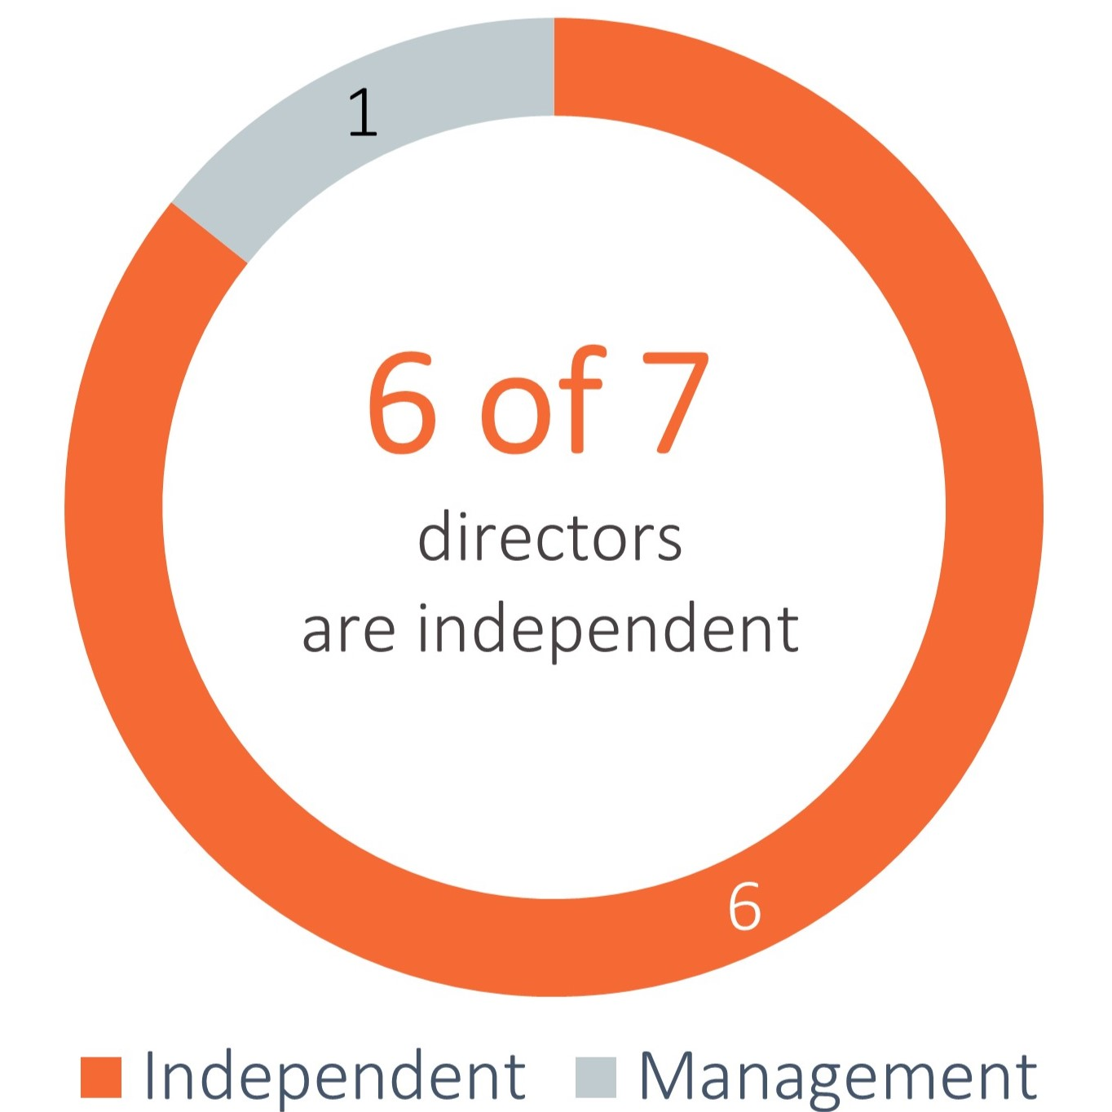  6 of 7 directors are Independent Independent Management 1 6 | 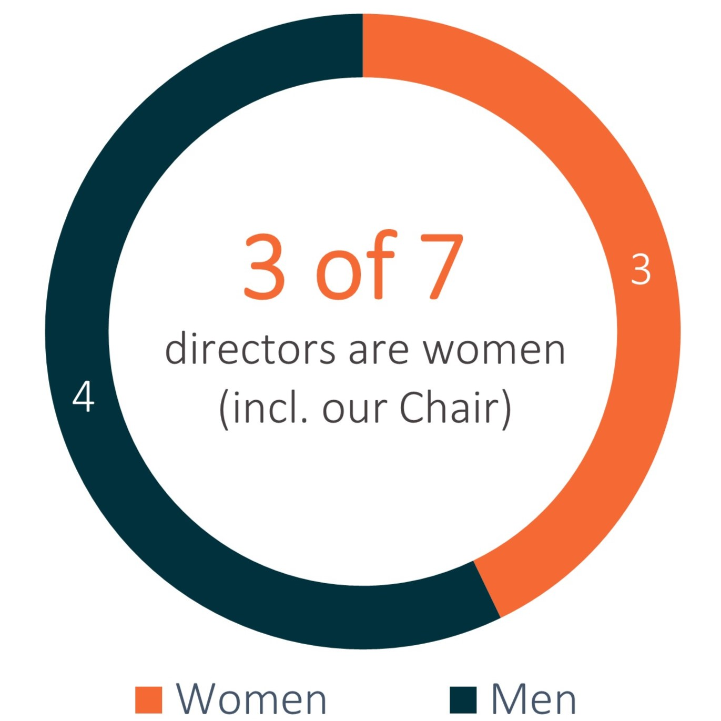  3 of 7 directors are women (incl. our Chair) Women Men 4 3 | 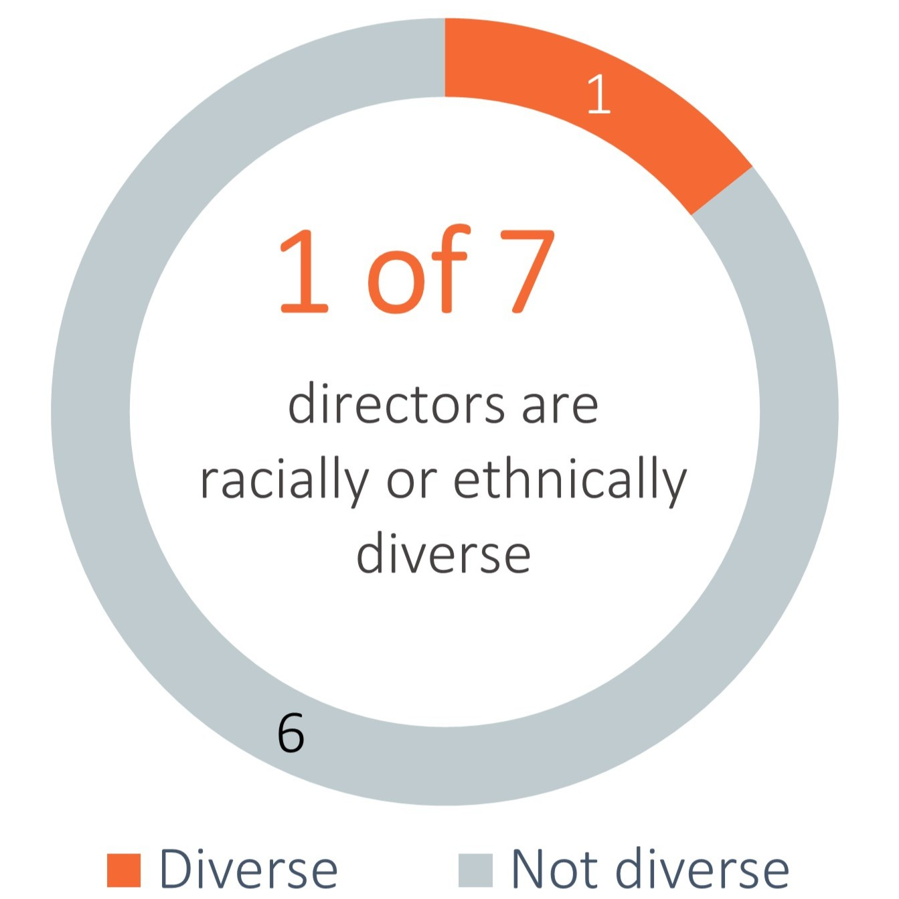  1 of 7 directors are racially or ethnically diverse Diverse Not Diverse 1 6

 | Tenure | Age
 | 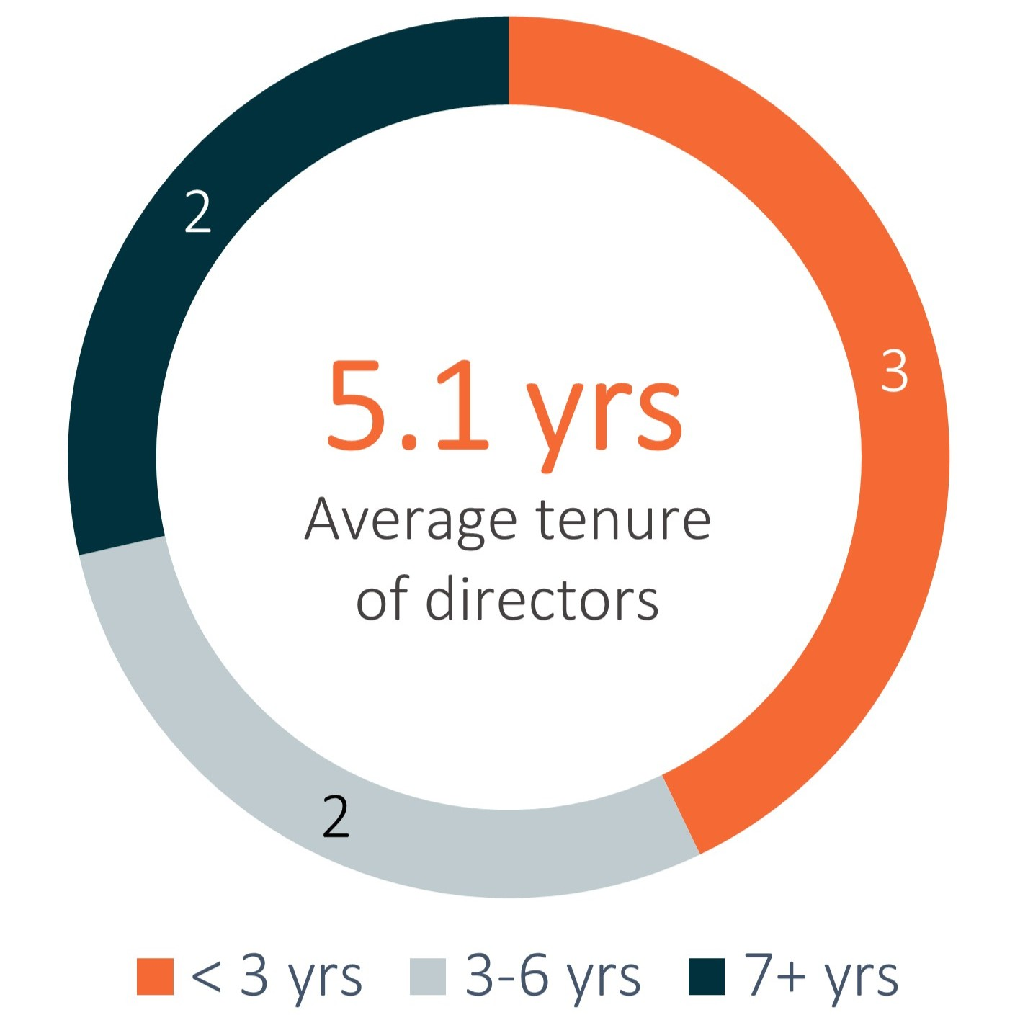  5.1 yrs Average tenure of directors 2 2 3 < 3 yrs 3-6 yrs 7+ yrs | 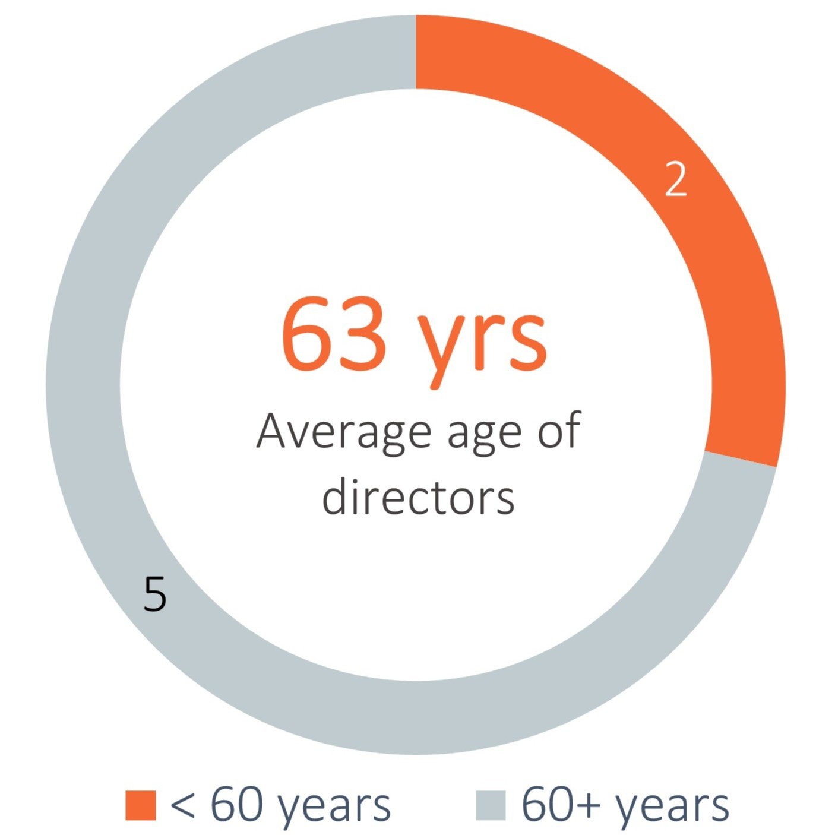  63 yrs Average age of directors 5 2 < 60 years 60+ years

Our directors bring a balance of skills and experience, including those listed in the skills matrix on the following page. The matrix identifies the most prominent skills and core competencies of each director (reflected on an aggregate basis). Each director possesses numerous other skills and competencies not reflected in the matrix below, however, we believe that representing only the most prominent skills and core competencies of our Board provides a more meaningful presentation of the key contributions and value that our directors bring to their service on our Board and committees and to our stockholders.

2026 Proxy Statement | 11

Table of Contents

Director Dashboard

Skills Matrix

 | Public Company Board Service
 | A deep understanding of the Board’s oversight responsibilities enhances transparency and accountability for management and the Board
 | Public Company CEO or CFO Experience
 | Critical to our Board’s understanding of the demands and challenges of managing a large public organization
 | Other Senior Leadership Role
 | Enhances our Board’s ability to oversee management’s performance, and understand organizations, processes and strategy
 | Healthcare / Medical Device Industries
 | Enables our Board to understand strengths and challenges specific to the healthcare and medical device industries in which we operate
 | Financial Literacy / Accounting
 | Crucial to our Board’s ability to advise on and oversee capital management, financial transactions, financial reporting and internal controls
 | FDA / Regulatory
 | Critical to enable effective oversight by our Board of our compliance with the complex regulations that apply to our business, including FDA
 | Sales & Marketing
 | Crucial to our Board’s understanding of how to effectively sell our products in existing markets and expand to new ones
 | Supply Chain / Manufacturing
 | Helps our Board effectively oversee our manufacturing operations and navigate any supply chain challenges
 | Human Capital Management
 | Enables effective oversight of culture development, succession planning and our ability to attract, retain and motivate key talent
 | M&A / Strategic Transactions
 | Essential to our Board’s ability to advise on and guide our strategic transactions and long-term growth
 | Risk Management
 | Critical to our Board’s ability to oversee, understand and help mitigate key risks to Outset
 | International Business
 | Important to our Board’s ability to advise on and help guide our long-term growth strategy
 | Environmental & Social
 | Helps us operate within a responsible, sustainable business model and create long-term value for our stockholders
 | Cybersecurity / Information Technology
 | Helps our Board oversee cybersecurity and other information technology risks that impact our company

2026 Proxy Statement | 12

Table of Contents

Director Nominees at the Annual Meeting – Class III Directors

Brent D. Lang  Director since: 2024  Age: 58  Committees:  · Audit | BACKGROUND:  Brent D. Lang has served on our Board since March 2024. Mr. Lang also currently serves as Chair of the board of directors of Eko Health, a private digital health company that provides tools to detect and monitor heart and lung disease, on the board of directors of Apella, a private AI technology company dedicated to improving surgery, and as Chair of the board of directors of USA Swimming. Mr. Lang previously served as President and Chief Executive Officer, and on the board of directors of Vocera Communications, Inc. (“Vocera”), a global provider of clinical communication and workflow solutions, from June 2013, and as Chairman of the board of directors from June 2018 until February 2022 when the company was acquired by Stryker Corporation (“Stryker”), a multinational medical technology corporation. Mr. Lang served as a Strategic Advisor to Stryker from February 2022 to December 2022. Prior to being named Chief Executive Officer of Vocera, Mr. Lang held various leadership positions at Vocera beginning in 2001, including as its President and Chief Operating Officer and Vice President of Marketing and Business Development. Earlier in his career, Mr. Lang held leadership roles at 3Com Corporation, a networking company, and worked as a strategy consultant for Monitor Company, Inc., a consulting firm advising Fortune 500 companies. Previously, Mr. Lang served as Chairman of the board of directors of Movella Holdings Inc., a company specializing in movement digitization, from November 2021 to April 2025, and as a member of the board of directors of Thriveworks, a private company that provides mental health services. Mr. Lang holds a B.S. from the University of Michigan and an M.B.A. from the Stanford University Graduate School of Business.  Key Qualifications:  We believe that Mr. Lang is qualified to serve on our Board because of his corporate leadership, commercial and industry experience, including his prior experience as Chairman and Chief Executive Officer of a global provider of clinical communication and workflow solutions primarily for healthcare providers. Mr. Lang also brings to the Board significant experience in business development, strategic transactions and oversight of supply chain operations. We believe Mr. Lang’s wealth of healthcare expertise, including in growing and scaling software-enabled business models, aligns with our recurring revenue business model and will help guide our continued growth as we execute on our commercial strategies.

Karen Prange  Director since: 2026  Age: 62  Committees:  · Compensation  Other Current Public Boards:  · Atricure, Inc.  · Embecta Corp. | BACKGROUND:  Karen Prange has served on our Board since January 2026. Ms. Prange has served on the board of directors of Atricure, Inc., a medical device company, since December 2019, and on the board of directors of Embecta Corp., a medical device and technology company, since April 2022. She also currently serves on the board of directors of WS Audiology, a privately held medical device company, and has served as a Senior Advisor at EQT Group, a global investment organization, since March 2020. In her most recent operating role, Ms. Prange was Executive Vice President and Chief Executive Officer for the Global Animal Health, Medical and Dental Surgical Group at Henry Schein, Inc., and a member of its Executive Committee, from May 2016 to April 2018. Prior to that, she was Senior Vice President of Boston Scientific and President of its Urology and Pelvic Health business from June 2012 to May 2016. Earlier in her career, Ms. Prange held various leadership positions at Johnson & Johnson, including sales, marketing, market development and general management roles. She also previously served on the boards of directors of several medical device companies: Nevro Corp. (acquired by Globus Medical, Inc.) from December 2019 to April 2025; ViewRay, Inc. from June 2021 to October 2023; and Cantel Medical Corporation (acquired by STERIS plc) from October 2019 to June 2021. Ms. Prange holds a B.S. from the University of Florida.  Key Qualifications:  We believe Ms. Prange is qualified to serve on our Board because of her corporate leadership and commercial, regulatory, industry and operational experience gained through senior management roles at global healthcare and medical device companies, including most recently as Chief Executive Officer of a global business unit within a publicly traded healthcare distribution company. She brings to our Board deep commercial operating experience in sales execution, go-to-market strategy, and global product commercialization in the acute care setting, which we believe aligns well with our commercial strategy in the acute market. Ms. Prange also contributes significant public company governance and risk management experience from her service on the boards of multiple public medical device companies.

2026 Proxy Statement | 13

Table of Contents
Continuing Class I Directors – Term Expiring at the 2027 Annual Meeting

Karen Drexler  Director since: 2021  Age: 66  Committees:  · Compensation  · Nominating & Corporate Governance (Chair)  Other Current Public Boards:  · ResMed Inc.  · EBR Systems, Inc. | BACKGROUND:  Karen Drexler has served on our Board since January 2021. Ms. Drexler has served on the board of directors of ResMed Inc., a medical device company, since November 2017, and on the board of directors of EBR Systems, Inc., a cardiac pacing company, since October 2021. She also currently serves on the boards of directors of two private companies: VIDA Health, a lung intelligence solutions and analytics company and Huma.AI, a healthcare artificial intelligence company. Ms. Drexler previously served as CEO of Sandstone Diagnostics, Inc., a private company developing instruments and consumables for point-of-care medical testing, from June 2016 until July 2020. She served on the board of directors of Tivic Health Systems, Inc., a bioelectronic medicine company, from August 2019 to September 2024, and as chair of the board of Hygieia, Inc., a private digital insulin therapy company, from 2011 to 2017. Ms. Drexler has also served on the board of directors of a number of private companies in the fields of diagnostics, medical devices, and digital health. Ms. Drexler was founder, president, and CEO of Amira Medical Inc., a private company focused on glucose monitoring technology, from 1996 until it was sold to Roche Holding AG in 2001. Prior to that, she held management roles at LifeScan, a medical device company, including leading its manufacturing function, and played a key role in its sale to Johnson & Johnson. Ms. Drexler is also a member of the W50 Network and Stanford Women on Boards. Ms. Drexler holds a B.S.E. from Princeton University and an M.B.A. from the Stanford University Graduate School of Business.  Key Qualifications:  We believe that Ms. Drexler is qualified to serve on our Board because of her corporate leadership and industry experience gained through chief executive officer and other management roles at medical device companies, as well as her experience as a board member at several companies in the medical device industry. Ms. Drexler also brings to the Board experience in business development and strategic transactions, a background in manufacturing operations, a deep understanding of using data analytics coupled with a consumer-centric approach to create a better patient experience, and an awareness of cybersecurity risk management gained through specialized training and coursework.

Kevin O’Boyle  Director since: 2025  Age: 70  Committees:  · Audit (Chair)  Other Current Public Boards:  · iRhythm Technologies, Inc.  · Carlsmed, Inc. | BACKGROUND:  Kevin O’Boyle has served on our Board since May 2025. Mr. O’Boyle has served on the board of directors of iRhythm Technologies, Inc., a digital healthcare company, since July 2025, and on the board of directors of Carlsmed, Inc., a medical technology company specializing in personalized spine surgery solutions, since September 2024. Previously, Mr. O’Boyle served on the board of directors of Nevro Corp., a global medical device company, from March 2019 through April 2025 when the company was acquired by Globus Medical, Inc. He also served as Chairman of the board of directors of GenMark Diagnostics, Inc., a diagnostics company, until its acquisition by Roche in May 2021. Additionally, Mr. O’Boyle also served on the boards of directors of Sientra, Inc., a medical aesthetics company, from May 2014 to June 2023, Wright Medical Group N.V. (acquired by Stryker), a global medical device company, from November 2015 to November 2020, Zeltiq Aesthetics, Inc. (acquired by Allergan), a medical aesthetics company, from July 2011 to April 2017, and Durata Therapeutics, Inc. (acquired by Actavis), a pharmaceutical company, from May 2012 to November 2014. Previously, Mr. O’Boyle served as Senior Vice President and Chief Financial Officer of Advanced Biohealing Inc., a medical device company, from December 2010 until it was acquired in July 2011. Prior to that, Mr. O’Boyle served as Chief Financial Officer of NuVasive, Inc., a medical device company, from January 2003 to December 2009. Earlier in his career, Mr. O’Boyle served in various leadership positions during his six years with ChromaVision Medical Systems, Inc. Mr. O’Boyle holds a B.S. in Accounting from the Rochester Institute of Technology.  Key Qualifications:  We believe Mr. O’Boyle is qualified to serve on our Board because of his corporate leadership and industry experience gained through chief financial officer and other executive management roles at medical device companies, and his extensive experience as a board member in the medical device industry. Mr. O’Boyle also brings to the Board significant financial expertise, including in the areas of financial operations, accounting, governance and general risk management matters gained through his career as a financial executive, and through his prior roles as an audit committee member (including chairperson) of multiple other public companies.

2026 Proxy Statement | 14

Table of Contents
Leslie Trigg  Director since: 2014  President, CEO and Board Chair  Age: 55 | BACKGROUND:  Leslie Trigg has served as our President and CEO and a member of our Board since November 2014 and as Chair of our Board since February 2022. Ms. Trigg joined the Company from Warburg Pincus, a private equity firm, where she was an Executive in Residence from March 2012 to March 2014. Prior to that, Ms. Trigg served in several roles at Lutonix (acquired by CR Bard), a medical device company, from January 2010 to February 2012, most recently as Executive Vice President, and as Chief Business Officer of AccessClosure (acquired by Cardinal Health), a medical device company, from September 2006 to June 2009. She also previously held positions with FoxHollow Technologies (acquired by ev3/Covidien), a manufacturer of devices to treat peripheral artery disease, Cytyc, a diagnostic and medical device company, Pro-Duct Health (acquired by Cytyc), a medical device company, and Guidant, a cardiovascular medical device company. Ms. Trigg serves on the board of directors of the Medical Device Manufacturers Association (MDMA). Previously, Ms. Trigg served on the boards of directors of Exact Sciences Corporation, a molecular diagnostics company, from April 2025 until its acquisition by Abbott in March 2026, Adaptive Biotechnologies Corporation, a biotechnology company, from March 2021 to June 2023, ARYA Sciences Acquisition Corp IV, a special purpose acquisition company, from March 2021 to July 2024, and Cardiovascular Systems, Inc., a medical device company, from 2010 to 2017. Ms. Trigg holds a B.S. degree from Northwestern University and an M.B.A. from The Haas School of Business, University of California, Berkeley.  Key Qualifications:  We believe that Ms. Trigg is qualified to serve on our Board because of her corporate leadership, regulatory, commercial and industry experience gained through chief executive officer and other management roles at medical technology companies, including global businesses, as well as her experience as a corporate board member in the healthcare sector and as a member of the MDMA board. As President and CEO of Outset for over 10 years, Ms. Trigg’s broad and deep knowledge of Outset, its day-to-day business operations and the competitive landscape provides valuable insights to our Board.

2026 Proxy Statement | 15

Table of Contents

Continuing Class II Directors - Term Expiring at the 2028 Annual Meeting

D. Keith Grossman  Director since: 2014  Lead Independent Director  Age: 66  Committees:  · Compensation (Chair)  · Nominating & Corporate Governance  Other Current Public Boards:  · Alcon Inc.  · MiniMed Group, Inc. | BACKGROUND:  D. Keith Grossman has served as our Lead Independent Director since February 2022 and served as Chairman of our Board from April 2014 to February 2022. Mr. Grossman served as Chairman of the board of directors of Nevro Corp. (“Nevro”), a global medical device company, from March 2019 through April 2025 when the company was acquired by Globus Medical, Inc., previously serving as Nevro’s Chief Executive Officer from March 2019 to April 2023 and Executive Chairman from April 2023 to October 2023. Mr. Grossman has also served as Vice Chairman of Alcon Inc., an eye care products company, since April 2019, and on the board of directors of MiniMed Group, Inc., a global medical technology company, since March 2026. Previously, he was Chief Executive Officer and President of Thoratec, a medical device company, from September 2014 to December 2015 and from January 1996 to January 2006; Chief Executive Officer and President of Conceptus, a manufacturer and developer of medical devices, from December 2011 to June 2013; and Managing Director for TPG, a private equity firm, from September 2007 to December 2011. He also previously held positions with Eon Labs, a pharmaceutical company, SulzerMedica, a manufacturer of implantable medical devices, and American Hospital Supply/McGaw Labs, a medical supply company. Mr. Grossman served on the board of directors of ViewRay, a medical device company in the field of cancer therapy, from July 2018 to February 2021; Zeltiq (acquired by Allergan), a company that markets and licenses devices used for cryolipolysis procedures, from October 2013 to May 2017; Kyphon (acquired by Medtronic plc), a medical device company, from May 2007 to November 2007; Intuitive Surgical, a medical device company, from April 2003 to April 2010; and Tandem Diabetes Care, a medical device company, from April 2010 to January 2012. Mr. Grossman has also served on the board of directors of a number of private companies. Mr. Grossman holds a B.S. from Ohio State University and an M.B.A. from the George L. Graziadio School of Business and Management, Pepperdine University.  Key Qualifications:  We believe that Mr. Grossman is qualified to serve on our Board because of his corporate leadership, regulatory, commercial and industry experience gained through chief executive officer roles at medical technology companies, including his prior experience as Chairman and Chief Executive Officer of a global public company in the medical device field. Mr. Grossman also brings to the Board experience as a board member and investor at a range of private and public companies in the medical technology industry, as well as experience in business development and strategic transactions. We believe Mr. Grossman’s extensive experience leading medical device companies through commercial growth aligns with our commercial strategies in both the acute and home markets.

Patrick T. Hackett  Director since: 2019  Age: 64  Committees:  · Audit  · Nominating & Corporate Governance | BACKGROUND:  Patrick T. Hackett has served on our Board since May 2019. Mr. Hackett has served on the board of directors of Intelligent Medical Objects, a private healthcare software company, since January 2017. Previously, Mr. Hackett served as a Managing Director at Warburg Pincus, a private equity firm, from June 1990 to July 2017, where he focused on investments in the technology and healthcare services fields across the firm’s global territories, and he currently serves as a senior advisor to Warburg Pincus. He previously held positions with Cove Capital Associates, a private merchant banking partnership, Acadia Partners, a private equity firm, and Donaldson, Lufkin and Jenrette, an investment bank. Mr. Hackett served on the board of directors of Stamford Health System, a nonprofit community hospital in Connecticut, from May 2016 to September 2024, including as its Chair from October 2020 to September 2022. He also served on the board of directors of Bridgepoint Education, a provider of post-secondary education services, from February 2008 to November 2017; Yodlee (acquired by Envestnet), a data aggregation and data analytics platform company, from January 2008 to October 2015; and Nuance Communications (acquired by Microsoft), a provider of voice and language software, from January 2009 to September 2014. Mr. Hackett has also served on the board of directors of a number of private companies. Mr. Hackett holds a B.A. from the University of Pennsylvania and a B.S. from The Wharton School, University of Pennsylvania.  Key Qualifications:  We believe that Mr. Hackett is qualified to serve on our Board because of his industry knowledge and significant experience in business development and strategic transactions gained as a corporate board member and investor in healthcare services companies. Through his global private equity role, Mr. Hackett’s extensive involvement in the investment and transaction evaluation processes requires a deep understanding of the financial and operational performance of companies across various industries and geographic territories that we believe provides valuable insight to our Board.

2026 Proxy Statement | 16

Table of Contents
Board Structure and Composition
Our Board currently consists of seven members and is divided into three classes of directors that serve staggered three-year terms. At each annual meeting of stockholders, a class of directors is elected for a three-year term to succeed the same class whose term is then expiring. As a result, only one class of directors is elected at each annual meeting of our stockholders, with the other classes continuing for the remainder of their respective three-year terms. Our directors are divided among the three classes as follows:
•
the Class I directors are Karen Drexler, Kevin O’Boyle and Leslie Trigg, whose terms will expire at the 2027 annual meeting of stockholders;
•
the Class II directors are D. Keith Grossman and Patrick T. Hackett, whose terms expire at the 2028 annual meeting of stockholders; and
•
the Class III directors are Brent D. Lang and Karen Prange, whose terms will expire at the Annual Meeting.
Each director’s term continues until the end of his or her three-year term and the election and qualification of his or her successor, or, if sooner, his or her death, resignation or removal. Our amended and restated certificate of incorporation and bylaws authorize only our Board to fill vacancies on our Board. Any increase or decrease in the number of directors will be distributed among the three classes so that, as nearly as possible, each class will consist of one-third of the directors.

Director Independence
Our Board has undertaken a review of the independence of each director and considered whether each director has a material relationship with us that could compromise his or her ability to exercise independent judgment in carrying out his or her responsibilities. As a result of this review, our Board determined that, with the exception of our CEO, Leslie Trigg, each member of our Board is an “independent director” as defined under the applicable rules and regulations of the SEC and the listing requirements and rules of the Nasdaq stock market (“Nasdaq”). Ms. Trigg is not an independent director because she is an employee of the Company. In addition, Dale E. Jones, who resigned from our Board in May 2025 and Andrea Saia, who resigned from our Board in January 2026, were each also determined to be independent. In making these determinations, our Board reviewed and discussed information provided by the directors and by us with regard to each director’s business and personal activities and relationships as they may relate to us and our management, including the beneficial ownership of our common stock by each non-employee director. There are no family relationships among any of our executive officers or directors.

Board Leadership Structure
Our bylaws provide our Board with the flexibility to determine the appropriate leadership structure of our Board, including by combining or separating the positions of Chair of the Board and CEO and/or implementing a Lead Independent Director position. Since 2022, our Board has been chaired by Leslie Trigg, who has served as our CEO and a member of our Board since 2014, and D. Keith Grossman has served as Lead Independent Director.
Given the dynamic and competitive environment in which the Company operates, our Board believes that our stockholders are best served by a Board Chair who has broad and deep knowledge of the Company’s day-to-day business operations and the competitive landscape, the ability to identify strategic issues and the vision to create sustainable long-term value for our stockholders. Based on these considerations, our Board has determined that, at this time, Ms. Trigg, our CEO, is best qualified to serve in the role of Board Chair. Our Board believes that Ms. Trigg’s combined role enables decisive leadership and effective execution of our strategic initiatives and business plans, helps ensure clear accountability for Company performance, enhances the Board’s ability to focus on the issues most critical to the Company’s success, creates a strong bridge between management and the Board by facilitating a regular flow of information, allows consistent communication and coordination throughout the Company and helps unify our stockholders, employees, customers and other stakeholders behind a consistent vision.

2026 Proxy Statement | 17

Table of Contents
Our Board believes the Lead Independent Director position helps maintain an appropriate level of independent checks and balances, enables independent oversight of management and encourages objective oversight of management’s performance, reinforcing the independence of the Board as a whole and enhancing its overall effectiveness. In accordance with our bylaws and corporate governance guidelines, in the role of Lead Independent Director, Mr. Grossman (i) presides over Board meetings at which the Board Chair is not present, (ii) presides over executive sessions of the independent directors, (iii) serves as a liaison between the independent directors and the Board Chair, (iv) is authorized to call meetings of the independent directors, (v) leads the Board in discussions concerning our CEO’s performance and CEO succession, (vi) consults with the Board Chair regarding meeting agendas and meeting schedules for the Board, (vii) is available for consultation and direct communication if requested by major stockholders and (viii) performs such other duties as requested by the Board.
Our Board continues to believe this leadership structure strikes an appropriate balance between strong Company leadership through a combined Board Chair and CEO, and independent oversight through a Lead Independent Director position.
While our Board has concluded that its current leadership structure is appropriate for us at this time, our Nominating and Corporate Governance Committee is charged with periodically reviewing the Board’s leadership structure. With the committee’s support, our Board will continue to regularly evaluate its leadership structure and may exercise its discretion to make changes designed to ensure an appropriate and effective framework of governance and accountability, taking into consideration the needs of our business and the long-term interests of our stockholders.

Role of our Board in Risk Oversight
One of the key functions of our Board is informed oversight of our risk management process. Our Board’s role in risk oversight is consistent with our leadership structure, with management having day-to-day responsibility for assessing and managing our risk exposure and our Board actively overseeing management of our risks – both at the Board and committee level. The risk oversight process includes receiving regular reports from committees and management to enable our Board to understand our risk identification, risk management and risk mitigation strategies with respect to areas of potential material risk, including operations, information technology (including cybersecurity and data privacy), finance, legal, regulatory, strategic and reputational risks. Our Board focuses on the overall risks affecting us, and each of its standing committees has been delegated responsibility for oversight of specific risks that fall within its areas of responsibility. For example:
•
Our Audit Committee is responsible for overseeing our major financial, legal and regulatory risk exposures, which spans a variety of areas including litigation, regulatory compliance, financial reporting and insurance, as well as data privacy, cybersecurity and other information technology risks. Our Audit Committee also oversees the steps management has taken to monitor and control such exposures, including guidelines and policies for assessing and managing risk and related compliance efforts.
•
Our Nominating and Corporate Governance Committee oversees the management of risks associated with our overall compliance and corporate governance practices and the independence and composition of our Board, including monitoring the effectiveness of our corporate governance guidelines and other policies such as our code of conduct and overseeing our environmental and sustainability efforts and progress and associated risks.
•
Our Compensation Committee regularly assesses risks arising from our compensation plans, policies and programs, including whether any such plans encourage excessive or inappropriate risk-taking.
While each committee is responsible for evaluating certain risks and overseeing the management of such risks, the full Board is regularly informed through committee reports about such risks.

2026 Proxy Statement | 18

Table of Contents
Cybersecurity Oversight
Oversight of our information security program, including oversight of risks related to cybersecurity threats and the assessment and management of such risks, is accomplished through a governance structure which includes our Board, Audit Committee, and executive management:

Board: |  | One of the key functions of our Board is informed oversight of our risk management process. Our Board focuses on the overall risks affecting us and delegates responsibility for oversight of certain specific risks to its standing committees. For significant risks related to cybersecurity, the Board has delegated oversight responsibility to the Audit Committee. |  | Our full Board and Audit Committee are kept informed about significant risks related to cybersecurity, including enterprise-level risks from cybersecurity threats. The Board receives written updates, generally on a quarterly basis, regarding the status of our information security program. In addition, the Audit Committee receives in-person updates on our information security programs on at least an annual basis.
Audit Committee: |  | Our Audit Committee is responsible for overseeing our major financial, legal, and regulatory risk exposures, which span a variety of areas, including cybersecurity.
Management: |  | Executive management plays a significant role in assessing and managing material risks from cybersecurity threats. Our VP of Information Technology (IT) manages our information security program. Our VP of IT periodically presents information about the Company’s information security program to our executive leadership team. Significant risks related to cybersecurity are escalated to the Audit Committee and/or the full Board as appropriate. We maintain an integrated cybersecurity program that involves collaboration across key functions from across the Company, and representatives of these functions meet regularly to review our cybersecurity program, evolving threats, and related action plans. In addition, we have established a risk governance committee that, among other things, reviews and manages certain cybersecurity-related risks facing the Company.
For additional information related to our cybersecurity risk management, strategy and governance, see the section entitled "Cybersecurity" under Part I, Item 1C of our 2025 annual report.

Meetings of our Board
Our Board held seven (7) meetings during 2025. Each incumbent director attended at least 75% of the aggregate total number of meetings of the Board and the committees on which he or she served, held during the portion of 2025 for which he or she was a director or committee member. We encourage our directors to attend our annual meetings of stockholders.

Committees of our Board
Our Board has established an Audit Committee, a Compensation Committee and a Nominating and Corporate Governance Committee. Members serve on these committees until their resignation or until otherwise determined by our Board. Our Board may establish other committees as it deems necessary or appropriate from time to time. The composition and responsibilities of each of the committees of our Board are described below and copies of the charter of each committee are available on our corporate website at www.outsetmedical.com in the Investors section under “Corporate Governance.” Reference to our website does not constitute incorporation by reference of the information contained at or accessible through our website into this proxy statement.

2026 Proxy Statement | 19

Table of Contents
Committee Composition and Meetings
The following table provides current membership and 2025 meeting information for each committee of our Board:
Name: |  | Audit Committee(1) |  | Compensation Committee(1) |  | Nominating and Corporate Governance Committee
Karen Drexler |  |  |  | X |  | Chair
D. Keith Grossman |  |  |  | Chair |  | X
Patrick T. Hackett |  | X |  |  |  | X
Brent D. Lang |  | X
Kevin O’Boyle(2) |  | Chair
Karen Prange(3) |  |  |  | X
Total meetings held in 2025 |  | 9 |  | 8 |  | 5

(1)
In addition to the current committee membership reflected in the table above, during 2025 (i) Dale Jones served as Chair of the Compensation Committee until his resignation from the Board effective May 14, 2025 at which time D. Keith Grossman was appointed as Chair of the Compensation Committee and (ii) Andrea Saia served as a member of the Audit Committee until May 14, 2025, and as a member of the Compensation Committee from May 14, 2025 through the remainder of the year until her resignation from the Board effective January 9, 2026.
(2)
Mr. O’Boyle was appointed as Chair of the Audit Committee upon joining the Board effective May 14, 2025. At that time, Mr. Hackett transitioned from Chair of the Audit Committee to a committee member.
(3)
Ms. Prange was appointed to our Board and as a member of the Compensation Committee effective January 9, 2026.
Audit Committee
Our Audit Committee currently consists of Patrick T. Hackett, Brent D. Lang and Kevin O’Boyle, with Mr. O’Boyle serving as Chair. Mr. O’Boyle was appointed as Chair of the Audit Committee upon joining the Board in May 2025. At that time, Mr. Hackett transitioned from Chair of the Audit Committee to a committee member and Andrea Saia transitioned off of the Audit Committee. Our Audit Committee met nine (9) times during 2025 and operates under a written charter.
The general purpose of our Audit Committee is to assist the Board in its oversight of our accounting and financial reporting processes and audits of its financial statements. Specific responsibilities of our Audit Committee include:
•
appointing, retaining, compensating and overseeing the work of our independent registered public accounting firm, assessing the firm’s qualifications, independence and performance and, when appropriate, terminating our independent registered public accounting firm;
•
discussing with management and the independent registered public accounting firm our annual audited financial statements and quarterly financial statements, as well as related disclosures;
•
pre-approving audit and permitted non-audit and tax services to be provided to us by the independent public accounting firm;
•
reviewing with our independent registered public accounting firm the scope and results of the firm’s annual audit of our financial statements, including our critical accounting policies;
•
reviewing our financial reporting processes and internal controls over financial reporting, as well as compliance with legal and regulatory requirements;
•
establishing and reviewing procedures for the confidential anonymous submission of concerns regarding questionable accounting, internal accounting controls or auditing matters, and reviewing any significant complaints received with management;
•
reviewing and approving any transaction between us and any related person (as defined by the Securities Act of 1933, as amended) in accordance with our related person transaction approval policy;

2026 Proxy Statement | 20

Table of Contents
•
discussing policies with respect to risk assessment and risk management (including with respect to data privacy, cybersecurity and other information technology risks); and
•
such other matters that are specifically designated to the Audit Committee by our Board from time to time.
Our Board has determined that each member of our Audit Committee is independent within the meaning of Rule 10A-3 under the Securities Exchange Act of 1934, as amended (“Exchange Act”) and Nasdaq listing rules, and that each member is also financially literate. Our Board has also determined that Messrs. Hackett, Lang and O’Boyle are each “audit committee financial experts” as defined by the applicable SEC rules.
Compensation Committee
Our Compensation Committee currently consists of Karen Drexler, D. Keith Grossman and Karen Prange, with Mr. Grossman serving as Chair. During 2025, Dale Jones served as Chair of the Compensation Committee until his resignation from the Board in May 2025. In connection with Mr. Jones’ resignation in May 2025, Mr. Grossman was appointed as Chair of the Compensation Committee and Andrea Saia was appointed as a member of the Compensation Committee and served on the committee through the remainder of the year until her resignation from the Board in January 2026. In connection with Ms. Saia’s resignation, Ms. Prange was appointed to our Board and as a member of the Compensation Committee in January 2026. Our Compensation Committee met eight (8) times during 2025 and operates under a written charter.
The general purpose of our Compensation Committee is to review, adopt or recommend and oversee our compensation plans, policies and programs. Specific responsibilities of our Compensation Committee include:
•
reviewing and approving corporate goals and objectives relevant to the compensation of our CEO, evaluating our CEO’s compensation in light of those goals, and recommending for approval by our Board our CEO’s compensation based on this evaluation;
•
reviewing, determining and approving the compensation of our other executive officers;
•
reviewing and administering our employee and management compensation and benefit plans, policies and programs;
•
administering and approving grants of equity awards under our equity-based incentive plans;
•
reviewing and approving, for the CEO and other executive officers, employment agreements, severance agreements, consulting agreements and change in control or termination agreements;
•
evaluating and recommending compensation for our non-employee directors; and
•
such other matters that are specifically designated to the Compensation Committee by our Board from time to time.
Our Board has determined that each member of our Compensation Committee is independent under applicable Nasdaq listing standards and a “non-employee director” as defined in Rule 16b-3 promulgated under the Exchange Act.
Compensation Committee Interlocks and Insider Participation
None of the directors who are currently or who were members of our Compensation Committee during 2025, are either currently, or have been at any time, one of our officers or employees. None of our executive officers currently serves, or served during 2025, as a member of the board of directors or compensation committee of any entity that has one or more executive officers serving as a member of our Board or Compensation Committee.
Nominating and Corporate Governance Committee
Our Nominating and Corporate Governance Committee currently consists of Karen Drexler, D. Keith Grossman and Patrick T. Hackett, with Ms. Drexler serving as Chair. Our Nominating and Corporate Governance Committee met five (5) times during 2025 and operates under a written charter.

2026 Proxy Statement | 21

Table of Contents
The general purpose of our Nominating and Corporate Governance Committee is to oversee matters related to board composition, director nominations and corporate governance. Specific responsibilities of our Nominating and Corporate Governance Committee include:
•
identifying and evaluating candidates to serve as members of our Board;
•
making recommendations to our Board for selection of director nominees to stand for election or reelection at our annual stockholder meetings or to fill board vacancies;
•
considering and making recommendations to our Board regarding changes to the size, composition and leadership structure of our Board;
•
considering and making recommendations to our Board regarding the composition and chairmanship of the committees of our Board;
•
instituting plans or programs for the continuing education of our Board and orientation of new directors;
•
establishing procedures to exercise oversight of, and oversee the performance evaluation process of, our Board (including committees) and management;
•
developing and making recommendations to our Board regarding corporate governance guidelines and certain other policies such as our code of conduct, and monitoring compliance with such guidelines and policies;
•
overseeing our environmental, sustainability and governance efforts and progress; and
•
such other matters that are specifically designated to the Nominating and Corporate Governance Committee by our Board from time to time.
Our Board has determined that each member of our Nominating and Corporate Governance Committee is independent under the applicable Nasdaq listing standards.
Director Nomination Process
Selection and Nomination Process
Our Board is responsible for nominating members for election to our Board by our stockholders at our annual meetings of stockholders. Whenever a vacancy occurs on our Board, whether due to a newly created director position or the death, resignation, removal or retirement of an existing director, our Board is authorized to select a person to fill the vacancy to serve as a director until the annual meeting of stockholders at which the director’s term expires and until the election and qualification of his or her successor or, if sooner, his or her death, resignation or removal. Any increase or decrease in the number of directors will be distributed among the three classes so that, as nearly as possible, each class will consist of one-third of the directors.
Criteria for Board Membership
Our Nominating and Corporate Governance Committee is responsible for identifying, reviewing, evaluating and recommending to our Board candidates to serve as members of our Board, in accordance with its charter and board-approved criteria as set forth in our corporate governance guidelines.
Our Nominating and Corporate Governance Committee believes that director candidates should meet certain minimum qualifications, including being able to read and understand basic financial statements, being over 21 years of age and having the highest personal integrity and ethics. In assessing and selecting candidates and incumbent directors for service on our Board, our Nominating and Corporate Governance Committee also considers such factors as possessing relevant expertise upon which to be able to offer advice and guidance to management, having sufficient time to devote to the Company’s affairs, demonstrated excellence in his or her field, having the ability to exercise sound business judgment and having the commitment to rigorously represent the long-term interests of our stockholders.

2026 Proxy Statement | 22

Table of Contents
In conducting this assessment, our Nominating and Corporate Governance Committee considers diversity, age, skills and such other factors deemed appropriate given the current needs of our Board and the Company to maintain a balance of knowledge, experience and capability. While we do not have a formal policy regarding diversity on our Board, our Board and Nominating and Corporate Governance Committee value the importance of nominating persons with different perspectives and experiences to enhance the deliberation and decision-making processes of our Board and diversity attributes such as race and gender may be among the factors considered. In the case of incumbent directors whose terms of office are set to expire, the committee reviews such directors’ overall service to the Company during their term, including the number of meetings attended, level of participation, quality of performance, and any other relationships and transactions that might impair such directors’ independence. In the case of new director candidates, the committee also determines whether the nominee is independent under applicable Nasdaq listing standards. In addition, to help ensure that it has access to a broad range of qualified, experienced and diverse candidates, our Nominating and Corporate Governance Committee may use the services of an independent search firm to help identify and assist in the evaluation of candidates. The committee conducts any appropriate inquiries into the backgrounds and qualifications of possible candidates after considering the function and needs of our Board, and then selects a nominee for recommendation to our Board.
Our Board and Nominating and Corporate Governance Committee may modify the criteria used to assess director candidates and incumbent directors from time to time. Candidates for director nomination are reviewed in the context of the current composition of our Board, the operating requirements of the Company and the long-term interests of our stockholders, consistent with our commitment to maintaining a board of directors composed of members who can productively contribute to the Company’s success. Existing members of our Board will also be evaluated on the basis of any new criteria.
Stockholder Recommendations and Nominations
Stockholders who wish to recommend candidates may contact the Nominating and Corporate Governance Committee in the manner described below under “Board and Corporate Governance Matters—Stockholder Communications with our Board.” Stockholder nominations must be made according to the procedures required under our bylaws and described in this proxy statement under the heading “Additional Information—Stockholder Proposals and Nominations for Next Year’s Annual Meeting of Stockholders.” Stockholder-recommended candidates and stockholder nominees whose nominations comply with these procedures will be evaluated by our Nominating and Corporate Governance Committee in the same manner as other nominees.
Stockholder Engagement
We value an open dialogue with our stockholders and believe that regular communication with our stockholders is a critical part of enabling our long-term success. We engage with our stockholders through a proactive stockholder outreach program designed to solicit and address feedback on matters relevant to our business, including executive compensation and corporate governance. Our goal is to better understand the views and interests of our stockholders, as well as share our perspectives on these important topics. Our stockholder outreach program is supplemented by our year-round investor relations program that includes quarterly financial and operational updates, post-earnings communications, investor meetings and presentations at conferences, and general availability to respond to investor inquiries.
Our stockholder outreach program is led by management and overseen by our Board. Our Board believes that, in most circumstances, members of our senior management are best positioned to speak with our stockholders on behalf of the Company. However, our Board and its committees receive regular reports on our stockholder engagement activities and are provided with the opportunity to discuss and ask questions about stockholder feedback we receive.
In 2022, we initiated an annual outreach program with the goal of seeking input from holders of approximately 80% of shares outstanding on various topics, including board composition, executive compensation and corporate governance issues. Since the program’s inception, more than 70% of stockholders contacted have provided written feedback, confirmed a meeting was not necessary, or scheduled a meeting. These conversations have been led by management, with participation by senior leaders with responsibility for our investor relations, finance and legal functions, as well as our Lead Independent Director. Investor comments were discussed with the Nominating and Corporate Governance Committee or Compensation Committee, as applicable, and generally summarized for the Board.

2026 Proxy Statement | 23

Table of Contents

We regularly review vote results from our most recent annual meeting of stockholders and incorporate related insights into our stockholder engagement program. Since 2022, we have held annual non-binding advisory votes on the compensation of our named executive officers (commonly known as “say-on-pay” votes). At our 2025 annual meeting of stockholders, our stockholders expressed strong support for our executive compensation program, with approximately 97.5% of stockholder votes cast in favor of our say-on-pay proposal. The feedback we have received from investors in connection with our stockholder outreach reinforced the strong support our stockholders expressed with their 2025 say-on-pay vote. For further information on our 2025 say-on-pay vote, please see the section of this proxy statement entitled “Compensation Discussion and Analysis – Executive Summary – Stockholder Advisory Votes on NEO Compensation.”

Code of Ethics and Business Conduct
We have adopted a code of conduct applicable to our employees, officers and directors, including our principal executive, financial and accounting officers and all persons performing similar functions. A copy of our code of conduct is available on our corporate website at www.outsetmedical.com in the Investors section under “Corporate Governance.” We intend to post any required disclosures regarding an amendment to, or waiver from, a provision of our code of conduct on the same website. Reference to our website does not constitute incorporation by reference of the information contained at or accessible through our website into this proxy statement.

Corporate Governance Guidelines
We have adopted written corporate governance guidelines which provide the framework for our corporate governance, along with our amended and restated certificate of incorporation, bylaws, committee charters and other key governance practices and policies. Our corporate governance guidelines cover a range of topics including, but not limited to, board composition, independence and selection of directors, board membership criteria, conduct of board meetings, board committee composition and functions, board leadership, board assessment, director compensation and succession planning. Our corporate governance guidelines are reviewed at least annually by our Nominating and Corporate Governance Committee and any proposed changes are recommended to our full Board for approval. A copy of our corporate governance guidelines is available on our corporate website at www.outsetmedical.com in the Investors section under “Corporate Governance.” Reference to our website does not constitute incorporation by reference of the information contained at or accessible through our website into this proxy statement.

Stock Ownership Guidelines
We maintain Stock Ownership Guidelines applicable to all of our executive officers designated as such for purposes of Section 16 of the Exchange Act (“covered executives”) and non-employee members of our Board (“covered directors”). Pursuant to these guidelines, each covered executive and covered director is required to own shares of our common stock having an aggregate value of at least the following amount (as a multiple of base salary or annual cash retainer, as applicable):

Position |  | Stock Ownership Guidelines
Chief Executive Officer |  | 3 times annual base salary
Other Covered Executives |  | 1 times annual base salary
Covered Directors |  | 3 times annual cash retainer for Board service(1)

(1)
Excludes additional retainers for services as Board Chair or Lead Independent Director, a committee chairperson or committee membership.

2026 Proxy Statement | 24

Table of Contents
In addition to shares owned outright by the covered executive or covered director, shares held in trust, unvested time-based RSUs and deferred stock units count towards required ownership levels. Covered executives and covered directors are required to achieve the applicable ownership level within five years from February 2, 2023, the effective date of the guidelines, or the date the individual becomes a covered executive or covered director, whichever is later. Compliance with these Stock Ownership Guidelines will be measured as of the last business day of each fiscal year. As of the record date for the Annual Meeting, all of our covered executives and covered directors were still within the five-year accumulation period under the Stock Ownership Guidelines, and therefore in compliance with the Stock Ownership Guidelines.

Recoupment Policy
We maintain a recoupment (or “clawback”) policy that applies to certain incentive compensation paid to current and certain former executive officers that was paid based on incorrect financial performance information. Under the policy, if we are required to prepare an accounting restatement due to the material noncompliance of any financial reporting requirement under applicable securities laws, the Compensation Committee is required to cause us to recoup from each executive officer the excess of the incentive compensation received by such executive officer during the three-year period preceding the date on which we are required to prepare the financial restatement, based on the erroneous financial information, over the incentive compensation that would have been received by the executive if it had been calculated based on the restated financial information. The policy is intended to comply with the requirements of SEC rules and Nasdaq listing standards implementing Section 954 of the Dodd-Frank Wall Street Reform and Consumer Protection Act of 2010.

Insider Trading Policy

We have adopted an insider trading policy which sets forth policies and procedures that govern the purchase, sale and other disposition of our securities by directors, officers and employees. We believe these policies and procedures are reasonably designed to promote compliance with insider trading laws, rules and regulations and listing standards applicable to the Company. A copy of our Insider Trading Policy is filed with our 2025 annual report as Exhibit 19.1.

Anti-Hedging and Anti-Pledging Policy
Our insider trading policy prohibits our directors, executive officers and other employees from engaging in hedging transactions or other inherently speculative transactions with respect to Company securities, such as short sales or transactions in put or call options. Our directors, executive officers and other employees are also prohibited from holding Company securities in a margin account or pledging Company securities as collateral for a loan.

Stockholder Communications with our Board
Any stockholder or other interested party who wishes to communicate with our Board or any individual director may send written communications to our Board or such director c/o Corporate Secretary, Outset Medical, Inc., 3052 Orchard Drive, San Jose, California 95134. The communication must include the stockholder’s name, address and an indication that the person is our stockholder. The Corporate Secretary will review any communications received from stockholders and will forward such communications to the appropriate director or directors, or committee of our Board, based on the subject matter. Communications that are deemed inappropriate (such as communications that are commercial or frivolous in nature) will not be forwarded. In addition, communications that appear to be unduly hostile, intimidating, threatening, illegal or similarly inappropriate will not be forwarded.

2026 Proxy Statement | 25

Table of Contents

Certain Relationships and Related Party Transactions
The following is a summary of the transactions since January 1, 2025 to which we have been a participant in which the amount involved in the transaction exceeds or will exceed $120,000 and in which any of our directors, executive officers or holders of more than 5% of our capital stock, or any immediate family member of, or person sharing the household with, any of these individuals, had or will have a direct or indirect material interest, other than compensation arrangements which are under the sections of this proxy statement entitled “Director Compensation” and “Executive Compensation.”
Private Placement
On January 3, 2025, we entered into securities purchase agreements with various institutional investors, certain members of management, and certain members of our Board for the issuance and sale by the Company of an aggregate of 863,340 shares of Series A Non-Voting Convertible Preferred Stock, par value $0.001 (“Series A Preferred Stock”), in a private placement transaction (the “Private Placement”). Subsequently, on March 7, 2025, following the stockholder approval of our issuance of shares of Series A Preferred Stock and shares of our common stock issuable upon the conversion thereof to certain of our directors, officers and employees at the special meeting of stockholders on March 5, 2025 (the “Special Meeting”), we issued 19,432 shares of Series A Preferred Stock to certain of our directors, officers and employees. Thereafter, on March 10, 2025, following the stockholder approval of our issuance of common stock in excess of 20% of our then-outstanding shares of common stock at the Special Meeting, 842,753 shares of Series A Preferred Stock converted into shares of our common stock.
The table below sets forth the executive officers, directors and holders of more than 5% of our capital stock that participated in the Private Placement, including (i) the number of shares of Series A Preferred Stock purchased, (ii) the purchase price paid for the Series A Preferred Stock, and (iii) the number of shares of our common stock into which their shares of Series A Preferred Stock converted.

Name and Position |  | Shares of Series A Preferred Stock |  |  |  | Purchase Price |  |  |  | Shares of Common Stock
FMR LLC(1)  5% Stockholder |  |  | 140,500 |  |  | $ | 28,100,000 |  |  |  | 2,341,666
Leslie Trigg(2)  President, CEO and Chair of the Board |  |  | 2,500 |  |  | $ | 500,000 |  |  |  | 41,666
Karen Drexler(3)  Director |  |  | 125 |  |  | $ | 25,000 |  |  |  | 2,083
D. Keith Grossman(4)  Lead Independent Director |  |  | 750 |  |  | $ | 150,000 |  |  |  | 12,500
Patrick T. Hackett(5)  Director |  |  | 12,500 |  |  | $ | 2,500,000 |  |  |  | 208,332
Brent D. Lang(6)  Director |  |  | 1,000 |  |  | $ | 200,000 |  |  |  | 16,666

(1)
Consists of shares purchased by Fidelity Advisor Series VII: Fidelity Advisor Health Care Fund, Fidelity Select Portfolios: Select Health Care Portfolio, and Variable Insurance Products Fund IV: VIP Health Care Portfolio.
(2)
Consists of shares purchased by the Trigg 2002 Revocable Trust UAD 12/30/02.
(3)
Consists of shares purchased by the Drexler Family Trust U/A DTD 5/23/1996.
(4)
Consists of shares purchased by The D. Keith and Hallie H. Grossman Family Living Trust.
(5)
Consists of shares purchased by Mr. Hackett, the Hackett Family Fund, and the Patrick T. Hackett 2006 GST Trust.
(6)
Consists of shares purchased by the Lang Van Schaack Family Revocable Trust.

2026 Proxy Statement | 26

Table of Contents
Indemnification of Directors and Executive Officers
We have entered into indemnification agreements with each of our directors and executive officers. The indemnification agreements and our bylaws require us to indemnify our directors against certain liabilities, costs and expenses to the fullest extent not prohibited by the Delaware General Corporation Law, and have purchased directors’ and officers’ liability insurance. Subject to very limited exceptions, our bylaws also require us to advance expenses incurred by our directors and officers.
Policies and Procedures for Related Party Transactions
Our Audit Committee has the primary responsibility for the review, approval and oversight of any “related person transaction,” which is any transaction, arrangement or relationship (or series of similar transactions, arrangements or relationships) in which we are, were or will be a participant and the amount involved exceeds $120,000, and in which the related person has, had or will have a direct or indirect material interest. We have adopted a written related person transaction policy under which our management is required to submit any related person transaction not previously approved or ratified by our Audit Committee to our Audit Committee. In approving or rejecting the proposed transactions, our Audit Committee takes into account all of the relevant facts and circumstances available.

2026 Proxy Statement | 27

Table of Contents

Director Compensation

Non-Employee Director Compensation Policy
Our non-employee directors receive annual cash retainers and equity awards as compensation for Board and committee service in accordance with our non-employee director compensation policy (our “director compensation policy”). Our director compensation policy applies only to our non-employee directors; our employee directors receive no additional compensation for serving on our Board. Our Board originally adopted our director compensation policy in 2020 in connection with our initial public offering after consultation with an independent compensation consultant.
Our Compensation Committee periodically reviews our director compensation policy and recommends any adjustments to our Board for approval. In early 2025, the Compensation Committee engaged Pearl Meyer & Partners LLC (“Pearl Meyer”), an independent compensation consultant, to review our director compensation policy and prepare an updated benchmarking analysis relative to our 2025 peer group. Based on this analysis, in February 2025, the Compensation Committee recommended the following modifications to our director compensation policy: (i) the value of the initial RSU grant for new non-employee directors was increased from $262,500 to $280,000 and (ii) the cap of 1,666 shares on the annual RSU grant for non-employee directors was removed. These modifications were approved by the Board. In addition, in March 2025, the Compensation Committee recommended to the Board that our director compensation policy be further modified (i) to clarify that the RSU grants are subject to the terms of our 2020 Equity Incentive Plan, such that, the grants will be suspended in the event an insufficient number of shares remain available under our 2020 Equity Incentive Plan for such grants, and (ii) to provide that any such suspended grants will be made once our Board determines that there are sufficient shares under our 2020 Equity Incentive Plan to complete such grants. These modifications were approved by the Board in April 2025.
During 2025, each of our non-employee directors was entitled to compensation in accordance with the following director compensation policy:
•
Annual Cash Compensation: Each non-employee director is entitled to receive annual cash compensation in the amounts summarized in the table below. These amounts are payable in equal quarterly installments, in arrears following the end of each quarter in which the service was performed, and are pro-rated for any partial months of service.

Position |  | Annual Cash  Retainer
Board Member |  | $ | 45,000
Chair of the Board or Lead Independent Director (additional) |  | $ | 45,000
Committee Chairs:
Audit |  | $ | 20,000
Compensation |  | $ | 20,000
Nominating and Corporate Governance |  | $ | 10,000
Committee Members:
Audit |  | $ | 10,000
Compensation |  | $ | 10,000
Nominating and Corporate Governance |  | $ | 5,000

•
Equity Compensation:
o
Upon appointment to our Board, each non-employee director is entitled to receive an initial grant of time-based RSUs (“Initial Director Grant”) valued at $280,000 as of the grant date, which will vest quarterly over three years, subject to such director’s continuous service on each applicable vesting date.
o
Each non-employee director continuing his or her service on our Board following the annual meeting of stockholders is entitled to receive an annual grant of RSUs (“Annual Director Grant”) valued at $160,000 as of the grant date, which will vest upon the earlier of the one-year anniversary of the grant date or the

2026 Proxy Statement | 28

Table of Contents
date of our next annual meeting of stockholders, subject to such director’s continuous service until such date.
o
Notwithstanding the vesting schedules described above, each non-employee director who remains in continuous service until a change in control (as defined in our 2020 Equity Incentive Plan) will become fully vested in all then-outstanding equity awards.
•
Expense Reimbursement: Our non-employee directors are also reimbursed for their reasonable out-of-pocket travel expenses to cover in-person attendance at and participation in Board and committee meetings.
In January 2026, following consultation with Pearl Meyer, the Compensation Committee recommended, and the Board approved, an amendment to our non-employee director compensation policy for 2026 to provide that the size of the Initial Director Grant and the Annual Director Grant as RSUs would be based on a fixed number of shares of common stock underlying the awards, rather than as awards determined by reference to a specified dollar value. As amended and effective January 8, 2026, the policy provides for an Initial Director Grant of 18,667 RSUs and an Annual Director Grant of 10,667 RSUs. These changes were designed to provide greater predictability in annual equity usage, help preserve shares available under our 2020 Equity Incentive Plan, mitigate potential stockholder dilution and align director equity grants with updates to our guidelines for employee equity awards. In addition, our 2020 Equity Incentive Plan includes an annual compensation limit applicable to non-employee directors, which caps the aggregate value of cash compensation paid and the grant date fair value of equity awards granted during any fiscal year at $400,000 for incumbent non-employee directors and $800,000 for non-employee directors first appointed during such fiscal year, providing an additional check on director pay levels. No other changes were made to the director compensation policy.

2025 Director Compensation Table
The following table summarizes, for 2025, certain information regarding the compensation of our non-employee directors. Ms. Trigg, our CEO, does not receive any separate compensation for her service on our Board. Please see “Executive Compensation—2025 Summary Compensation Table” for a summary of the compensation received by Ms. Trigg in 2025 in her capacity as an executive officer.

Name: |  | Fees Earned or  Paid in Cash  ($)(1) |  |  |  | Stock Awards  ($)(2)(3) |  |  |  | Option Awards  ($)(4) |  |  |  | Total  ($)
Karen Drexler |  |  | 65,000 |  |  |  | 159,987 |  |  |  | — |  |  |  | 224,987
D. Keith Grossman |  |  | 111,291 |  |  |  | 159,987 |  |  |  | — |  |  |  | 271,278
Patrick T. Hackett |  |  | 63,709 |  |  |  | 159,987 |  |  |  | — |  |  |  | 223,696
Dale E. Jones(5) |  |  | 24,107 |  |  |  | — |  |  |  | — |  |  |  | 24,107
Brent D. Lang |  |  | 55,000 |  |  |  | 159,987 |  |  |  | — |  |  |  | 214,987
Kevin O'Boyle(5) |  |  | 40,893 |  |  |  | 439,985 |  |  |  | — |  |  |  | 480,878
Andrea L. Saia(6) |  |  | 55,000 |  |  |  | 159,987 |  |  |  | — |  |  |  | 214,987

(1)
Cash amounts represent cash fees paid to each non-employee director during 2025 for his or her Board or committee service. Cash fees are paid quarterly in arrears.
(2)
Dollar amounts represent the aggregate grant date fair value of stock awards granted during 2025, computed in accordance with the Financial Accounting Standards Board (“FASB”) ASC 718, Compensation—Stock Compensation (“ASC 718”) and the assumptions outlined in Note 2, of our financial statements included in our 2025 annual report.
(3)
The aggregate number of shares subject to stock awards outstanding as of December 31, 2025 for each of the non-employee directors was as follows: Ms. Drexler, 8,983; Mr. Grossman, 8,983; Mr. Hackett, 8,983; Mr. Jones, 0; Mr. Lang, 12,583; Mr. O’Boyle, 21,594; and Ms. Saia, 8,983.
(4)
No options were granted to the non-employee directors in 2025. The aggregate number of shares subject to outstanding stock options held by each of the non-employee directors as of December 31, 2025 was as follows: Ms. Drexler, 0; Mr. Grossman, 10,041; Mr. Hackett, 2,531; 0; Mr. Jones, 0; Mr. Lang, 0; Mr. O’Boyle, 0; and Ms. Saia, 0.
(5)
Effective May 14, 2025, Mr. Jones resigned from our Board, and Mr. O’Boyle joined our Board to fill the vacancy created by Mr. Jones’ resignation.
(6)
Ms. Saia resigned from our Board effective January 9, 2026.

2026 Proxy Statement | 29

Table of Contents

EXECUTIVE COMPENSATION

Proposal Two: Advisory Vote on Named Executive Officer Compensation
General
In accordance with Section 14A of the Exchange Act, we are requesting stockholder approval, on a non-binding advisory basis, of the compensation of our named executive officers (“NEOs”) during 2025, as described in this proxy statement. This proposal, commonly known as a “say-on-pay” vote, gives our stockholders the opportunity to express their views on the design and effectiveness of our executive compensation program. This vote is not intended to address any specific element of compensation, but rather the overall compensation of our NEOs and the compensation philosophy, policies and practices described in this proxy statement. Consistent with the preference of our stockholders expressed at the 2022 annual meeting of stockholders, the Board has determined that say-on-pay votes will be held annually.
As discussed in further detail in the Compensation Discussion and Analysis section of this proxy statement, our executive compensation program is designed to achieve the following key objectives: attract, mobilize and retain the right talent; incentivize a collective focus on corporate goals; reward and recognize outstanding performance; and create long-term stockholder value.
Our Compensation Committee has created an executive compensation program that combines short-term and long-term components, cash and equity, as well as fixed, at-risk and variable compensation elements, in the proportions it believes achieve these guiding principles. For details on our executive compensation program, including our compensation philosophy and objectives and the 2025 compensation of our NEOs, we urge you to carefully read the Compensation Discussion and Analysis section of this proxy statement, the 2025 Summary Compensation Table, as well as the other related tables and disclosure.
Accordingly, we are asking our stockholders to approve the following resolution at the Annual Meeting:
RESOLVED, that the Company’s stockholders approve, on an advisory basis, the compensation of the named executive officers as disclosed in the Company’s proxy statement for the 2026 annual meeting of stockholders pursuant to the compensation disclosure rules of the Securities and Exchange Commission, including the Compensation Discussion and Analysis section, the 2025 Summary Compensation Table and the other related tables and disclosure.
Although this advisory vote is non-binding, our Board and Compensation Committee value the opinions of our stockholders and will consider the outcome of this say-on-pay vote when making future compensation decisions for our executive officers.

Vote Required: | Advisory approval of the 2025 compensation of our NEOs as described in this proxy statement requires the affirmative vote of a majority of the shares of common stock cast at the Annual Meeting. Abstentions and broker non-votes will have no effect on the outcome of this vote.
Board Recommendation: | Our Board unanimously recommends a vote “FOR” the approval, on a non-binding advisory basis, of the 2025 compensation of our NAMED EXECUTIVE OFFICERS as described in this proxy statement.

2026 Proxy Statement | 30

Table of Contents

Compensation Discussion and Analysis
This Compensation Discussion and Analysis provides an overview of our 2025 executive compensation program, including a discussion of our executive compensation philosophies, objectives and practices, and a review of the compensation paid or awarded to our NEOs during 2025.
Our NEOs consist of our (i) our CEO, (ii) each Chief Financial Officer (“CFO”) serving during 2025 (including both our current and former CFO) and (iii) our two other most highly compensated executive officers as of December 31, 2025. As the Company only had two other individuals (besides the CEO and CFOs) serving as executive officers, as defined under Section 16 of the Exchange Act, as of December 31, 2025, there was no third executive officer eligible for inclusion. Accordingly, for 2025, our NEOs were:
•
Leslie Trigg, our President, CEO and Board Chair;
•
Renee Gaeta, our CFO;(1)
•
John Brottem, our General Counsel and Secretary;
•
Marc Nash, our Executive Vice President (“EVP”), R&D, Operations and Service; and
•
Nabeel Ahmed, our former CFO.(1)
Executive Summary
Outset is a medical technology company pioneering a first-of-its-kind technology to improve clinical outcomes in dialysis with less cost and complexity. We believe the Tablo® Hemodialysis System (referred to below as “Tablo”), cleared by the U.S. Food and Drug Administration (“FDA”) for use in the hospital, clinical or home setting, represents a significant technological advancement designed to transform the dialysis experience for patients and operationally simplify it for providers. We designed Tablo from the ground up to be a single enterprise solution that can be utilized across the continuum of care, allowing dialysis to be delivered anytime, anywhere, anytime and by virtually anyone.
2025 Business Highlights
During 2025, we achieved the following:
•
We recorded net revenue of $119.5 million, representing a 5% increase compared to 2024 revenue;
•
Recurring revenue, consisting of Tablo consumables and services, was $88.7 million, representing growth of 6% over recurring revenue in 2024;
•
We achieved gross margin for the full year of 39.1% (39.6% on a non-GAAP basis)(2), an increase of more than 500 basis points over 2024;
•
Exiting 2025, nearly 1,000 acute sites of care have insourced dialysis with Outset, performing roughly 1 million treatments per year and more than 3 million cumulative treatments on Tablo; and
•
In January 2025, we raised $172.2 million from existing and new institutional investors, as well as certain members of management and our Board, and reduced our debt position by 50%, from $200 million to $100 million, solidifying our balance sheet with funds expected to capitalize the Company through cashflow breakeven based on our current projections.

(1)
As previously disclosed, Ms. Gaeta joined the Company and was appointed CFO, effective June 3, 2025, upon Mr. Ahmed’s departure from the role.
(2)
Appendix A includes a reconciliation of gross margin as prepared and presented under the United States generally accepted accounting principles (“GAAP”) to non-GAAP gross margin.

2026 Proxy Statement | 31

Table of Contents
2025 Executive Compensation Highlights
The Compensation Committee took the following key actions with respect to NEO compensation for 2025:
•
Base Salaries: As part of its annual review of our NEOs’ compensation, the Compensation Committee increased the annual base salaries of our NEOs (excluding Ms. Gaeta who joined the Company during the year) by amounts ranging from 3.0% to 12.6% (with an average increase of 5.9%) compared to the prior year. In determining these increases, the Compensation Committee took into consideration competitive benchmarking data, as well as individual performance and retention priorities. Subsequently, Mr. Nash’s annual base salary was increased by an additional 13.3% in connection with his promotion to EVP, R&D, Operations and Service, reflecting the expanded scope of his role to include oversight of the field service team.

•
Annual Performance-Based Cash Bonuses:

-
The Compensation Committee determined not to make any changes to the NEOs’ target annual cash bonus opportunities with respect to 2025, as a percentage of base salary, as compared to the prior year, as they remained market competitive.

-
As compared to the 2024 cash bonus program, when designing the 2025 annual cash bonus program, the Compensation Committee reduced the number of performance goals from four to two, with two pre-established performance goals tied to 2025 revenue and 2025 non-GAAP operating income, each weighted 50%. For each performance goal, payouts ranged from 20% (at threshold performance) to 100% (at target performance) and up to a maximum of 200%. In restructuring the annual cash bonus program for 2025, the Compensation Committee intended to streamline and balance the program, place greater emphasis on direct financial metrics and further align, focus and incentivize our executives to prioritize the Company’s most critical financial goals of driving revenue growth, managing operating expenses and achieving cashflow breakeven. By reducing the number of performance goals from four to two, a shortfall in one goal would have a greater impact on the overall payout, as there are fewer goals to offset underperformance. Our Compensation Committee believed these changes would create stronger alignment between payout and the achievement of both key financial goals, helping to ensure that our executives are incentivized to consistently perform well on both financial metrics.

-
Based on performance against the 2025 corporate performance goals, the Compensation Committee approved overall payouts under our annual cash bonus program equal to 39% of each NEO’s target bonus opportunity.

•
Equity Incentive Awards:

-
As reflected in the charts below, in 2025, the Compensation Committee granted each of our NEOs (other than Mr. Ahmed who departed the Company prior to these annual grants) a mix of RSUs and performance-based restricted stock units (“PSUs”) with performance and vesting terms described below.

-
The Compensation Committee made several key modifications to the PSUs granted to our NEOs in 2025 as compared to the prior-year PSU grants:

▪
To place greater emphasis on a direct financial metric aligned with the Company’s key objectives of driving revenue growth and advancing toward profitability – and to more directly align executive incentives with long-term stockholder value creation – the Compensation Committee replaced the prior-year operational metric (the number of patients treating at home on Tablo) with a financial metric tied to the Company’s three-year cumulative adjusted non-GAAP EBITDA (as defined below), and granted EBITDA PSUs (as defined below) to our NEOs.

2026 Proxy Statement | 32

Table of Contents
▪
Consistent with feedback received from stockholders during our outreach efforts initiated in late 2024, the Compensation Committee added a cap to the TSR PSUs granted to NEOs in 2025, limiting the maximum payout to 100% of target if the Company’s absolute TSR over the performance period is negative (regardless of the Company’s percentile rank relative to the comparator group). Other than this change, the performance and vesting terms of the 2025 TSR PSUs remained substantially similar to the prior-year TSR PSUs granted to our executives.

▪
The Compensation Committee modified the vesting schedule of the 2025 annual RSU grants to our NEOs from three years to two years, as described below. This adjustment was intended to improve the retentive effect of the awards, taking into account the decline in our stock price and a competitive talent market, where longer vesting periods could, under the circumstances, have the effect of reducing the perceived and realizable value of the equity awards. The Compensation Committee determined that a two-year vesting schedule would help provide a more effective retention tool, under the circumstances, by enhancing the immediate and mid-term retention value of the awards, while continuing to align executives’ interests with those of our stockholders. Moreover, the Compensation Committee views this change as temporary and expects to return to a three-year vesting schedule for the 2026 awards. For Ms. Gaeta’s new-hire RSU award and the one-time RSU award for Mr. Nash in connection with his promotion to EVP, R&D, Operations and Service, the Company retained three-year vesting, consistent with the prior-year executive RSU grants.

-
For 2025, the Compensation Committee approved a mix of 50% PSUs and 50% RSUs for our CEO, and a mix of 20% PSUs and 80% RSUs for our other NEOs (other than Mr. Ahmed). Of the PSU awards granted to each NEO, 70% were comprised of EBITDA PSUs and 30% were comprised of TSR PSUs. These were the same equity mix ratios that the Compensation Committee approved for 2024 equity awards to our executives.

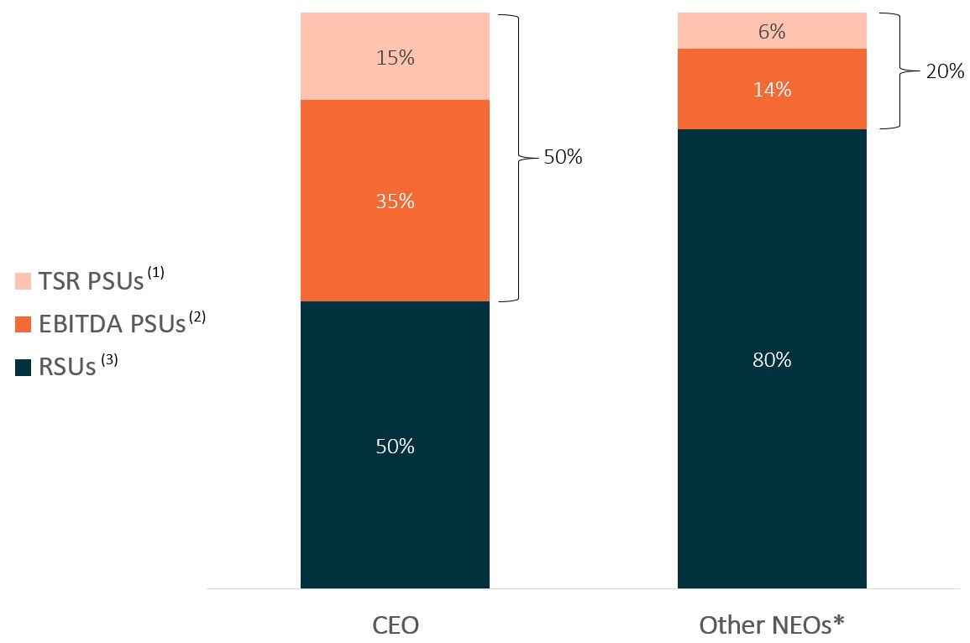
TSR PSUs(1)EBITDA PSUs(2) RSUs(3) 15% 35% 50% 50% 6% 14% 80% 20% CEO Other NEOs*

* Excludes Mr. Ahmed who departed the Company prior to the annual grants.

2026 Proxy Statement | 33

Table of Contents
(1)
TSR PSUs: Shares subject to these PSU awards are earned and vest based on our relative total stockholder return (“relative TSR”) over a three-year performance period as compared to companies in a pre-determined index of medical device companies, with 100% of earned units vesting immediately after certification of the achievement level at the end of the three-year performance period (“TSR PSUs”). The number of TSR PSUs earned vary based on actual performance from 0% to 250% of the target number for our CEO and from 0% to 200% of the target number for our other NEOs, subject to a payout cap at the target level (corresponding to a payout of 100%) if the Company’s absolute TSR over the performance period is negative.
(2)
EBITDA PSUs: Shares subject to these PSU awards are earned and vest based on achievement against the Company’s three-year cumulative adjusted non-GAAP earnings before income tax, depreciation and amortization (“EBITDA”) at the end of 2027, with 100% of earned units vesting immediately after certification of the achievement level following the end of 2027 (“EBITDA PSUs”). The number of EBITDA PSUs earned vary based on actual performance from 0% to 250% of the target number for our CEO and from 0% to 200% of the target number for our other NEOs.
(3)
RSUs: Other than as noted below, shares subject to these RSU awards vest over a two-year period, with 50% vesting on the first anniversary of the vesting commencement date (January 17, 2025) and the remaining 50% vesting quarterly over the following year. For Ms. Gaeta’s new-hire RSU award and the one-time RSU award for Mr. Nash in connection with his promotion to EVP, R&D, Operations and Service, shares vest over a three-year period, with one-third vesting on the first anniversary of the grant date and the remaining two-thirds vesting quarterly over the following two years.
Preview of Certain 2026 Executive Compensation Actions
In early 2026, following consultation with Pearl Meyer, the Compensation Committee took certain actions with respect to executive officer and director compensation, including the following:
•
For 2026, the Compensation Committee determined not to change the annual base salaries or cash bonus opportunities (as a percentage of base salary) for our CEO or other executive officers as compared to the prior year, as they remained market competitive.
•
For 2026, the Compensation Committee generally maintained the overall structure of our annual cash bonus program but updated the performance goals to 50% revenue and 50% non-GAAP gross margin (replacing non-GAAP operating income) and added a required year-end corporate cash balance minimum as a gating criterion for bonus payments to be made. These updates were designed by the Compensation Committee to more closely align executive incentives with our stated financial priorities communicated to investors: revenue growth, gross margin improvement and profitability. The revenue metric continues to encourage top-line growth, while the shift to non-GAAP gross margin reflects the Compensation Committee’s focus on gross margin improvement and the profitability of our products and services. The Compensation Committee added a required year-end cash balance minimum to further encourage disciplined cash management and support our broader profitability and liquidity objectives.
•
To support retention priorities and leadership continuity, the Compensation Committee approved one-time cash retention bonuses payable in December 2026 (subject to continued employment through the payment date) for each of our current executive officers other than our CEO. The retention bonus amounts are $66,795 for Renee Gaeta, $106,620 for John Brottem, and $100,460 for Marc Nash, each in addition to regular 2026 annual cash bonus opportunities.
•
To further support retention and incentivize achievement of key cost-savings initiatives, the Compensation Committee also approved a separate one-time performance-based cash bonus for Mr. Nash tied to 2026 service efficiency and profitability goals. This bonus provides target payouts of $95,000 and $105,000 for the two goals, with no payment below 90% of target, linear scaling from 90% to 100% achievement, and an overachievement opportunity of 15% of incremental savings above target up to a cap of $100,000 in the aggregate, payable following year-end certification and subject to continued employment through the payment date.
Executive Compensation Philosophy and Objectives
Our executive compensation program is designed to meet the following key objectives:
•
Attract, mobilize and retain the right talent. Executive compensation should be market-competitive in order to attract and retain highly qualified, experienced and motivated talent to act as inspirational leaders, drive our strategic initiatives, grow our business and help pave the way to a patient-centric dialysis service model.

2026 Proxy Statement | 34

Table of Contents
•
Incentivize a collective focus on corporate goals. Our work environment is goal-driven and we believe compensation is a critical tool in the successful execution of our business objectives. By tying elements of our executives’ pay to key corporate goals, we encourage our executives to focus their teams and execute on these goals.
•
Reward and recognize outstanding performance. We firmly believe that executive compensation should incentivize and reward outstanding performance that contributes to our overall growth and success as a company both in the short term and long term.
•
Create long-term stockholder value. Through the risks and rewards of owning Outset equity, we incentivize our executives to stay focused collectively on activities that intended to ensure Outset’s sustainable success.
Our Compensation Committee has created an executive compensation program that combines short-term and long-term components, cash and equity, as well as fixed, at-risk and variable compensation elements, in the proportions it believes achieve these guiding principles.
Linking Pay to Performance; Our Program Design
Consistent with our philosophy of aligning executive pay with the short-term and long-term performance of the Company, and to align the interests of management and stockholders, a significant majority of the overall compensation paid to each NEO is at-risk or variable in the form of annual cash bonuses and equity-based compensation. Our annual cash bonuses are at-risk because they are earned only upon the achievement of pre-established performance metrics. Our PSU awards are at-risk because the underlying shares are earned and vest only upon the achievement of performance metrics. Our RSU awards are variable because the value earned varies based on our stock price.
As reflected in the charts below, for 2025, approximately 81% of our CEO’s target annual pay, and 69% of our other NEOs’ (excluding Ms. Gaeta and Mr. Ahmed) target annual pay on average, was at-risk or variable. We believe this target annual pay mix reflects the strong pay-for-performance design of our executive compensation program.

CEO Target Annual Pay(1) Mix | Other NEOs, Average Target Annual Pay(1)(2) Mix
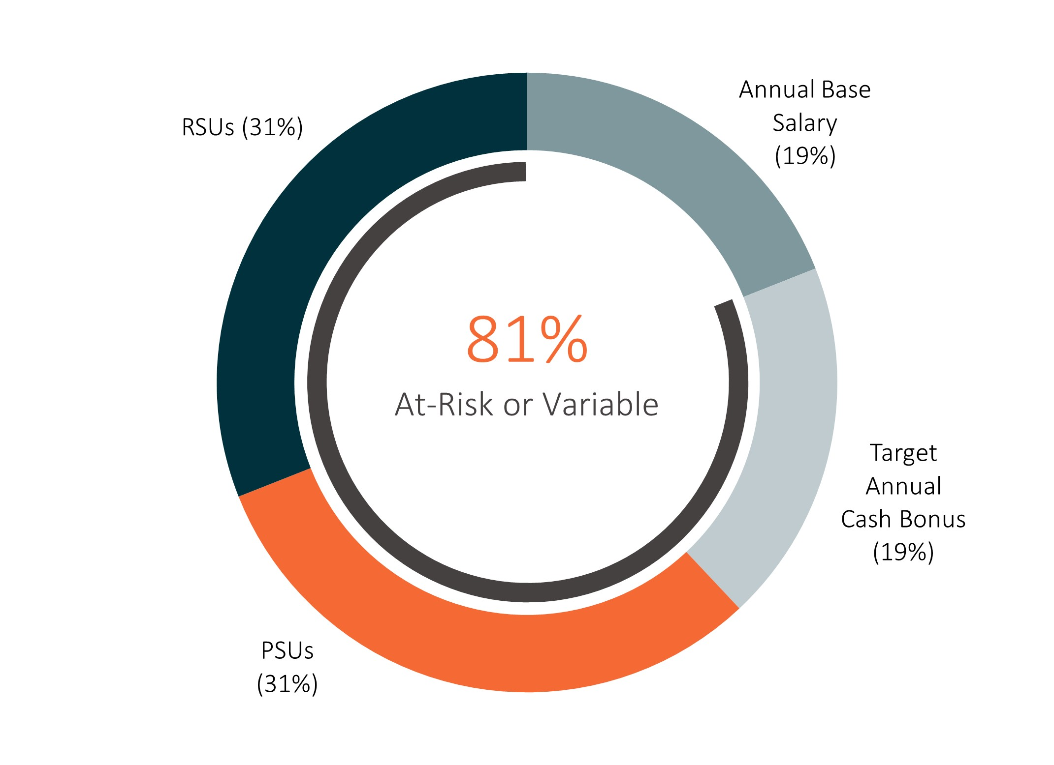 | 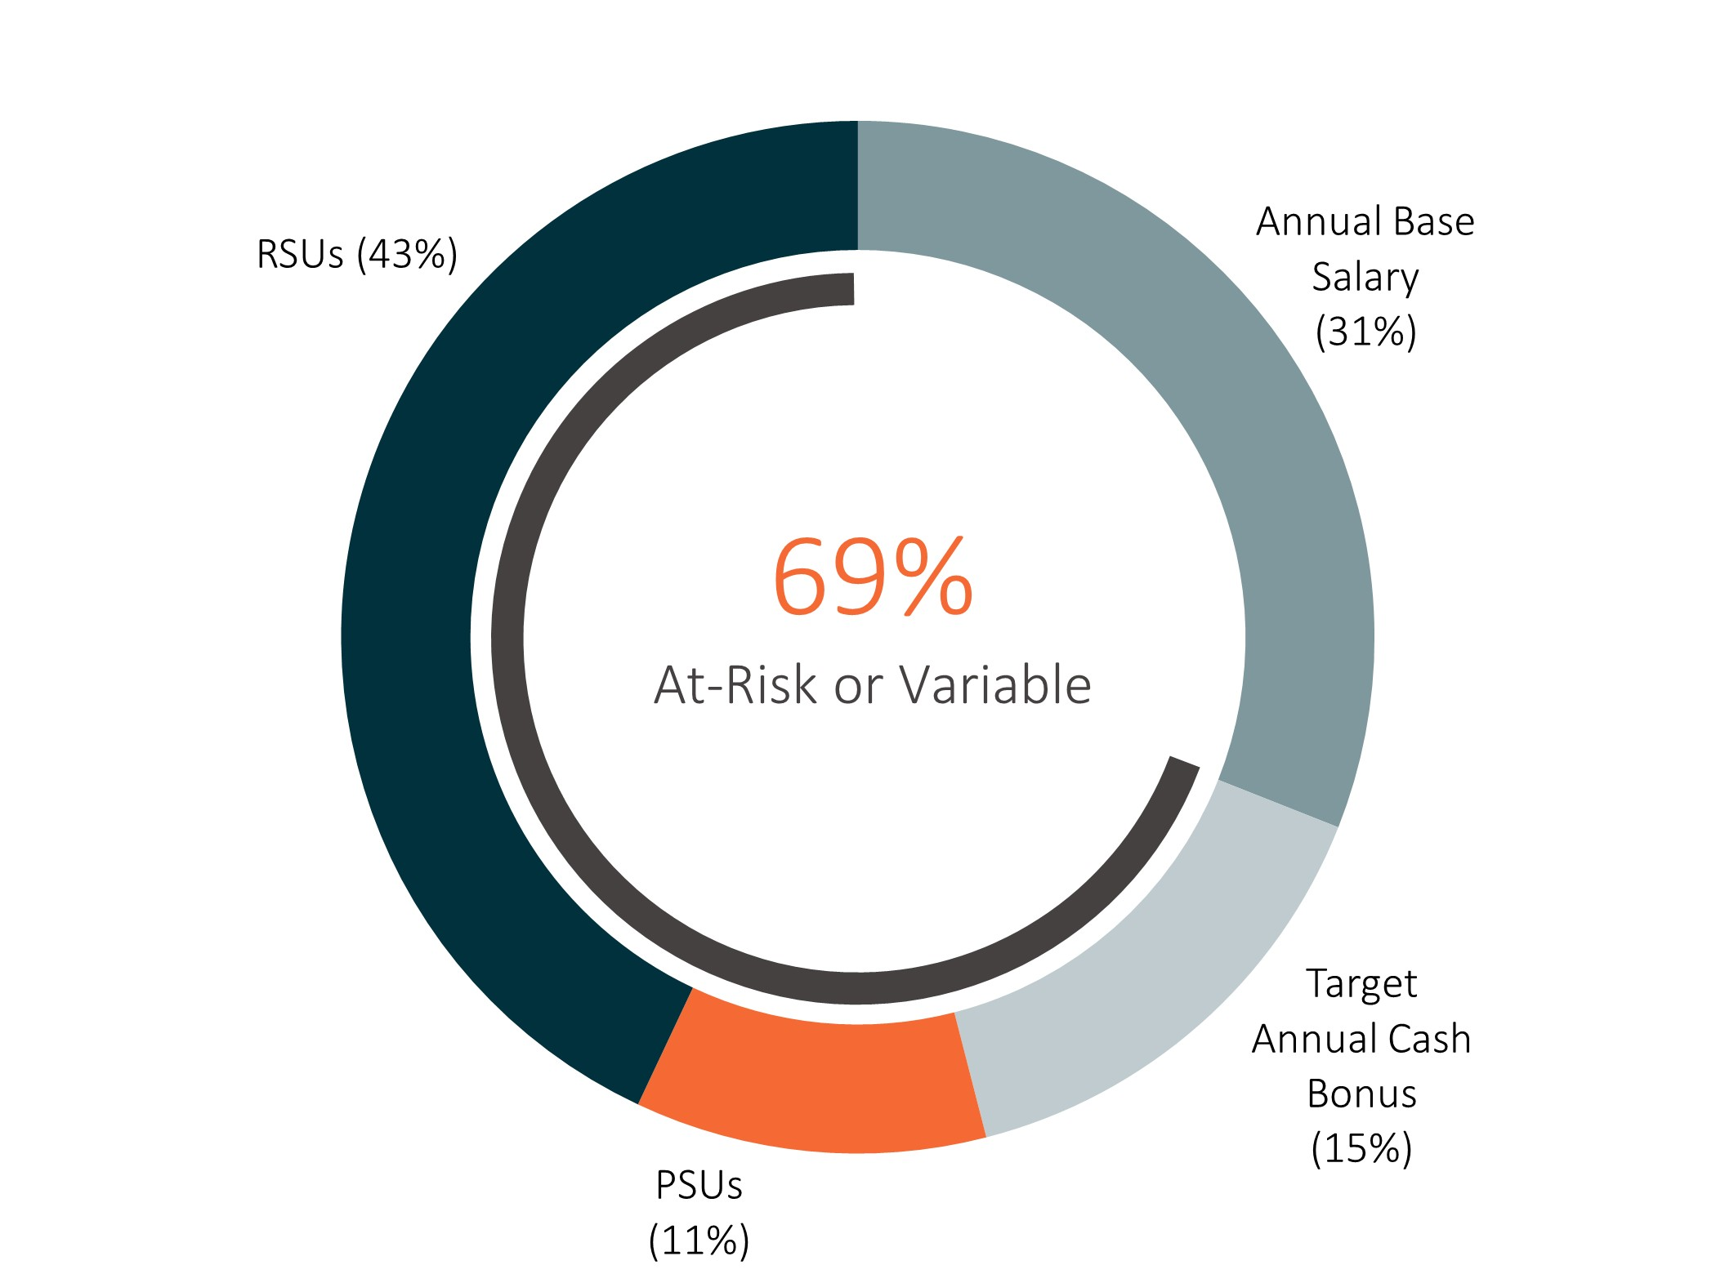
RSUs(31%) Annual Base Salary (19%) Target Annual Cash Bonus (19%) PSUs(31%) 81% AT- Risk or Variable RSUs(43%) Annual Base Salary (31%) Target Annual Cash Bonus (15%) PSUs(11%) 69% AT- Risk or Variable

(1)
“Target annual pay” consists of each NEO’s (i) annualized 2025 base salary, (ii) target annual cash bonus opportunity for 2025 (expressed as a percentage of annualized base salary for 2025 and assuming a 100% payout, with no overachievement), and (iii) target values of annual equity awards granted to such NEO during 2025 (which were converted to share numbers using the methodology described below in the section entitled “2025 Equity Award Determinations”). For Mr. Nash, target annual pay reflects his annualized base salary at the end of 2025 (without proration for mid-year adjustments) and includes the one-time equity grant he received in connection with his promotion to EVP, R&D, Operations and Service.
(2)
Ms. Gaeta has been excluded from the chart because she joined the Company in 2025 and her compensation mix is not representative of our regular annual executive compensation program due to her one-time new hire equity grants. Mr. Ahmed has also been excluded from the chart because he departed the Company in 2025 before annual equity awards were granted, and therefore his compensation mix is likewise not representative of our annual executive compensation program.

2026 Proxy Statement | 35

Table of Contents
Elements of Our Executive Compensation Program
For 2025, the material elements of compensation for our NEOs were base salary, annual cash bonuses tied to corporate performance goals, and equity-based compensation in the form of RSUs and PSUs. The following table outlines these principal elements, including the primary objectives of each element, any associated performance measures, and whether each element is categorized as “fixed,” “at-risk” or “variable” based on corporate performance (including stock price appreciation).

Compensation  Element |  | Form |  | Type |  | Primary Objectives |  | Performance Measures
Base Salary |  | Cash |  | Fixed |  | •  Provide base amount of market competitive pay to attract, retain and motivate an effective leadership team  •  Provide a predictable level of financial stability for our executives |  | Not applicable
Annual Cash Incentive |  | Cash |  | At-risk |  | •  Focus executives on key annual corporate financial goals  •  Motivate and reward performance in achievement of these goals  •  Create a “pay for performance” culture |  | Pre-established performance metrics based on achievement of two one-year financial goals (tied to revenue and non-GAAP operating income)
Equity Incentive Awards |  | RSUs |  | Variable |  | •  Attract, incentivize and retain executives through time-based multi-year vesting  •  Align interests of stockholders and executives by linking realized value to stock price performance  •  Focus our executives on performance that creates long-term value for our stockholders |  | Stock price appreciation
Equity Incentive Awards |  | PSUs |  | At-risk |  | •  Incentivize and retain executives  •  Focus executives on key corporate goals considered to be critical drivers of our growth and creation of long-term stockholder value  •  Motivate and reward performance that creates long-term value for our stockholders (no payout if performance measures are not met)  •  Align interests of stockholders and executives |  | Performance metrics based on achievement against two metrics: (1) a financial metric tied to our three-year non-cumulative adjusted non-GAAP EBITDA at the end of 2027 and (2) our relative stockholder return over a three-year performance period compared to companies in a pre-determined index of medical device companies

2026 Proxy Statement | 36

Table of Contents
Our Executive Compensation Practices
During 2025, our Compensation Committee maintained a number of practices designed to reinforce our executive compensation philosophy and objectives:

WHAT WE DO: |  | WHAT WE DON’T DO:
ü A significant majority of our NEOs’ annual target pay is at-risk or variable in the form of annual cash bonuses and long-term equity compensation tied to corporate performance and/or stock price appreciation  ü Annual cash bonuses contingent on multiple pre-established financial performance metrics that align with key corporate goals intended to create long-term stockholder value, subject to a cap on payout  ü PSUs tied to multiple performance metrics over multi-year performance periods  ü Our short-term and long-term incentive programs are tied to different measures of performance  ü Annual advisory vote for stockholders to approve NEO compensation  ü Maintain a fully (100%) independent Compensation Committee  ü Retain independent compensation consultant reporting directly to the Compensation Committee  ü Annual executive compensation review (including market comparison against a relevant peer group)  ü Annual risk assessment of compensation plans, policies and programs  ü Meaningful stock ownership guidelines for our directors and executive officers  ü Compensation recoupment (“clawback”) policy |  | û No guaranteed bonuses or base salary increases  û No employment contracts that guarantee continued employment of our executive officers  û No excessive perquisites provided to our executive officers  û No “single trigger” change of control arrangements  û No repricing, cash-out or exchange of “underwater” stock options without stockholder approval  û No health, welfare or retirement plans for executive officers that are not available to all employees  û We prohibit our employees and directors from engaging in hedging or other speculative transactions in our securities, and from pledging our securities  û No dividend or dividend equivalent payments on unearned equity awards
Stockholder Advisory Votes on NEO Compensation
Since 2022, we have held annual say-on-pay votes seeking advisory approval from our stockholders of the compensation of our named executive officers.
As previously disclosed in our 2025 proxy statement, following our 2024 say on-pay vote, in late 2024, we initiated a stockholder outreach campaign where we sought input from our stockholders who held approximately 80% of our outstanding shares, with the primary goals of seeking feedback on our executive compensation program and to better understand the decrease in stockholder support reflected in the 2024 say-on-pay vote. As described in detail in our 2025 proxy statement, our Compensation Committee thoughtfully considered feedback from stockholders received during the course of this outreach and took certain responsive actions. Moreover, as part of the Compensation Committee’s continuing efforts to consider and incorporate stockholder feedback into our program design, the Compensation Committee added a cap to the TSR PSUs granted to NEOs in June 2025, limiting the maximum payout to 100% of target if the Company’s absolute TSR over the performance period is negative (regardless of the Company’s percentile rank relative to the comparator group). We believe the addition of this cap to the TSR PSUs reflects the Compensation Committee’s ongoing responsiveness to stockholder feedback and its commitment to strengthening the alignment of executive pay with long-term value creation for our stockholders.

2026 Proxy Statement | 37

Table of Contents
At our annual meeting of stockholders held in June 2025, our say-on-pay proposal was approved on an advisory basis, with approximately 97.5% of stockholder votes cast in favor of the proposal, representing a return to the high levels of support we have received since initiating say-on-pay votes in 2022. In evaluating our executive compensation practices during the remainder of 2025 and in early 2026, we were mindful of the strong support our stockholders expressed for our philosophy of linking executive pay to short-term and long-term performance of the Company and aligning the interests of management and stockholders. In light of this strong support, the Compensation Committee has retained our general approach to executive compensation, continuing to apply the same general principles and philosophy in determining executive pay, while remaining attentive to stockholder feedback received through ongoing engagement efforts.
We value the opinions of our stockholders. Our Board and Compensation Committee take very seriously the voting results and feedback received from our stockholders and will continue to thoughtfully consider the outcome of future say-on-pay votes and stockholder feedback when making future compensation decisions for our executive officers. Consistent with the preference of our stockholders as reflected in the non-binding, advisory vote on the frequency of future say-on-pay votes (commonly known as a “say-on-frequency” vote) held at our 2022 annual meeting of stockholders, our Board has determined that we will hold a say-on-pay vote every year. Accordingly, we are holding a say on-pay vote at this Annual Meeting (see “Proposal Two” in this proxy statement for more detailed information).
As part of our investor relations program, we engage in ongoing outreach to and discussions with our stockholders, including on matters related to executive compensation and corporate governance. Please see the section above entitled “Board and Corporate Governance Matters – Stockholder Engagement” for further details on our stockholder engagement efforts.
How We Make Executive Compensation Decisions
Role of the Compensation Committee and Management
Our Board has delegated to the Compensation Committee responsibility for overseeing and administering our executive compensation program, including reviewing and approving or recommending the compensation of our CEO and other executive officers (including our NEOs). With respect to the compensation of our CEO, the Compensation Committee is charged with reviewing and approving corporate goals and objectives relevant to the compensation of our CEO, evaluating our CEO’s performance in light of those goals, and determining, approving or recommending our CEO’s compensation based on this evaluation and other factors. Our Board approves the level of our CEO’s, base salary, target annual bonus and target annual equity award after considering the Compensation Committee’s recommendation. Our CEO does not participate in discussions regarding her own compensation.
Our Compensation Committee also approves the compensation of our executive officers other than our CEO. In doing so, the Compensation Committee takes into account our CEO’s evaluation of each executive officer’s performance and her recommendations with respect to their compensation. While our Compensation Committee solicits and reviews our CEO’s recommendations and proposals with respect to compensation of our executive officers (other than her own), the Compensation Committee uses these recommendations and proposals as one of several factors in making such compensation decisions, and exercises its discretion in accepting, rejecting or modifying any such recommendations and proposals. In addition, from time to time, various members of management and other employees may be invited by the Compensation Committee to provide financial or other information or advice to the committee or otherwise participate in committee meetings.
In setting executive compensation, the Compensation Committee considers a number of factors, including the recommendations of our CEO (other than with respect to herself), market data and competitive benchmarking assessments prepared by the Company’s independent compensation consultant (as discussed below in the section entitled “Benchmarking Comparison to Peer Group”), current and past total compensation, current equity holdings and the retention value thereof, overall forecast and budget considerations, current market conditions and the talent market environment, company performance and growth, the specific needs of the business at critical points in time, each executive’s role, criticality and relative scope of responsibility, individual performance and contributions, longevity and depth in role, overall experience and expertise, as well as internal equity considerations.

2026 Proxy Statement | 38

Table of Contents
Guidance from Independent Compensation Consultant
In accordance with its written charter, the Compensation Committee has authority to retain or obtain the advice of an independent compensation consultant, legal counsel or other advisors to assist with the execution of its duties including as it relates to executive officer compensation. The Compensation Committee believes that working with an independent compensation consultant furthers its objectives to recruit and retain qualified executives, align their interests with those of our stockholders and help design compensation packages that will appropriately motivate and reward ongoing achievement of our business goals.
The Compensation Committee engaged the services of Pearl Meyer as an independent executive compensation consultant to assist in its evaluation of executive and director compensation for 2025. At the request of the Compensation Committee, Pearl Meyer advised on principal aspects of our 2025 executive compensation program, including reviewing our executive compensation philosophy, developing a comparative group of peer companies, reviewing peer group trends with respect to levels and types of compensation elements, and performing competitive benchmarking assessments of executive officer compensation against our peer group and certain industry-specific survey data. In addition, Pearl Meyer reviewed and benchmarked our non-employee director compensation policy, reviewed competitive market practices and trends for equity compensation of our non-executive employees, conducted pay for performance assessments with respect to our 2025 CEO compensation, and provided support on other ad hoc matters throughout the year.
Pearl Meyer is retained by and continues to report to the Compensation Committee and, at the request of the committee, participates in committee meetings. Based on consideration of the various factors set forth in applicable Nasdaq and SEC rules, the Compensation Committee does not believe that its relationship with Pearl Meyer and the work of Pearl Meyer on behalf of the Compensation Committee have raised any conflicts of interest. The Compensation Committee reviews these factors and receives written confirmation from Pearl Meyer stating its belief that it remains an independent compensation consultant to the Compensation Committee.
Benchmarking Comparison to Peer Group
In order to obtain a broad view of compensation practices among industry peers and competitors for executive talent, and to help design a competitive executive compensation program to attract, motivate and retain effective leadership, our Compensation Committee worked closely with Pearl Meyer to identify an appropriate group of comparable publicly traded peer companies against which to benchmark our 2025 executive officer compensation.
In selecting the peer group to be used to help guide 2025 executive compensation decisions, the Compensation Committee, in consultation with Pearl Meyer, reviewed and updated the peer group selection criteria designed to capture a meaningful cross-section from which to benchmark executive officer compensation as follows:

Step |  | Criteria
Starting Pool |  | An initial group of U.S.-based public companies traded on a major exchange was identified
Filtering Criteria |  | The initial group was filtered to focus on companies operating in comparable industries, with comparable revenue, market capitalization and full-time employee headcount generally within the following ranges:  •  Trailing 12-month revenue ranging from $50 million to $450 million  •  6-month average market capitalization ranging from $50 million to $650 million  •  150 to 1,500 full-time employees
Selection Criteria |  | Peer companies meeting the above filtering criteria were prioritized and selected using selection criteria based on geography (west-coast based companies), sector (technology-driven capital equipment or device providers), and comparison to proxy advisor peer groups

2026 Proxy Statement | 39

Table of Contents
Due to significant changes in the Company’s profile in the latter months of 2024, in particular, a decline in our stock price and market capitalization, in July 2024, the Compensation Committee, in consultation with Pearl Meyer, conducted a comprehensive review of our peer group. To improve alignment with the Company’s then-current size and profile, the Compensation Committee narrowed the market capitalization filtering criteria range used for peer selection to $50 million to $650 million (revised from the prior $350 million to $3.5 billion). As a result, the Compensation Committee removed ten companies – three of which were acquired during 2024, and seven of which exceeded the updated market capitalization range (with market capitalizations above $1 billion). To maintain our target peer group size, the Compensation Committee added nine companies that met the updated market capitalization criteria and that also had revenue and full-time employee headcount within our filtering criteria ranges.
Following this comprehensive review, in July 2024, our Compensation Committee approved the following peer group of companies for evaluating 2025 executive officer compensation (the “2025 peer group”):

 |  | 2025 Peer Group
Accuray Incorporated* |  | Neuronetics, Inc.* |  | Pulmonx Corporation
Adaptive Biotechnologies Corporation* |  | NeuroPace, Inc.* |  | SI-BONE, Inc.
AngioDynamics, Inc.* |  | Nevro Corp.* |  | Sight Sciences, Inc.*
Butterfly Network, Inc.* |  | Pacific Biosciences of California, Inc. |  | Tactile Systems Technology, Inc.
CareDx, Inc. |  | Paragon 28, Inc. |  | Treace Medical Concepts, Inc.
Inogen, Inc.* |  | PROCEPT BioRobotics Corporation

* Companies marked with an “*” are new additions to the 2025 peer group (i.e., they were not included in the 2024 peer group).
The Compensation Committee reviews our peer group on an annual basis to make adjustments if warranted based on changes in both our business and the businesses of the companies in our peer group, while typically maintaining year-over-year continuity in the list for comparability of competitive analysis. As described above, in July 2024, the Compensation Committee, in consultation with Pearl Meyer, undertook a comprehensive review and made the following changes to the 2024 peer group in determining the 2025 peer group:
•
Removed Axonics, Inc., NanoString Technologies, Inc. and Silk Road Medical, Inc., each of which was acquired during 2024;
•
Removed AtriCure, Inc., Glaukos Corporation, STAAR Surgical Company, TransMedics Group, Inc. and Veracyte, Inc., each of which exceeded the updated market capitalization filtering criteria range;
•
Removed Inari Medical, Inc. and iRhythm Technologies, Inc., each of which exceeded both the updated market capitalization and revenue filtering criteria ranges; and
•
Added eight healthcare equipment companies and one life sciences tools and services company (marked with an “*” in the table above), each of which fell within our revenue, market capitalization and full-time employee headcount filtering criteria ranges, in order to replace the removed companies and maintain a similarly sized peer group.
In early 2025, Pearl Meyer prepared reports summarizing a benchmarking review and assessment of our executive compensation program, including base salary, annual incentive bonus and equity award levels for our NEOs as compared to our 2025 peer group and certain industry-specific survey data. The Compensation Committee considered these reports, among other factors, in determining the size, components and mix of compensation elements for the NEOs in 2025.

2026 Proxy Statement | 40

Table of Contents
Our Compensation Committee believes competitive market data is a useful tool in its deliberations to help design an executive compensation program that is competitive in relation to our peers, enabling us to attract, motivate and retain a qualified leadership team. The Compensation Committee generally considers the 25th, 50th and 75th percentiles of market data, and makes individual compensation decisions based on comparable positions at our peer group. However, the Compensation Committee does not rely solely on competitive market data to determine any element of executive compensation or overall compensation. In making executive compensation decisions, the Compensation Committee considers a number of additional factors, including those discussed above in the section entitled “Role of the Compensation Committee and Management” as well as below in the section entitled “Elements of NEO Compensation and 2025 Determinations.”
Elements of NEO Compensation and 2025 Determinations
The principal elements of our NEOs’ 2025 compensation consisted of cash compensation in the form of base salary and annual cash bonuses tied to corporate performance goals, as well as equity-based compensation in the form of RSUs and PSUs. Each of these compensation elements is discussed in further detail below, including a description of how it fits into our overall executive compensation program and a discussion of the amounts of compensation paid or awarded to our NEOs during 2025 under each of these elements.
In addition, our NEOs are eligible to participate in our standard retirement, health and welfare and other available employee benefit plans on the same basis as our other employees. We also maintain severance and change in control arrangements with our executive officers (including our NEOs) as described below.
Base Salary
Base salary represents the fixed portion of our executive officers’ compensation, which we view as an important element to attract and retain an effective leadership team. As the only fixed component of our executive compensation program, base salaries are also intended to provide our executives with a reasonable degree of financial stability, predictability and security of compensation.
Our Compensation Committee generally reviews and determines the base salaries of our executive officers on an annual basis, as well as upon hire of a new executive and upon promotion to an executive position. In setting base salaries, the Compensation Committee generally considers competitive market data for comparable positions within our peer group and certain industry-specific survey data, while also taking into consideration other factors including current and past total compensation, each executive’s role, criticality and relative scope of responsibility, individual performance and contributions, longevity and depth in role, overall experience and expertise, company performance and growth, retention priorities, operating budget considerations and cost reduction initiatives, as well as the recommendations of our CEO (other than with respect to herself).
As part of its annual review of executive compensation levels in early 2025, the Compensation Committee reviewed the base salaries of our NEOs (excluding Ms. Gaeta, who joined the Company later in the year), including an assessment of market data prepared by Pearl Meyer based on our 2025 peer group and certain industry-specific survey data. Based on this review, the Compensation Committee approved the base salary increases shown in the table below. As further described below, the increase for Mr. Nash reflects both the annual adjustment and an additional increase approved later in the year in connection with his promotion.
In determining these annual increases for NEO base salaries, the Compensation Committee considered competitive market benchmark data and internal equity considerations. The Compensation Committee generally targets the 50th percentile of market data for comparable positions within our 2025 peer group and certain industry-specific survey data, but retains discretion to set base salaries above or below this level based on individual and Company-specific factors. The Compensation Committee also considered individual performance and contributions, current and anticipated responsibilities and scope expansion, and the importance of retaining strong and stable leadership during a critical time for the Company in a competitive talent market. In evaluating the appropriateness of 2025 base salary adjustments, the Compensation Committee further took into account that executive base salaries were not increased in 2024 due to cost reduction efforts (other than in the case of Mr. Nash, whose 2024 increase was approved in connection with his promotion and expanded responsibilities).

2026 Proxy Statement | 41

Table of Contents
The table below sets forth the annual base salaries in effect for each NEO in 2024 and 2025, and the percentage increase.

Name: |  | 2024  Annual Base Salary  ($) |  |  |  | 2025  Annual Base Salary  ($) |  |  |  | Percentage Increase
Leslie Trigg |  |  | 725,000 |  |  |  | 756,000 |  |  |  | 4.3 | %
Renee Gaeta(1) |  |  | — |  |  |  | 500,000 |  |  | N/A
John Brottem(2) |  |  | 415,800 |  |  |  | 468,000 |  |  |  | 12.6 | %
Marc Nash(3) |  |  | 400,000 |  |  |  | 470,000 |  |  |  | 17.5 | %
Nabeel Ahmed(4) |  |  | 460,100 |  |  |  | 473,800 |  |  |  | 3.0 | %

(1)
Ms. Gaeta’s annual base salary was determined by our Compensation Committee when she joined the Company in June 2025 in connection with a recruitment and hiring process, taking into consideration various factors including market data prepared by Pearl Meyer for Chief Financial Officer positions based on our 2025 peer group, the scope of her role, her qualifications and prior experience, as well as the recommendation of our CEO. The amount reported for 2025 reflects her annualized base salary and has not been adjusted to reflect her partial year of service.
(2)
Mr. Brottem’s annual base salary increase was determined by our Compensation Committee after considering competitive market benchmark data and internal equity considerations and noting that his prior salary was below the 50th percentile of market data for comparable positions within our 2025 peer group. The Committee also considered that Mr. Brottem’s base salary was not increased in 2024 due to cost reduction efforts and determined that a larger adjustment was appropriate in order to better align his base salary with market levels.
(3)
Mr. Nash’s annual base salary was increased from $400,000 to $415,000, representing an increase of 3.8%, in connection with the Compensation Committee’s annual review of executive compensation levels in early 2025. Effective August 25, 2025, the Compensation Committee approved an additional increase in Mr. Nash’s annual base salary from $415,000 to $470,000, representing an additional increase of 13.3%, in connection with his promotion to EVP, R&D, Operations and Service, taking into consideration a number of factors, including the expanded scope of his role to include oversight of the field service team, market data prepared by Pearl Meyer for comparable positions based on industry-specific survey data, his qualifications and prior experience, internal equity considerations, as well as the recommendation of our CEO.
(4)
Mr. Ahmed departed the Company in June 2025. The amount reported for 2025 reflects his annualized base salary and has not been adjusted to reflect his partial year of service.
Annual Cash Incentive
We provide our executives with short-term incentive compensation through our annual cash bonus program. Consistent with our executive compensation philosophy, our annual incentive program is designed to focus our employees (including our executives) on key strategic corporate goals and motivate and reward performance in achievement of these goals, helping to create a goal-oriented and “pay for performance” environment. We believe that company-wide goals help foster effective cross-functional performance and a culture of collaboration, in furtherance of our philosophy that we drive for success as a team, not as individuals.
Our annual cash bonus program provides cash incentive award opportunities based on the level of achievement of key financial performance goals established by our Compensation Committee at the beginning of the fiscal year. Payout varies depending on company performance as compared to the threshold and target performance goals established by the Compensation Committee. Our bonus program is designed to pay above-target bonuses when we exceed our target annual corporate objectives and below-target bonuses when we do not meet these objectives, with no payout in the event that we fail to meet any of the threshold objectives.
Target annual cash bonus opportunities for our NEOs were set by our Compensation Committee as a percentage of their respective base salaries. In connection with its annual review of our executives’ compensation in early 2025, our Compensation Committee reviewed the 2025 bonus targets of our NEOs (excluding Ms. Gaeta), taking into consideration market data prepared by Pearl Meyer based on our 2025 peer group and certain industry-specific survey data, each executive’s scope of responsibilities and individual and company performance, as well as the recommendation of our CEO (except with respect to herself), with a view towards generally maintaining consistent bonus percentages amongst our

2026 Proxy Statement | 42

Table of Contents
non-CEO executive officers. Based on this analysis, the Compensation Committee decided not to change the NEOs’ 2025 bonus target percentages as compared to the prior year, as they remained market competitive.
The following table sets forth the bonus targets (as a percentage of annual base salary) for each NEO during 2025, which were unchanged from the prior year, as reflected below:

Name: |  | 2024  Bonus Target Percentage |  |  |  | 2025  Bonus Target Percentage |  |  |  | Increase
Leslie Trigg |  |  | 100 | % |  |  | 100 | % |  |  | —
Renee Gaeta(1) |  |  | — |  |  |  | 50 | % |  | N/A
John Brottem |  |  | 50 | % |  |  | 50 | % |  |  | —
Marc Nash |  |  | 50 | % |  |  | 50 | % |  |  | —
Nabeel Ahmed(2) |  |  | 50 | % |  |  | 50 | % |  |  | —

(1)
Ms. Gaeta’s bonus target was determined by our Compensation Committee when she joined Outset in June 2025 in connection with a recruitment and hiring process, after consideration of various factors including competitive market data, the scope of her role, her qualifications and prior experience, as well as the recommendation of our CEO. Her annual bonus was prorated based on the length of his employment during 2025.
(2)
Mr. Ahmed was not eligible to receive a payout under our 2025 bonus program because he departed the Company during 2025.
Corporate Performance Goals
The payment of awards under our 2025 annual cash bonus program applicable to our NEOs was subject to the attainment of two pre-established corporate performance goals relating to the Company’s financial performance, which we refer to as “performance goals.”
These performance goals were approved by our Compensation Committee in February 2025. As compared to our prior year cash bonus program, when designing the 2025 annual cash bonus program, the Compensation Committee reduced the number of performance goals from four to two, with two pre-established performance goals tied to 2025 revenue and 2025 non-GAAP operating income, each weighted 50%. For each performance goal, payouts ranged from 20% (at threshold performance) to 100% (at target performance) and up to a maximum of 200%. In restructuring the annual cash bonus program for 2025 were, the Compensation Committee intended to streamline and balance the program, place greater emphasis on direct financial metrics and further align, focus and incentivize our executives to prioritize the Company’s most critical financial goals of driving revenue growth, managing operating expenses and achieving cashflow breakeven. By reducing the number of performance goals from four to two, a shortfall in one goal would have a greater impact on the overall payout, as there are fewer goals to offset underperformance. Our Compensation Committee believed these changes would create stronger alignment between payout and the achievement of both key financial goals, helping to ensure that our executives are incentivized to consistently perform well on both financial metrics.
Our Compensation Committee established “threshold” and “target” achievement levels for each performance goal with resulting payouts for each such goal ranging from 20% (at threshold) to 100% (at target), plus an overachievement opportunity for achievement levels above target up to a maximum of 200% for each performance goal. As compared to our prior year cash bonus program, our Compensation Committee determined to expand the achievement spectrum by adjusting the threshold for each performance goal to 20% (down from 50%) to allow for a greater range of performance to be recognized and support retention objectives.
Our Compensation Committee designed these threshold and target corporate performance goals for 2025 to (i) be challenging, but attainable with superior performance as well as focused effort and execution by our executives, (ii) appropriately drive successful execution of key financial objectives, namely driving revenue growth, managing operating expenses and advancing toward cashflow breakeven, and (iii) support long-term stockholder value creation by aligning executive pay with disciplined financial performance consistent with our overall growth strategies.

2026 Proxy Statement | 43

Table of Contents
Each performance goal was weighted according to the Compensation Committee’s assessment of its relative importance to achieving our key 2025 financial objectives and its expected contribution to long-term stockholder value. In order to incentivize and proportionately reward exceptional above-target performance of each goal, while balancing fiscal responsibility and the desire to discourage excessive risk taking by our executives, the Compensation Committee allowed for overachievement opportunities for each goal based on pre-determined payout slopes, while capping payouts for each goal at a maximum of 200% of the target bonus opportunity that relates to such goal.
2025 Cash Bonus Plan Design and Payouts
In February 2026, our Compensation Committee, based on achievement of our 2025 corporate performance goals, approved overall payouts under our 2025 annual cash bonus program equal to 39% of each NEO’s target bonus opportunity. This overall payout was the result of below-target performance on each of the revenue and non-GAAP operating income goals.
The table below summarizes (i) the design of our 2025 cash bonus program, including the weighting, as well as threshold, target and maximum achievement levels, for each corporate performance goal, (ii) actual achievement and corresponding payout levels at 2025 year-end with respect to each corporate performance goal, and (iii) the total payout level under the 2025 cash bonus program.

 |  |  |  |  |  |  |  |  |  | Actual Achievement
Corporate Performance Goal |  | Weighting |  | Threshold:  20% Payout(1) |  | Target:  100% Payout(1) |  | Maximum  200% Payout(1) |  | Attainment at  2025 Year-End |  | Payout Level |  | Weighted Payout
Revenue  (2025) |  | 50% |  | $114.0 million |  | $131.4 million |  | $144.5 million |  | Below target  $119.5 million |  | 44% |  | 22%
Operating income  (non-GAAP 2025) |  | 50% |  | $(51.6) million |  | $(44.9) million |  | $(40.4) million |  | Below target  $(50.5) million(2) |  | 34% |  | 17%
 |  |  |  |  |  |  |  |  |  | Total payout: |  |  |  | 39%

(1)
For each performance goal (i) achievement below threshold results in no payout for such goal and (ii) payouts scale linearly from 20% to 100% for achievement between threshold and target levels and from 100% to a cap of 200% for achievement between target and maximum levels. Payout for any individual performance goal is capped at a maximum of 200%.
(2)
Appendix A includes a reconciliation of operating income as prepared and presented under GAAP to non-GAAP operating income.
The following table summarizes the 2025 target bonus opportunities (assuming 100% payout at target) for each NEO, as well actual cash bonus amounts earned by each NEO during 2025 under our cash bonus program that were paid in April 2026.

Name:(1) |  | Actual Base  Salary Paid  in 2025  ($)(2) |  |  |  | 2025 Bonus  Target  Percentage  (%) |  | 2025 Target Bonus Opportunity at 100% Payout  ($) |  |  |  | 2025 Actual  Bonus  Payout Level  (%) |  | 2025 Actual  Bonus  Amount  ($)(3)
Leslie Trigg |  |  | 755,166 |  |  | 100% |  |  | 755,166 |  |  | 39% |  |  | 294,515
Renee Gaeta |  |  | 276,923 |  |  | 50% |  |  | 138,462 |  |  | 39% |  |  | 54,000
John Brottem |  |  | 466,595 |  |  | 50% |  |  | 233,298 |  |  | 39% |  |  | 90,986
Marc Nash |  |  | 432,577 |  |  | 50% |  |  | 216,289 |  |  | 39% |  |  | 84,353

(1)
Mr. Ahmed is excluded from the table as he departed the Company during 2025 and was therefore not eligible to receive a payout under our 2025 cash bonus program.
(2)
Ms. Gaeta joined the Company on June 3, 2025 and this amount reflects her partial year of service. Mr. Nash’s base salary was increased from $415,000 to $470,000 effective August 25, 2025 in connection with his promotion and expanded scope of responsibilities.
(3)
Actual cash bonus amounts earned by each NEO during 2025 were calculated based on such NEO’s actual salary paid during 2025, multiplied by the product of (i) such NEO’s 2025 bonus target percentage and (ii) the actual bonus payout level (39%).

2026 Proxy Statement | 44

Table of Contents
Equity Incentive Awards
Our equity-based compensation is intended to attract, motivate and retain our executive officers, align the interests of our executive officers with the interests of our stockholders and focus our executive officers on performance that creates long-term value for our stockholders, using a mix of both time-based vesting and performance-based vesting. We typically grant equity awards to executive officers on an annual basis, as well as upon hire of a new executive and upon promotion to an executive position. We do not intend to time, and in 2025 did not time, the release of material non-public information based on equity grant dates or for the purpose of affecting the value of our equity incentive awards. In addition, we did not grant stock options or stock appreciation rights in 2025, and the purchase dates under our Employee Stock Purchase Plan occur on pre-established, fixed dates.
2025 Equity Award Types
During 2025, we granted equity-based compensation to our NEOs (excluding Mr. Ahmed) in the form of RSUs and PSUs. Key elements of equity awards granted to our NEOs during 2025, including the target mix of annual awards and vesting schedules, are summarized in the following table:

Target Equity Mix(1)
(% of Annual Equity Award)
Equity Award Type |  | Recipients(2) |  | CEO |  | Other NEOs |  | At-Risk or Variable |  | Vesting(3)
RSUs |  | All NEOs |  | 50% |  | 80% |  | Variable: Value varies based on stock price performance |  | Time-based vesting as follows: (1) over two years, with 50% vesting on the first anniversary of the vesting commencement date (January 17, 2025) and the remaining 50% vesting quarterly over the following year and (2) in the case of Ms. Gaeta's new-hire RSU award and the one-time RSU award for Mr. Nash in connection with his promotion to EVP, R&D, Operations and Service, over three years, with one third vesting on the first anniversary of the grant date and the remaining two thirds vesting quarterly over the following two years
PSUs |  | All NEOs |  | 50%(4) |  | 20%(4) |  | At-risk: No payout if threshold performance measure is not met |  | Performance-based vesting, with PSUs earned and vesting based on achievement against two separate metrics tied to: (1) the Company's three-year cumulative adjusted non-GAAP EBITDA measured at the end of the second full year following the year in which the awards were granted and (2) relative TSR measured at the end of a three-year performance period

(1)
Percentages are based on the target value of each award type as described below in the section entitled “2025 Equity Award Determinations.”
(2)
Mr. Ahmed did not receive any equity awards in 2025 because he departed the Company prior to the annual executive equity grants made in June 2025.
(3)
All vesting is subject to continued service through the applicable vesting date(s).
(4)
Of the annual PSU awards granted to each NEO, 70% were comprised of EBITDA PSUs and 30% were comprised of TSR PSUs.
Design of 2025 PSUs
In designing the PSUs awarded to the NEOs in 2025, the Compensation Committee, in consultation with Pearl Meyer, retained certain features from the 2024 PSU program, including the granting of TSR PSUs, while implementing design enhancements to better align the program with the Company’s key financial goals and long-term stockholder value creation strategy. Most notably, to place greater emphasis on a direct financial metric aligned with the Company’s key objectives of driving revenue growth and progressing toward profitability – and to further reinforce alignment between executive incentives and long-term stockholder value creation – the Compensation Committee replaced the prior-year operational metric (the number of patients treating at home on Tablo) with a financial metric tied to the Company’s three-year cumulative adjusted non-GAAP EBITDA, and granted EBITDA PSUs to our NEOs as described below. In addition, for the

2026 Proxy Statement | 45

Table of Contents
TSR PSUs granted to NEOs in 2025, the Compensation Committee maintained performance and vesting terms substantially consistent with those granted in 2024, with one key refinement informed by feedback received from stockholders during the Company’s outreach efforts initiated in late 2024. Specifically, the Compensation Committee added a cap to the 2025 TSR PSUs, limiting the maximum payout to 100% of target if the Company’s absolute TSR for the performance period is negative, regardless of the Company’s percentile rank relative to the comparator group.
The table below summarizes key features of the two types of PSUs awarded to the NEOs in 2025, and the Compensation Committee’s rationale:
 | EBITDA PSUs | TSR PSUs | Rationale
Performance metrics | Non-GAAP cumulative EBITDA | Relative TSR compared to companies in the Russell 2000 Medical Device Index | •  Cumulative adjusted non-GAAP EBITDA is a direct measure of the Company’s progress toward its key financial objectives of driving revenue growth and advancing toward profitability, which the Compensation Committee determined would help focus and incentivize executives to drive sustained operational execution and financial performance over the performance period, supporting the Company’s long-term success and creation of stockholder value.  •  Relative TSR, in addition to being a common incentive metric amongst peer group companies, is an effective measure of the Company’s long-term success and creation of stockholder value as compared to a pre-determined index of medical device companies which the Compensation Committee determined to be most comparable in sector and company size. The relative nature of the metric helps normalize external macroeconomic factors that fall outside of management’s control.  •  The use of multiple metrics (one absolute and one relative) helps balance the PSU structure, focusing executives and incentivizing and rewarding performance based on more than a single metric.
Weighting | 70% | 30% | •  The Compensation Committee determined the split between EBITDA PSUs and TSR PSUs based on relative importance of each metric to the Company’s short-term and long-term success and strategy, with greater emphasis on EBITDA as a critical financial metric due to its central role in driving revenue growth, advancing profitability, and aligning executive incentives with the Company’s long-term creation of stockholder value.
Payout scale and maximum | 0% to 250% (CEO)  0% to 200% (other NEOs) | 0% to 250% (CEO)(1)  0% to 200% (other NEOs)(1) | •  Incentivizes and proportionately rewards exceptional above-target performance, while discouraging excessive risk-taking by our executives.
Performance period and vesting | Performance period of three years ending on December 31, 2027), with 100% of earned units vesting upon certification of achievement following the performance period | Three-year performance period (June 10, 2025 through June 10, 2028), with 100% of earned units vesting upon certification of achievement following the performance period | •  To maintain consistency with prior-year awards and support retentive value and risk management, the Compensation Committee retained performance periods of three years. The Compensation Committee determined that these multi-year performance periods provide an appropriate time horizon for measuring performance, balancing the one-year annual cash bonus program with the two- or three-year vesting of time-based RSUs, and creating an overall executive compensation program designed to align executive pay with both the short-term and long-term performance of the Company.

(1)
Payout is capped at 100% of target if the Company’s absolute TSR for the performance period is negative, regardless of the Company’s percentile rank relative to the comparator group.

2026 Proxy Statement | 46

Table of Contents
EBITDA PSUs:
Of the PSUs awarded to our NEOs in 2025, 70% were comprised of EBITDA PSUs. The EBITDA PSUs awarded to our NEOs during 2025 may become earned and vested based on achievement against a financial metric tied to the Company’s three-year cumulative adjusted non-GAAP EBITDA as of the end of 2027, with 100% of earned units vesting upon certification of the requisite achievement level following the end of 2027, subject to continued service through the vesting date.
The number of EBITDA PSUs earned at the end of the three-year performance period ending December 31, 2027 (“Earned EBITDA Units”) varies based on actual performance from 0% to 250% in the case of our CEO and from 0% to 200% in the case of our other NEOs. The table below summarizes the payout opportunities for the EBITDA PSUs:
 |  | Non-GAAP Cumulative Adjusted EBITDA at end of 2027 |  | Earned EBITDA Units
Level of Achievement |  | (as a Percentage of 3-Year Target)(1) |  | (as a Percentage of Target)
Below Threshold |  | Less than 85% |  | 0%
Threshold |  | 85% |  | 50%
Target |  | 100% |  | 100%
Above Target | ﻿ | Each additional $1,000,000 above target | ﻿ | Additional 2.97%, up to a maximum of 250% (for our CEO) or 200% (for our other NEOs)

(1)
Payouts scale linearly for achievement between threshold and target levels and for achievement between target and maximum levels.
The Compensation Committee approved a three-year performance period for the 2025 EBITDA PSUs, with adjusted non-GAAP EBITDA targets to be set annually for each of the three reference years (2025, 2026 and 2027). The 2025 target was established by the Compensation Committee in June 2025 at the time the EBITDA PSUs were granted, the 2026 target was established in February 2026, and the 2027 target will be established in early 2027, aligned with the Company’s operating plan for each such year. Each annual target is set at a level the Compensation Committee believes is challenging but reasonably achievable with superior performance, designed to appropriately incentivize the NEOs.

The three annual targets will be aggregated to determine the cumulative three-year adjusted non-GAAP EBITDA target against which performance will be measured at the end of the performance period. Following the end of each reference year, the Compensation Committee will certify actual adjusted non-GAAP EBITDA performance for that year, and at the conclusion of the three-year performance period, the Compensation Committee will certify cumulative performance over the full period and the extent to which the PSUs are earned based on such cumulative performance. No PSUs are earned until the Compensation Committee certifies the cumulative performance results following the end of the performance period.

The Compensation Committee sets targets on an annual basis to incorporate the most current business conditions and financial outlook for each year, while measuring performance on a single cumulative three-year basis to maintain long-term alignment. As the Compensation Committee believes it does not have sufficient visibility to set a meaningful three-year cumulative non-GAAP EBITDA target in advance, annual target-setting allows the Compensation Committee to establish rigorous yet reasonably achievable goals while linking awards to sustained performance over the full three-year period. This approach supports consistent execution across all three years and reduces the impact of year-to-year volatility on potential payouts, while maintaining strong alignment between executive incentives and the Company’s long-term performance and stockholder value creation.
TSR PSUs:
Of the PSUs awarded to our NEOs in 2025, 30% were comprised of TSR PSUs. The TSR PSUs awarded to our NEOs during 2025 may become earned and vested based on our relative TSR over a three-year performance period (beginning June 10, 2025 and ending June 10, 2028) as compared to companies included in the Russell 2000 Medical Device Index as of June 10, 2025, with 100% of earned units vesting upon certification of the requisite achievement level following the end of the performance period, subject to continued service through the vesting date.
The number of TSR PSUs earned at the end of the three-year performance period ending June 10, 2028 (“Earned TSR Units”) will vary based on actual performance from 0% to 250% in the case of our CEO and from 0% to 200% in the case of our other NEOs. The table below summarizes the payout opportunities for the TSR PSUs:

2026 Proxy Statement | 47

Table of Contents
Level of Achievement |  | TSR Percentile(1) |  | Earned TSR Units  (as a Percentage of Target)
Below threshold |  | Less than 25th percentile |  | 0%
Threshold |  | 25th percentile |  | 50%
Target |  | 50th percentile |  | 100%
Maximum |  | 75th percentile or above |  | 250% for our CEO; 200% for our other NEOs(2)

(1)
Payouts scale linearly for achievement between threshold and target levels and for achievement between target and maximum levels.
(2)
In each case, payout is capped at 100% of target if the Company’s absolute TSR for the performance period is negative, regardless of the Company’s percentile rank relative to the comparator group.

2025 Equity Award Determinations

For equity awards granted to our NEOs during 2025, the Compensation Committee approved the total target value of equity awards for each NEO, and then allocated such target value as applicable between RSUs and PSUs (and between EBITDA PSUs and TSR PSUs) to achieve the desired target equity award mix. As approved by the Compensation Committee, to determine the total number of shares underlying each RSU and PSU award, the target value of the stock award was divided by the average closing price of a share of our common stock over 20 trading days ending on the last trading day preceding the grant date. For the actual grant date fair values of the equity awards granted to our NEOs in 2025, computed in accordance with ASC 718, please see the “Stock Awards” column of the 2025 Summary Compensation Table below. The terms of the RSUs and PSUs are described above in “2025 Equity Award Types.”
Annual Equity Grants

In setting the target equity award values of the annual executive grants, the Compensation Committee considered a broad range of factors. These included competitive market data prepared by Pearl Meyer based on our peer group and certain industry-specific survey data, each executive’s scope of responsibilities, individual contributions and performance, and the importance of retaining strong and stable leadership during a critical period for the Company in an increasingly competitive talent market. The Compensation Committee also considered the size and value of prior year awards (including as a percentage of common shares outstanding), as well as the recommendations of our CEO (except with respect to herself).

The Compensation Committee also evaluated the impact of the annual executive equity awards on the Company’s available share reserve under its equity plan. Although these annual awards were granted on June 10, 2025, shortly after stockholders approved an increase to the plan’s share reserve at the annual meeting of stockholders held on June 2, 2025, the Compensation Committee has remained focused on managing the pool prudently to help ensure its sufficiency for future needs, particularly in light of potential stock price volatility. As a result, the Compensation Committee calibrated the 2025 award levels to balance competitive market positioning, retention priorities and long-term sustainability of the share reserve.
New Hire and Promotion Equity Grants

Ms. Gaeta’s new hire equity awards were approved by the Compensation Committee when she joined Outset in June 2025 and were determined in connection with a recruitment and hiring process. In setting the value of these awards, the Compensation Committee considered market data prepared by Pearl Meyer, the scope of her role, her qualifications and prior experience, as well as the recommendation of our CEO. Consistent with the target mix used for annual grants to NEOs other than our CEO, Ms. Gaeta’s equity awards were delivered 50% in RSUs and 50% in PSUs, with the PSU portion allocated 70% to EBITDA PSUs and 30% to TSR PSUs, in each case vesting as described in the table above in the section entitled “Equity Award Types.”

In addition to receiving his annual equity grant in June 2025, Mr. Nash received an additional award in connection with his promotion to EVP, R&D, Operations and Service in August 2025. In setting the target equity award value of this promotion award, the Compensation Committee considered the expanded scope of his role, including oversight of the field service team, the value of awards granted to him earlier in the year, his qualifications and prior experience, and the

2026 Proxy Statement | 48

Table of Contents
recommendation of our CEO. Consistent with the target mix used for annual grants to NEOs other than our CEO, Mr. Nash’s promotion grant was delivered 50% in RSUs and 50% in PSUs, with the PSU portion allocated 70% to EBITDA PSUs and 30% to TSR PSUs, in each case vesting as described in the table above in the section entitled “Equity Award Types.”
2025 Equity Awards for NEOs
Taking into consideration all of the above factors, the Compensation Committee approved awarding the following equity awards to our NEOs in 2025, including annual grants awarded on June 10, 2025 and new hire or promotion grants awarded outside the regular annual grant cycle.

 |  | Annual Awards |  |  |  |  |  |  |  |  |  |  |  |  |  |  |  | New Hire / Promotion Awards
Name:(1) |  | Aggregate Target Value |  |  |  | Number of  RSUs |  |  |  | Number of  EBITDA PSUs |  |  |  | Number of  TSR PSUs |  |  |  | Aggregate Target Value |  |  |  | Number of  RSUs |  |  |  | Number of  EBITDA PSUs |  |  |  | Number of  TSR PSUs
Leslie Trigg |  | $ | 2,457,000 |  |  |  | 65,103 |  |  |  | 45,572 |  |  |  | 19,531 |  |  |  | — |  |  |  | — |  |  |  | — |  |  |  | —
Renee Gaeta |  |  | — |  |  |  | — |  |  |  | — |  |  |  | — |  |  | $ | 3,100,000 |  |  |  | 131,425 |  |  |  | 22,999 |  |  |  | 9,857
John Brottem |  | $ | 849,000 |  |  |  | 35,993 |  |  |  | 6,299 |  |  |  | 2,699 |  |  |  | — |  |  |  | — |  |  |  | — |  |  |  | —
Marc Nash |  | $ | 700,000 |  |  |  | 29,676 |  |  |  | 5,193 |  |  |  | 2,226 |  |  | $ | 100,000 |  |  |  | 5,617 |  |  |  | 983 |  |  |  | 421

(1)
Mr. Ahmed is excluded from table as he did not receive any equity awards in 2025 because he departed the Company prior to the annual executive equity grants made in June 2025.
Please see below the table entitled “Outstanding Equity Awards at 2025 Fiscal Year-End” for a summary of the outstanding stock option and stock awards held by each of our NEOs as of December 31, 2025, including a summary of the applicable vesting terms.

2024 PRSU Achievement Levels
As previously disclosed, based on our non-GAAP operating income performance for fiscal year 2024, which exceeded the 2024 non-GAAP operating income target that was set in 2024 for the one-time special retention PSU awards granted to executives in 2024 (the “2024 PRSUs”), 50% of the 2024 PRSUs were earned and vested upon the Compensation Committee’s certification of the achievement level in January 2025. Based on our non-GAAP operating income performance for fiscal year 2025, which fell below the 2025 non-GAAP operating income target for the 2024 PRSUs that was set in early 2025, the Compensation Committee determined that the remaining 50% of the 2024 PRSUs was not earned. Accordingly, the unearned 50% of the 2024 PRSUs remains outstanding and eligible for vesting over the remainder of the performance period ending December 31, 2026 based solely on achievement of pre-established stock price thresholds. The non-GAAP operating income targets were intended to be based on meaningful targets that would be challenging, but reasonably achievable with superior performance.

Stock Ownership Guidelines
We maintain Stock Ownership Guidelines applicable to all of our executive officers designated as such for purposes of Section 16 of the Exchange Act (including our NEOs), as well as our non-employee directors of our Board. For additional details on our Stock Ownership Guidelines, please see the section of this proxy statement entitled “Board and Corporate Governance Matters – Stock Ownership Guidelines.”

Recoupment Policy

We maintain a recoupment (or “clawback”) policy that applies to certain incentive compensation paid to current and certain former executive officers that was paid based on incorrect financial performance information. For additional details on our recoupment policy, please see the section of this proxy statement entitled “Board and Corporate Governance Matters – Recoupment Policy.”

2026 Proxy Statement | 49

Table of Contents
Change in Control and Severance Agreements
During 2025, we were party to Change in Control and Severance Agreements with each of our NEOs that provide for severance benefits upon certain qualifying terminations of employment with the Company. Our Compensation Committee believes that these types of arrangements serve to minimize the distraction caused by a potential separation, including in connection with a potential transaction, encourage retention through the conclusion of a transaction, enable our executives to focus on continuing normal business operations and on the success of a potential business combination, and help ensure stability and leadership continuity during a potentially uncertain period. Furthermore, our Compensation Committee believes these arrangements are important for attracting and retaining executive talent, as many of the companies with which we compete for executive talent have similar agreements in place for their senior management.
A description of these arrangements is set forth below in the section entitled “Additional Narrative Disclosure – Change in Control and Severance Arrangements.”
401(k) Plan
We maintain a qualified 401(k) savings plan which allows our eligible employees, including the NEOs, to defer a percentage of their cash compensation up to the maximum amount allowed under Internal Revenue Service guidelines. We may make discretionary matching and nonelective contributions to the plan. We match 100% of each employee’s contributions up to a maximum matching contribution equal to 2% of such employee’s eligible compensation. Participants are always vested in their contributions to the plan.

Compensation Committee Report
The Compensation Committee has reviewed and discussed with management the section entitled “Compensation Discussion and Analysis” contained in this proxy statement. Based on this review and discussion, the Compensation Committee has recommended to our Board that the section entitled “Compensation Discussion and Analysis” be included in this proxy statement and incorporated into our Annual Report on Form 10-K for the year ended December 31, 2025.

Submitted by the Compensation Committee of our Board:

D. Keith Grossman (Chair)
Karen Drexler
Karen Prange

2026 Proxy Statement | 50

Table of Contents

2025 Summary Compensation Table
The following table shows information regarding the compensation awarded or paid to, or earned by, our NEOs for services performed in 2023, 2024 and 2025.

Name and Principal Position |  | Year |  | Salary  ($) |  |  |  | Bonus  ($)(1) |  |  |  | Stock  Awards  ($)(2)(3) |  |  |  |  | Option  Awards  ($) |  |  |  | Non-Equity Incentive Plan Compensation  ($)(5) |  |  |  |  | All Other  Compensation  ($)(7) |  |  |  | Total  ($)
Leslie Trigg |  | 2025 |  |  | 755,166 |  |  |  | — |  |  |  | 2,197,882 |  | (4) |  |  | — |  |  |  | 294,515 |  |  |  |  | 7,947 |  |  |  | 3,255,510
President, CEO & Board Chair |  | 2024 |  |  | 725,000 |  |  |  | — |  |  |  | 2,400,223 |  |  |  |  | — |  |  |  | 870,000 |  |  |  |  | 7,397 |  |  |  | 4,002,620
 |  | 2023 |  |  | 723,077 |  |  |  | — |  |  |  | 5,254,876 |  |  |  |  | — |  |  |  | 489,876 |  | (6) |  |  | 7,117 |  |  |  | 6,474,946
Renee Gaeta |  | 2025 |  |  | 276,923 |  |  |  | — |  |  |  | 3,061,977 |  | (4) |  |  | — |  |  |  | 54,000 |  |  |  |  | 5,125 |  |  |  | 3,398,025
Chief Financial Officer |  | 2024 |  |  | — |  |  |  | — |  |  |  | — |  |  |  |  | — |  |  |  | — |  |  |  |  | — |  |  |  | —
 |  | 2023 |  |  | — |  |  |  | — |  |  |  | — |  |  |  |  | — |  |  |  | — |  |  |  |  | — |  |  |  | —
John Brottem |  | 2025 |  |  | 466,595 |  |  |  | 1,000 |  |  |  | 838,557 |  | (4) |  |  | — |  |  |  | 90,986 |  |  |  |  | 7,506 |  |  |  | 1,404,644
General Counsel & Secretary |  | 2024 |  |  | 415,800 |  |  |  | — |  |  |  | 837,841 |  |  |  |  | — |  |  |  | 249,480 |  |  |  |  | 7,397 |  |  |  | 1,510,518
 |  | 2023 |  |  | 415,208 |  |  |  | — |  |  |  | 1,197,419 |  |  |  |  | — |  |  |  | 124,770 |  |  |  |  | 7,117 |  |  |  | 1,744,514
Marc Nash |  | 2025 |  |  | 432,577 |  |  |  | — |  |  |  | 783,340 |  | (4) |  |  | — |  |  |  | 84,353 |  |  |  |  | 7,198 |  |  |  | 1,307,468
EVP, R&D, Operations & Service |  | 2024 |  |  | 398,942 |  |  |  | 1,000 |  |  |  | 830,290 |  |  |  |  | — |  |  |  | 239,365 |  |  |  |  | 7,103 |  |  |  | 1,476,700
 |  | 2023 |  |  | 335,481 |  |  |  | 15,000 |  |  |  | 605,612 |  |  |  |  | — |  |  |  | 85,290 |  |  |  |  | 6,794 |  |  |  | 1,048,177
Nabeel Ahmed |  | 2025 |  |  | 212,841 |  |  |  | — |  |  |  | — |  |  |  |  | — |  |  |  | — |  |  |  |  | 397,287 |  | (8) |  | 610,128
Former Chief Financial Officer |  | 2024 |  |  | 460,100 |  |  |  | — |  |  |  | 1,047,630 |  |  |  |  | — |  |  |  | 276,060 |  |  |  |  | 7,224 |  |  |  | 1,791,014
 |  | 2023 |  |  | 459,521 |  |  |  | — |  |  |  | 1,715,620 |  |  |  |  | — |  |  |  | 146,873 |  | (6) |  |  | 6,937 |  |  |  | 2,328,951

(1)
The amounts reported in this column for Mr. Brottem for 2025 and Mr. Nash for 2024 represent one-time bonus awards in connection with reaching five years of service. The amount reported in this column for Mr. Nash for 2023 represents a one-time bonus awarded to him in connection with a promotion.
(2)
Amounts reported in this column include the aggregate grant date fair value of RSUs granted to the NEOs in 2025, 2024 and 2023, in accordance with ASC 718, using the product of the number of units granted and the closing price of our common stock on the grant date.
(3)
Amounts reported in this column also include the aggregate grant date fair value of PSUs granted to the NEOs in 2025, 2024 and 2023, in accordance with ASC 718 as further described for 2025 in footnote 4 below. Under ASC 718, the vesting conditions related to the 2025 TSR PSUs, 2024 TSR PSUs and 2023 TSR PSU awards, are considered market conditions and not performance conditions. Accordingly, there is no grant date fair value below or in excess of the amounts reflected in this column that could be calculated and disclosed based on achievement of the underlying market conditions.
(4)
Amounts reported for 2025 include:
(i) With respect to the 2025 TSR PSUs, the product of the number of units granted to each NEO and the fair value for one PSU share as of the grant date estimated using the Monte Carlo simulation model as outlined in Note 2 of our financial statements included in our 2025 annual report.
(ii) Because the grant date of the 2025 EBITDA PSUs will not be considered established for accounting purposes until the cumulative three-year target for such PSUs is determined and approved by the Compensation Committee in early 2027, no associated expense was recognized when such PSUs were awarded, and they are not reflected in this column for 2025.
(5)
Amounts reported in this column reflect the actual annual performance-based cash bonus awards earned by each NEO in 2025, 2024 and 2023 under our annual performance-based cash bonus program, except as noted in footnote 6 below.
(6)
In December 2023, Ms. Trigg and Mr. Ahmed each received 100% and 50%, respectively, of their 2023 actual cash bonus amounts in the form of fully-vested RSUs in lieu of cash, such that, fully-vested RSUs for 8,779 shares were granted to Ms. Trigg and fully-vested RSUs for 1,394 shares were granted to Mr. Ahmed.

2026 Proxy Statement | 51

Table of Contents
(7)
The amounts reported in this column for each NEO in 2025 consist of Company-paid life insurance premiums and matching contributions made by the Company to our 401(k) plan as follows:

 |  | Life Insurance Premiums  ($) |  |  |  | 401(k) Matching Contributions  ($)
Leslie Trigg |  |  | 947 |  |  |  | 7,000
Renee Gaeta |  |  | 125 |  |  |  | 5,000
John Brottem |  |  | 506 |  |  |  | 7,000
Marc Nash |  |  | 198 |  |  |  | 7,000
Nabeel Ahmed |  |  | 239 |  |  |  | 7,000
(8)
In addition to the Company-paid life insurance premiums and 401(k) matching contributions for Mr. Ahmed’s benefit paid through his departure date that are reflected in footnote 7 above, this amount includes (i) a severance payment of $355,350 equal to nine months of base salary and (ii) $34,698 in payment of premiums for COBRA continuation coverage for nine months, in each case, paid to Mr. Ahmed in connection with his departure from the Company on June 3, 2025.

Grants of Plan-Based Awards in 2025

The following table presents certain information regarding grants of plan-based awards to the NEOs during 2025:

 |  |  |  |  | Estimated Future Payouts Under Non-Equity Incentive Plan Awards(1) |  |  |  |  |  |  |  |  |  |  |  | Estimated Future Payouts Under  Equity Incentive Plan Awards(4)
 |  |  |  |  | Threshold |  |  |  | Target |  |  |  | Maximum |  |  |  | Threshold |  |  |  | Target |  |  |  | Maximum |  |  |  | All Other Stock Awards: Number of Shares of Stock or Units |  |  |  | Grant Date Fair Value of Stock and Option Awards(8)
Name |  | Grant Date |  |  | ($) |  |  |  | ($) |  |  |  | ($) |  |  |  | (#) |  |  |  | (#) |  |  |  | (#) |  |  |  | (#) |  |  |  | ($)
Leslie Trigg |  |  |  |  |  | 75,600 |  |  |  | 756,000 |  |  |  | 1,512,000
 |  | 6/10/2025 | (5) |  |  |  |  |  |  |  |  |  |  |  |  |  |  | 9,765 |  |  |  | 19,531 |  |  |  | 48,827 |  |  |  |  |  |  |  | 853,505
 |  | 6/10/2025 | (6) |  |  |  |  |  |  |  |  |  |  |  |  |  |  |  |  |  |  |  |  |  |  |  |  |  |  | 65,103 |  |  |  | 1,344,377
Renee Gaeta |  |  |  |  |  | 14,521 |  | (2) |  | 145,206 |  | (2) |  | 290,411 |  | (2)
 |  | 6/10/2025 | (5) |  |  |  |  |  |  |  |  |  |  |  |  |  |  | 4,928 |  |  |  | 9,857 |  |  |  | 19,714 |  |  |  |  |  |  |  | 348,051
 |  | 6/10/2025 | (7) |  |  |  |  |  |  |  |  |  |  |  |  |  |  |  |  |  |  |  |  |  |  |  |  |  |  | 131,425 |  |  |  | 2,713,926
John Brottem |  |  |  |  |  | 23,400 |  |  |  | 234,000 |  |  |  | 468,000
 |  | 6/10/2025 | (5) |  |  |  |  |  |  |  |  |  |  |  |  |  |  | 1,349 |  |  |  | 2,699 |  |  |  | 5,398 |  |  |  |  |  |  |  | 95,302
 |  | 6/10/2025 | (6) |  |  |  |  |  |  |  |  |  |  |  |  |  |  |  |  |  |  |  |  |  |  |  |  |  |  | 35,993 |  |  |  | 743,255
Marc Nash |  |  |  |  |  | 23,690 |  | (3) |  | 217,219 |  | (3) |  | 434,438 |  | (3)
 |  | 6/10/2025 | (5) |  |  |  |  |  |  |  |  |  |  |  |  |  |  | 1,113 |  |  |  | 2,226 |  |  |  | 4,452 |  |  |  |  |  |  |  | 78,600
 |  | 6/10/2025 | (6) |  |  |  |  |  |  |  |  |  |  |  |  |  |  |  |  |  |  |  |  |  |  |  |  |  |  | 29,676 |  |  |  | 612,809
 |  | 8/25/2025 | (5) |  |  |  |  |  |  |  |  |  |  |  |  |  |  | 210 |  |  |  | 421 |  |  |  | 842 |  |  |  |  |  |  |  | 14,866
 |  | 8/25/2025 | (7) |  |  |  |  |  |  |  |  |  |  |  |  |  |  |  |  |  |  |  |  |  |  |  |  |  |  | 5,617 |  |  |  | 77,065
Nabeel Ahmed(9) |  |  |  |  |  | 23,690 |  |  |  | 236,900 |  |  |  | 473,800

(1)
These columns set forth the potential threshold, target and maximum annual cash bonus awards for each NEO under our 2025 cash bonus program based on each NEO’s annual base salary and target bonus percentage for 2025, prorated as described below in the case of Ms. Gaeta and Mr. Nash. The threshold amounts assume achievement at the threshold level for one of the equal-weighted performance goals (weighted 50%), and achievement below threshold for the other performance goal, resulting in 10.0% payout. The target amounts assume achievement at the target level for each of the two performance goals, resulting in 100% payout. The maximum amounts assume payout at the cap of 200% for each of the two performance goals, resulting in 200% total payout. The actual cash bonus award earned for 2025 by each NEO is set forth in the “Non-Equity Incentive Plan Compensation” column of the 2025 Summary Compensation Table above. These awards are described in further detail above in the section entitled “Elements of NEO Compensation and 2025 Determinations—Annual Cash Incentive.”
(2)
Ms. Gaeta’s annualized target cash bonus opportunity for 2025 was $250,000. The potential threshold, target and maximum amounts reported are prorated to reflect days of service from her June 3, 2025 hire date.
(3)
Mr. Nash’s annual base salary increased from $415,000 to $470,000 effective August 25, 2025 in connection with his promotion, while his target bonus percentage remained 50%. The potential threshold, target and maximum amounts reported are prorated to reflect the portion of 2025 he served at each base salary level.

2026 Proxy Statement | 52

Table of Contents
(4)
In addition to the awards reflected in these columns, the 2025 EBITDA PSUs were awarded to the NEOs (other than Mr. Ahmed) in 2025 pursuant to our 2020 Equity Incentive Plan which are earned and vest based on achievement against a financial metric tied to the Company’s three-year cumulative adjusted non-GAAP EBITDA as of the end of 2027, with 100% of earned units vesting upon certification of the requisite achievement level following the end of 2027, subject to the NEO’s continued service through the vesting date. Although the 2025 EBITDA PSU awards were approved in 2025, the grant date of the 2025 EBITDA PSUs will not be considered established for accounting purposes until the three-year cumulative performance target for such PSUs is determined and approved by the Compensation Committee in early 2027. As a result, such PSUs were not considered granted during 2025 and are not included in this table. These awards are described in further detail above in the section entitled “Elements of NEO Compensation and 2025 Determinations—Equity Incentive Awards.”
(5)
These TSR PSUs were granted pursuant to our 2020 Equity Incentive Plan and are earned and vest based on our relative TSR over a three-year performance period as compared to companies in a pre-determined index of medical device companies, with 100% of earned units vesting upon certification of the achievement level following the performance period, subject to the NEO’s continued service through the vesting date. The threshold amount represents 50% of the shares underlying the PSU grant assuming achievement at the threshold level, the target amount represents 100% of the shares underlying the PSU grant assuming achievement at the target level, and the maximum amount represents 200% of the shares underlying the PSU grant (250% in the case of the PSUs granted to Ms. Trigg) assuming achievement at the maximum level. These awards are described in further detail above in the section entitled “Elements of NEO Compensation and 2025 Determinations—Equity Incentive Awards.”
(6)
These RSUs were granted pursuant to our 2020 Equity Incentive Plan. 50% of the shares subject to these RSU awards vest on the first anniversary of the vesting commencement date (January 17, 2025), after which the remaining shares vest quarterly in equal installments over the following year on each February 15, May 15, August 15 and November 15, subject to the NEO’s continued service through the applicable vesting date.
(7)
These RSUs were granted pursuant to our 2020 Equity Incentive Plan. One-third of the shares subject to these RSU awards vest on the first anniversary of the grant date, after which the remaining shares vest quarterly in equal installments over the following two years on each February 15, May 15, August 15 and November 15, subject to the NEO’s continued service through the applicable vesting date.
(8)
Amounts reported in this column reflect the aggregate grant date fair value of PSUs and RSUs granted to the NEOs in 2025, computed in accordance with ASC 718 using (i) in the case of the 2025 TSR PSUs, the product of the number of units granted and the fair value for one PSU share as of the grant date estimated using the Monte Carlo simulation model as outlined in Note 2 of our financial statements in our 2025 annual report and (ii) in the case of RSUs, the product of the number of units granted and the closing price of our common stock on the grant date.
(9)
Mr. Ahmed departed the Company in June 2025. As a result, he was not eligible to receive a payout under our 2025 cash bonus program. In addition, he did not receive any equity awards in 2025 because he departed the Company prior to the annual executive equity grants made in June 2025.

2026 Proxy Statement | 53

Table of Contents

Outstanding Equity Awards at 2025 Year-End
The following table presents information regarding the outstanding stock options, RSUs and PSUs held by each of the NEOs as of December 31, 2025.

 |  |  |  | Option Awards |  |  |  |  |  |  |  |  |  |  |  |  |  |  |  |  | Stock Awards
Name |  | Grant Date |  | Number of Securities Underlying Unexercised Options  (#)  Exercisable |  |  |  | Number of Securities Underlying Unexercised Options  (#)  Unexercisable |  |  |  |  | Option Exercise Price  ($) |  |  |  | Option Expiration Date |  |  |  | Number of Units of Stock that Have Not Vested  (#) |  |  |  |  | Market Value of Units of Stock that Have Not Vested  ($)(7) |  |  |  | Equity Incentive Plan Awards: Number of Unearned Units of Stock that Have Not Vested  (#) |  |  |  |  | Equity Incentive Plan Awards: Market Value of Unearned Units of Stock that Have Not Vested  ($)(7)
Leslie Trigg |  | 11/3/2018 |  |  | 10,158 |  |  |  | — |  |  |  |  | 61.65 |  |  | 11/3/2028 |  |  |  |  | — |  |  |  |  | — |  |  |  | — |  |  |  |  | —
 |  | 11/3/2018 |  |  | 1,696 |  |  |  | — |  |  |  |  | 61.65 |  |  | 11/3/2028 |  |  |  |  | — |  |  |  |  | — |  |  |  | — |  |  |  |  | —
 |  | 3/6/2019 |  |  | 16,064 |  |  |  | — |  |  |  |  | 61.65 |  |  | 3/6/2029 |  |  |  |  | — |  |  |  |  | — |  |  |  | — |  |  |  |  | —
 |  | 2/3/2020 |  |  | 10,815 |  |  |  | — |  |  |  |  | 129.30 |  |  | 2/3/2030 |  |  |  |  | — |  |  |  |  | — |  |  |  | — |  |  |  |  | —
 |  | 2/3/2020 |  |  | 7,210 |  |  |  | — |  |  |  |  | 129.30 |  |  | 2/3/2030 |  |  |  |  | — |  |  |  |  | — |  |  |  | — |  |  |  |  | —
 |  | 3/15/2021 |  |  | 3,862 |  |  |  | — |  |  |  |  | 750.15 |  |  | 3/15/2031 |  |  |  |  | — |  |  |  |  | — |  |  |  | 1,942 |  | (1) |  |  | 7,205
 |  | 1/12/2024 |  |  | — |  |  |  | — |  |  |  |  | — |  |  |  | — |  |  |  | 4,724 |  | (2) |  |  | 17,526 |  |  |  | 2,125 |  | (3) |  |  | 7,884
 |  | 1/12/2024 |  |  | — |  |  |  | — |  |  |  |  | — |  |  |  | — |  |  |  | — |  |  |  |  | — |  |  |  | 3,333 |  | (4) |  |  | 12,365
 |  | 6/10/2025 |  |  | — |  |  |  | — |  |  |  |  | — |  |  |  | — |  |  |  | 65,103 |  | (5) |  |  | 241,532 |  |  |  | 9,765 |  | (6) |  |  | 36,228
Renee Gaeta |  | 6/10/2025 |  |  | — |  |  |  | — |  |  |  |  | — |  |  |  | — |  |  |  | 131,425 |  | (2) |  |  | 487,587 |  |  |  | 4,928 |  | (6) |  |  | 18,283
John Brottem |  | 5/26/2020 |  |  | 1,044 |  |  |  | — |  |  |  |  | 142.20 |  |  | 5/26/2030 |  |  |  |  | — |  |  |  |  | — |  |  |  | — |  |  |  |  | —
 |  | 3/15/2021 |  |  | 1,480 |  |  |  | — |  |  |  |  | 750.15 |  |  | 3/15/2031 |  |  |  |  | — |  |  |  |  | — |  |  |  | — |  |  |  |  | —
 |  | 1/12/2024 |  |  | — |  |  |  | — |  |  |  |  | — |  |  |  | — |  |  |  | 2,135 |  | (2) |  |  | 7,921 |  |  |  | 240 |  | (3) |  |  | 890
 |  | 1/12/2024 |  |  | — |  |  |  | — |  |  |  |  | — |  |  |  | — |  |  |  | — |  |  |  |  | — |  |  |  | 1,666 |  | (4) |  |  | 6,181
 |  | 6/10/2025 |  |  | — |  |  |  | — |  |  |  |  | — |  |  |  | — |  |  |  | 35,993 |  | (5) |  |  | 133,534 |  |  |  | 1,349 |  | (6) |  |  | 5,005
Marc Nash |  | 2/3/2020 |  |  | 1,265 |  |  |  | — |  |  |  |  | 129.30 |  |  | 2/3/2030 |  |  |  |  | — |  |  |  |  | — |  |  |  | — |  |  |  |  | —
 |  | 2/3/2020 |  |  | 843 |  |  |  | — |  |  |  |  | 129.30 |  |  | 2/3/2030 |  |  |  |  | — |  |  |  |  | — |  |  |  | — |  |  |  |  | —
 |  | 3/8/2021 |  |  | 480 |  |  |  | — |  |  |  |  | 704.10 |  |  | 3/8/2031 |  |  |  |  | — |  |  |  |  | — |  |  |  | — |  |  |  |  | —
 |  | 3/15/2021 |  |  | 115 |  |  |  | — |  |  |  |  | 750.15 |  |  | 3/15/2031 |  |  |  |  | — |  |  |  |  | — |  |  |  | — |  |  |  |  | —
 |  | 3/15/2023 |  |  | — |  |  |  | — |  |  |  |  | — |  |  |  | — |  |  |  | 107 |  | (2) |  |  | 397 |  |  |  | — |  |  |  |  | —
 |  | 7/24/2023 |  |  | — |  |  |  | — |  |  |  |  | — |  |  |  | — |  |  |  | 68 |  | (2) |  |  | 252 |  |  |  | — |  |  |  |  | —
 |  | 1/12/2024 |  |  | — |  |  |  | — |  |  |  |  | — |  |  |  | — |  |  |  | 2,135 |  | (2) |  |  | 7,921 |  |  |  | 240 |  | (3) |  | 890
 |  | 1/12/2024 |  |  | — |  |  |  | — |  |  |  |  | — |  |  |  | — |  |  |  | — |  |  |  |  | — |  |  |  | 1,666 |  | (4) |  |  | 6,181
 |  | 6/10/2025 |  |  | — |  |  |  | — |  |  |  |  | — |  |  |  | — |  |  |  | 29,676 |  | (5) |  |  | 110,098 |  |  |  | 1,113 |  | (6) |  |  | 4,129
 |  | 8/25/2025 |  |  | — |  |  |  | — |  |  |  |  | — |  |  |  | — |  |  |  | 5,617 |  | (2) |  |  | 20,839 |  |  |  | 210 |  | (6) |  |  | 779
Nabeel Ahmed |  |  |  |  | — |  |  |  | — |  |  |  |  | — |  |  |  | — |  |  |  | — |  |  |  |  | — |  |  |  | — |  |  |  |  | —

(1)
Shares subject to this PSU award vest as follows: (i) 50% vest on the last day of any period of 30 consecutive trading days during which the closing price of our stock exceeds $1,125 per share on each trading day during such period, and (ii) 50% vest on the last day of any period of 30 consecutive trading days during which the closing price of our stock exceeds $1,350 per share on each trading day during such period, subject to Ms. Trigg’s continued service through the applicable vesting date.
(2)
One-third of the shares subject to this RSU award vest on the first anniversary of the grant date, after which the remaining shares vest quarterly in equal installments over the following two years on each February 15, May 15, August 15 and November 15, subject to the NEO’s continued service through the applicable vesting date.
(3)
Shares subject to this 2024 TSR PSU award are earned and vest based on our relative TSR over a three-year performance period as compared to companies in a pre-determined index of medical device companies, with 100% of earned units vesting upon certification of the achievement level following the end of the three-year performance period, subject to the NEO’s continued service through the applicable vesting date. In addition to the 2024 TSR PSU awards, 2024 Home PSUs were awarded to the NEOs in 2024 which are earned and vest based on achievement against an operational metric tied to home patients as of the end of 2026, with 100% of earned units vesting after certification of the achievement level following the end of 2026, subject to the NEO’s continued service through the applicable vesting date. The grant date of the 2024 Home PSUs was not considered established for accounting purposes until the target for such PSUs was determined and approved by the Compensation Committee in early 2026. As a result, such PSUs were not considered granted as of December 31, 2025 and are not included in this table.
(4)
Shares subject to this 2024 PRSU award are earned and vest over a performance period of up to three years based on appreciation of our stock price above pre-determined stock price thresholds (measured based on 20-trading day VWAP) or achievement of specified non-GAAP operating income targets. 50% of the PRSUs were earned and vested based on 2024 non-GAAP operating income performance upon certification of the achievement level by the Compensation Committee in January 2025, and the remaining 50% remain unearned and eligible for vesting over the remainder of the performance period.

2026 Proxy Statement | 54

Table of Contents
(5)
50% of the shares subject to this RSU award vest on the first anniversary of the vesting commencement date (January 17, 2025), after which the remaining shares vest quarterly in equal installments over the following year on each February 15, May 15, August 15 and November 15, subject to the NEO’s continued service through the applicable vesting date.
(6)
Shares subject to this 2025 TSR PSU award are earned and vest based on our relative TSR over a three-year performance period as compared to companies in a pre-determined index of medical device companies, with 100% of earned units vesting upon certification of the achievement level following the end of the three-year performance period, subject to the NEO’s continued service through the applicable vesting date. In addition to the 2025 TSR PSU awards, 2025 EBITDA PSUs were awarded to the NEOs in 2025 which are earned and vest based on achievement against a financial metric tied to the Company’s three-year cumulative adjusted non-GAAP EBITDA as the end of 2027, with 100% of earned units vesting after certification of the achievement level following the end of 2027, subject to the NEO’s continued service through the applicable vesting date. The grant date of the 2025 EBITDA PSUs will not be considered established for accounting purposes until the three-year cumulative performance target for such PSUs is determined and approved by the Compensation Committee in early 2027. As a result, such PSUs were not considered granted as of December 31, 2025 and are not included in this table.
(7)
The dollar amount is calculated based on $3.71 per share, the closing price of our common stock on December 31, 2025, the last trading day of our fiscal year.

Option Exercises and Stock Vested in 2025

The following table presents information regarding the exercise of stock options and vesting of stock awards during 2025 for each of the NEOs on an aggregated basis.

 |  | Option Awards |  |  |  |  |  |  |  | Stock Awards
Name: |  | Number of Shares Acquired on Exercise  (#) |  |  |  | Value Realized on Exercise  ($)(1) |  |  |  | Number of Shares Acquired on Vesting  (#) |  |  |  | Value Realized on Vesting  ($)(2)
Leslie Trigg |  |  | — |  |  |  | — |  |  |  | 24,177 |  |  |  | 318,282
Renee Gaeta |  |  | — |  |  |  | — |  |  |  | — |  |  |  | —
John Brottem |  |  | — |  |  |  | — |  |  |  | 9,061 |  |  |  | 116,445
Marc Nash |  |  | — |  |  |  | — |  |  |  | 8,609 |  |  |  | 110,361
Nabeel Ahmed |  |  | — |  |  |  | — |  |  |  | 9,315 |  |  |  | 128,999

(1)
The value realized on exercise is equal to the difference between the fair market value of our common stock on the date of exercise and the stock option’s exercise price, multiplied by the number of shares for which the stock option was exercised.
(2)
The value realized on vesting is equal to the closing price of our common stock on the vesting date, multiplied by the number of shares that vested.

Additional Narrative Disclosure
Change in Control and Severance Agreements
We have entered into Change in Control and Severance Agreements (“CIC Agreements”) with each of our NEOs. The agreements with Ms. Trigg and Mr. Brottem (originally effective September 2020) and Mr. Ahmed (originally effective July 2021) were each amended and restated in February 2024. We entered into CIC Agreements with Mr. Nash in February 2024 and Ms. Gaeta in June 2025 when she joined the Company.
Under the CIC Agreements:

2026 Proxy Statement | 55

Table of Contents
•
If an NEO’s employment is terminated by Outset without “cause” or if the NEO resigns for “good reason” (each as defined in the CIC Agreements), in each case other than during the period beginning three months prior to a “change in control” (as defined in the CIC Agreements) and ending 12 months following a change in control (referred to as a “qualifying non-CIC termination”), and subject to the NEO’s execution and non-revocation of a general release of claims in favor of us, the NEO would receive (i) a lump sum payment equal to nine months of base salary (12 months for Ms. Trigg) and (ii) payment of premiums for COBRA continuation coverage at active employee rates for nine months (12 months for Ms. Trigg) for such NEO and his or her eligible dependents.
•
If an NEO’s employment is terminated by Outset without cause or if the NEO resigns for good reason, in each case during the period beginning three months prior to a change in control and ending 12 months following a change in control (referred to as a “qualifying CIC termination”) and subject to the NEO’s execution and non-revocation of a general release of claims in favor of us, the NEO would receive (i) a lump sum payment equal to 12 months of base salary (24 months for Ms. Trigg), (ii) payment of premiums for COBRA continuation coverage at active employee rates for 12 months (18 months for Ms. Trigg) for such NEO and his or her eligible dependents, (iii) a lump sum payment equal to 100% of the NEO’s target annual bonus for the year in which such termination occurs (200% in the case of Ms. Trigg), and (iv) accelerated vesting of 100% of the then-unvested shares subject to each of his or her then-outstanding equity awards, with any applicable performance-based vesting conditions to be deemed achieved at target unless otherwise specified in the applicable equity award agreement.
In the case of PSUs and PRSUs that are outstanding as of December 31, 2025, the terms of the related equity award agreements provide the following:
•
For Ms. Trigg’s PSUs granted in March 2021, if a change in control occurs while the award remains outstanding and unvested, the award becomes vested upon consummation of such change in control if and to the extent the performance and vesting conditions are satisfied. However, in such a change-in-control context the share price performance conditions would apply as follows: the value of a share of common stock used to determine the vesting of the award would be based solely on the amount or value of the per share consideration payable in such change in control, such that (i) the award would become 50% vested if such per share consideration is at least $1,125 and (ii) the award would become 100% vested if such per share consideration is at least $1,350.
•
For the Home PSUs granted to the NEOs in 2022, 2023 and 2024, if a change in control occurs prior to the end of the performance period, performance is measured at the time of the change in control compared to a target reduced proportionately to reflect the shortened performance period, with the number of earned units based on the greater of (i) actual performance compared to the reduced target and (ii) the number of target units. Earned units are subject to continued time-based vesting per the terms of the award, and become fully vested upon a qualifying CIC termination.
•
For the TSR PSUs granted to the NEOs in 2022, 2023, 2024 and 2025, if a change in control occurs prior to the end of the performance period, performance is measured at the time of the change in control, with the number of earned units based on Outset’s relative stockholder return measured by the fair market value of our common stock on the date of the change in control. Earned units are subject to continued time-based vesting per the terms of the award, and become fully vested upon a qualifying CIC termination.
•
For the PRSUs granted to the NEOs in 2024, if a change in control occurs while the award remains outstanding and unvested, the award shall become vested upon consummation of such change in control if and to the extent the performance and vesting conditions are satisfied. However, in such a change-in-control context, the share price performance conditions would apply as follows: the value of a share of common stock used to determine the vesting of the award would be based on the greater of (i) the amount or value of the per share consideration payable in such change in control or (ii) the 20-trading day VWAP determined on or before the date of such change in control.

2026 Proxy Statement | 56

Table of Contents
•
For the EBITDA PSUs granted to NEOs in 2025, if a change in control occurs prior to the end of the performance period, performance is measured at the time of the change in control compared to a target reduced proportionately to reflect the shortened performance period, with the number of earned units based on the greater of (i) actual performance compared to the reduced target and (ii) the number of target units. Earned units are subject to continued time-based vesting per the terms of the award, and become fully vested upon a qualifying CIC termination.
Under the terms of the CIC Agreements, if the payments and benefits to an NEO under his or her CIC Agreement or another plan, arrangement or agreement would subject the NEO to the excise tax imposed by Section 4999 of the Internal Revenue Code of 1986, as amended, then such payments will be reduced by the minimum amount necessary to avoid such excise tax, but only if such reduction will result in the NEO receiving a higher net after-tax amount.
Potential Payments Upon Termination or Change of Control

The table below summarizes the amount of compensation and benefits that would be payable to each NEO (other than Mr. Ahmed) in the event of a qualifying non-CIC termination and a qualifying CIC termination assuming, in each case, that such a termination had occurred on December 31, 2025, the last trading day of our fiscal year. See the section above entitled “Change in Control and Severance Agreements” for further details. The actual amount of compensation and benefits payable in any termination event can only be determined at the time of the termination of the NEO’s employment with us. Mr. Ahmed departed the Company on June 3, 2025, and his actual severance payment is described below.

 |  | Qualifying Non-CIC Termination |  |  |  |  |  |  |  |  |  |  |  | Qualifying CIC Termination
Name: |  | Base Salary  ($)(1) |  |  |  | COBRA Premiums  ($)(2) |  |  |  | Total  ($) |  |  |  | Base Salary  ($)(1) |  |  |  | Target Annual Cash Bonus  ($)(3) |  |  |  | COBRA Premiums  ($)(2) |  |  |  | Equity Award Vesting Acceleration  ($)(4) |  |  |  | Total  ($)
Leslie Trigg |  |  | 756,000 |  |  |  | 35,902 |  |  |  | 791,902 |  |  |  | 1,512,000 |  |  |  | 1,512,000 |  |  |  | 53,853 |  |  |  | 464,918 |  |  |  | 3,542,771
Renee Gaeta |  |  | 375,000 |  |  |  | 23,816 |  |  |  | 398,816 |  |  |  | 500,000 |  |  |  | 250,000 |  |  |  | 31,755 |  |  |  | 572,913 |  |  |  | 1,354,668
John Brottem |  |  | 351,000 |  |  |  | 34,294 |  |  |  | 385,294 |  |  |  | 468,000 |  |  |  | 234,000 |  |  |  | 45,726 |  |  |  | 168,979 |  |  |  | 916,705
Marc Nash |  |  | 352,500 |  |  |  | 33,977 |  |  |  | 386,477 |  |  |  | 470,000 |  |  |  | 235,000 |  |  |  | 45,303 |  |  |  | 166,575 |  |  |  | 916,878

(1)
Amounts reported in this column represent (i) for a qualifying non-CIC termination, nine months of base salary (12 months for Ms. Trigg) and (ii) for a qualifying CIC termination, 12 months of base salary (24 months for Ms. Trigg), in each case, based on base salaries for each NEO in effect as of December 31, 2025.
(2)
Amounts reported in this column represent estimates of the following (i) for a qualifying non-CIC termination, nine months of COBRA premium payments (12 months for Ms. Trigg) and (ii) for a qualifying CIC termination, 12 months of COBRA premium payments (18 months for Ms. Trigg), in each case, based on monthly rates in effect for each NEO as of December 31, 2025, and assuming a timely election by each NEO of such COBRA continuation coverage.
(3)
Amounts reported in this column represent each NEO’s annual bonus target percentage as of December 31, 2025 multiplied by such NEO’s base salary in effect as of December 31, 2025 (multiplied by two (2) in the case of Ms. Trigg).
(4)
Amounts reported in this column represent the estimated dollar value of equity acceleration calculated as (i) the difference in the closing price of our common stock on December 31, 2025 ($3.71) minus the exercise price of then-unvested in-the-money stock options times the number of shares underlying then-outstanding unvested in-the-money stock options, plus (ii) the closing price of our common stock on December 31, 2025 ($3.71) times the number of shares underlying then-outstanding unvested RSUs, plus (iii) the closing price of our common stock on December 31, 2025 ($3.71) times the target number of shares underlying the 2024 Home PSUs and 2025 EBITDA PSUs. For purposes of this column, because our stock price on December 31, 2025 was trading below the performance threshold that applies to the PSU award granted to Ms. Trigg on March 15, 2021, no portion of this award is treated as accelerated. In addition, none of the 2024 TSR PSUs or 2025 TSR PSUs are treated as accelerated, as no shares would have been earned if performance had been measured as of December 31, 2025, because our stock price was trading below the applicable performance threshold at that date.
Mr. Ahmed departed the Company on June 3, 2025. In connection with his departure, and subject to his execution and non-revocation of a general release of claims in favor of the Company, Mr. Ahmed received severance benefits of (i) a lump sum payment of $355,350 equal to nine months of base salary and (ii) $34,698 in payment of premiums for COBRA continuation coverage for nine months, pursuant to the terms of the CIC Agreement between Mr. Ahmed and the Company dated February 7, 2024.

2026 Proxy Statement | 57

Table of Contents

Compensation Risk Assessment
Our Compensation Committee considers, on an annual basis, whether risks arising from our compensation plans, policies and programs for our employees are reasonably likely to have a material adverse effect on the Company, including whether our incentive compensation programs encourage excessive or inappropriate risk-taking. Based on this review, our Compensation Committee concluded that our incentive compensation programs, which include an appropriate mix of fixed and variable compensation elements, as well as short-term and long-term incentives aligned with corporate goals, do not encourage excessive or inappropriate risk-taking, and that risks arising from our compensation plans, policies and programs are not reasonably likely to have a material adverse effect on the Company.
CEO Pay Ratio

Presented below is a reasonable estimate of the ratio of the annual total compensation of our CEO to the annual total compensation of the median of our other employees, calculated in a manner consistent with Item 402(u) of Regulation S-K (“CEO Pay Ratio”).

We identified our median employee using our employee population on December 31, 2025 (including all employees, whether employed on a full-time, part-time, seasonal or temporary basis). For purposes of measuring the compensation of our employee population, we selected a “consistently applied compensation measure” (“CACM”). We chose a CACM that closely approximates the annual target total direct compensation of our employees. Specifically, we identified the median employee by aggregating, for each employee as of December 31, 2025: (1) annual base salary as of December 31, 2025, (2) annual target cash bonus or target commissions, in each case, assuming 100% achievement and (3) the grant date fair value of equity awards granted during 2025. After applying our CACM methodology, we identified our median employee.

For 2025: (i) the annual total compensation of Leslie Trigg, our President and CEO, was $3,255,510, as reflected in the Summary Compensation Table included in this proxy statement and (ii) the annual total compensation of our median employee was $135,629, using the same methodology required for calculating the annual total compensation of our NEOs for purposes of the Summary Compensation Table. As a result, our CEO Pay Ratio for 2025 was approximately 24 to 1.

This information is being provided for compliance purposes and is a reasonable estimate calculated in a manner consistent with SEC rules, based on our internal records and the methodology described above. The SEC rules for identifying the median compensated employee allow companies to adopt a variety of methodologies, to apply certain exclusions and to make reasonable estimates and assumptions that reflect their employee populations and compensation practices. Accordingly, the pay ratio reported by other companies may not be comparable to our pay ratio reported above, as other companies have different employee populations and compensation practices and may use different methodologies, exclusions, estimates and assumptions in calculating their own pay ratios. Neither our Compensation Committee nor management used the CEO Pay Ratio measure in making compensation decisions.

2026 Proxy Statement | 58

Table of Contents

Pay Versus Performance
Pay Versus Performance Table
As required by SEC rules, the following table summarizes certain information intended to illustrate the relationship between executive compensation “actually paid” and our financial performance in the last five fiscal years.
“Compensation actually paid,” as calculated pursuant to SEC disclosure rules, differs from the total compensation reported in the Summary Compensation Table in the applicable year due to the impact of changes in our stock price as well as the achievement of the underlying vesting conditions with respect to our equity awards, while compensation reported in the Summary Compensation Table calculates equity awards based on the grant date fair value of such equity awards and does not include any adjustments for failure to achieve the underlying vesting conditions or changes in our stock price. Amounts shown below as “compensation actually paid” do not reflect what was actually paid to or realized by our NEOs. Furthermore, these amounts are not taken into account by our Compensation Committee in making compensation decisions for our NEOs. For further information concerning our variable pay-for-performance philosophy and how we align executive compensation with the Company’s performance, please refer to the section of this proxy statement entitled “Compensation Discussion and Analysis —Executive Compensation Philosophy and Objectives.”

 |  |  |  |  |  |  |  |  |  |  |  |  |  |  |  |  |  | Value of Initial Fixed $100 Investment Based on:(5)
Year(1) |  | Summary Compensation Table Total for PEO  ($)(2) |  |  |  | Compensation Actually Paid to PEO  ($)(3) |  |  |  | Average Summary Compensation Table Total for  Non-PEO NEOs  ($)(2) |  |  |  | Average Compensation Actually Paid to Non-PEO NEOs  ($)(4) |  |  |  | Total Stockholder Return  ($) |  |  |  | Peer Group Total Stockholder Return  ($) |  |  |  | Net Income  ($) |  |  |  | Revenue  ($)(6)
2025 |  |  | 3,255,510 |  |  |  | 1,025,360 |  |  |  | 1,680,066 |  |  |  | 648,634 |  |  |  | 0.44 |  |  |  | 78.69 |  |  |  | (81,653,000 | ) |  |  | 119,476,000
2024 |  |  | 4,002,620 |  |  |  | 1,986,969 |  |  |  | 1,650,766 |  |  |  | 776,074 |  |  |  | 1.95 |  |  |  | 78.89 |  |  |  | (127,976,000 | ) |  |  | 113,689,000
2023 |  |  | 6,474,946 |  |  |  | (742,679 | ) |  |  | 2,120,417 |  |  |  | 269,676 |  |  |  | 9.52 |  |  |  | 74.82 |  |  |  | (172,797,000 | ) |  |  | 130,376,000
2022 |  |  | 4,128,283 |  |  |  | (1,465,408 | ) |  |  | 1,857,888 |  |  |  | 425,809 |  |  |  | 45.43 |  |  |  | 79.32 |  |  |  | (162,956,000 | ) |  |  | 115,375,000
2021 |  |  | 7,138,281 |  |  |  | 802,378 |  |  |  | 1,790,467 |  |  |  | (1,356,955 | ) |  |  | 81.09 |  |  |  | 103.50 |  |  |  | (131,935,000 | ) |  |  | 102,602,000

(1)
Leslie Trigg served as our principal executive officer (“PEO”) for the entirety of 2021, 2022, 2023, 2024 and 2025 and our other named executive officers for the applicable fiscal years were as follows:
-
2025: Renee Gaeta, John Brottem, Marc Nash and Nabeel Ahmed
-
2024: Nabeel Ahmed and John Brottem
-
2023: Nabeel Ahmed, John Brottem, Jean-Olivier Racine and Steve Williamson
-
2022: Nabeel Ahmed, John Brottem, Martin Vazquez and Steve Williamson
-
2021: Nabeel Ahmed, Rebecca Chambers, John Brottem, Jean-Olivier Racine and Martin Vazquez
(2)
Amounts reported in this column represent (i) the total compensation reported in the Summary Compensation Table for the applicable fiscal year in the case of our PEO and (ii) the average of the total compensation reported in the Summary Compensation Table for the applicable fiscal year for our named executive officers for the applicable fiscal year other than the PEO for such years.

2026 Proxy Statement | 59

Table of Contents
(3)
Amounts reported in this column represent the compensation actually paid to our PEO in the indicated fiscal years, based on her total compensation reported in the Summary Compensation Table for the indicated fiscal years and adjusted as shown in the table below:

 |  |  |  | PEO
 |  |  |  | 2025  ($) |  |  |  | 2024  ($) |  |  |  | 2023  ($) |  |  |  | 2022  ($) |  |  |  | 2021  ($)
 |  | Summary Compensation Table - Total Compensation(a) |  |  | 3,255,510 |  |  |  | 4,002,620 |  |  |  | 6,474,946 |  |  |  | 4,128,283 |  |  |  | 7,138,281
- |  | Grant Date Fair Value of Option Awards and Stock Awards Granted in Fiscal Year(b) |  |  | (2,197,882 | ) |  |  | (2,400,223 | ) |  |  | (5,254,876 | ) |  |  | (2,904,800 | ) |  |  | (5,600,575 | )
+ |  | Fair Value at Fiscal Year-End of Outstanding and Unvested Option Awards and Stock Awards Granted in Fiscal Year(c) |  |  | 340,017 |  |  |  | 488,450 |  |  |  | 713,379 |  |  |  | 1,963,877 |  |  |  | 4,874,562
+ |  | Change in Fair Value of Outstanding and Unvested Option Awards and Stock Awards Granted in Prior Fiscal Years(d) |  |  | 9,622 |  |  |  | (238,222 | ) |  |  | (2,126,911 | ) |  |  | (2,894,318 | ) |  |  | (1,357,052 | )
+ |  | Fair Value at Vesting of Option Awards and Stock Awards Granted in Fiscal Year That Vested During Fiscal Year(e) |  |  | — |  |  |  | 489,876 |  |  |  | — |  |  |  | — |  |  |  | —
+ |  | Change in Fair Value as of Vesting Date of Option Awards and Stock Awards Granted in Prior Fiscal Years For Which Applicable Vesting Conditions Were Satisfied During Fiscal Year(f) |  |  | 77,303 |  |  |  | (355,531 | ) |  |  | (549,217 | ) |  |  | (1,758,449 | ) |  |  | (4,252,838 | )
- |  | Fair Value as of Prior Fiscal Year-End of Option Awards and Stock Awards Granted in Prior Fiscal Years That Failed to Meet Applicable Vesting Conditions During Fiscal Year(g) |  |  | (459,211 | ) |  |  | — |  |  |  | — |  |  |  | — |  |  |  | —
= |  | Compensation Actually Paid |  |  | 1,025,360 |  |  |  | 1,986,969 |  |  |  | (742,679 | ) |  |  | (1,465,408 | ) |  |  | 802,378

(a)
Represents Total Compensation as reported in the Summary Compensation Table for the indicated fiscal year.
(b)
Represents the aggregate grant date fair value of the option awards and stock awards granted to our PEO during the indicated fiscal year, computed in accordance with ASC 718.
(c)
Represents the aggregate fair value as of the indicated fiscal year-end of our PEO’s outstanding and unvested option awards and stock awards granted during such fiscal year, computed in accordance with ASC 718. For awards subject to performance-based vesting conditions, the value set forth herein is based on the probable outcome of such performance-based vesting conditions as of the last day of the fiscal year.
(d)
Represents the aggregate change in fair value during the indicated fiscal year of the outstanding and unvested option awards and stock awards held by our PEO as of the last day of the indicated fiscal year and granted in a prior fiscal year, computed in accordance with ASC 718 and, for awards subject to performance-based vesting conditions, based on the probable outcome of such performance-based vesting conditions as of the last day of the fiscal year.
(e)
Represents the aggregate fair value at vesting of the option awards and stock awards that were granted to our PEO and vested during the indicated fiscal year, computed in accordance with ASC 718.
(f)
Represents the aggregate change in fair value, measured from the prior fiscal year-end to the vesting date, of each option award and stock award held by our PEO that was granted in a prior fiscal year and which vested during the indicated fiscal year, computed in accordance with ASC 718.
(g)
Represents the aggregate fair value as of the last day of the prior fiscal year of our PEO’s option awards and stock awards that were granted in a prior fiscal year and which failed to meet the applicable vesting conditions in the indicated fiscal year, computed in accordance with ASC 718.

2026 Proxy Statement | 60

Table of Contents
(4)
Amounts reported in this column represent the compensation actually paid to the Company’s named executive officers other than our PEO in the indicated fiscal year, based on the average total compensation for such named executive officers reported in the Summary Compensation Table for the indicated fiscal year and adjusted as shown in the table below:

 |  |  |  | Other Named Executive Officers Average(a)
 |  |  |  | 2025  ($) |  |  |  | 2024  ($) |  |  |  | 2023  ($) |  |  |  | 2022  ($) |  |  |  | 2021  ($)
 |  | Summary Compensation Table - Total Compensation(b) |  |  | 1,680,066 |  |  |  | 1,650,766 |  |  |  | 2,120,417 |  |  |  | 1,857,888 |  |  |  | 1,790,467
- |  | Grant Date Fair Value of Option Awards and Stock Awards Granted in Fiscal Year(c) |  |  | (1,170,969 | ) |  |  | (942,736 | ) |  |  | (1,511,218 | ) |  |  | (1,175,932 | ) |  |  | (1,269,394 | )
+ |  | Fair Value at Fiscal Year-End of Outstanding and Unvested Option Awards and Stock Awards Granted in Fiscal Year(d) |  |  | 227,878 |  |  |  | 215,616 |  |  |  | 285,115 |  |  |  | 826,328 |  |  |  | 931,355
+ |  | Change in Fair Value of Outstanding and Unvested Option Awards and Stock Awards Granted in Prior Fiscal Years(e) |  |  | (14,518 | ) |  |  | (74,611 | ) |  |  | (403,901 | ) |  |  | (612,082 | ) |  |  | (203,933 | )
+ |  | Fair Value at Vesting of Option Awards and Stock Awards Granted in Fiscal Year That Vested During Fiscal Year(f) |  |  | — |  |  |  | 38,915 |  |  |  | — |  |  |  | — |  |  |  | —
+ |  | Change in Fair Value as of Vesting Date of Option Awards and Stock Awards Granted in Prior Fiscal Years For Which Applicable Vesting Conditions Were Satisfied During Fiscal Year(g) |  |  | 15,683 |  |  |  | (111,876 | ) |  |  | (220,737 | ) |  |  | (464,855 | ) |  |  | (959,759 | )
- |  | Fair Value as of Prior Fiscal Year-End of Option Awards and Stock Awards Granted in Prior Fiscal Years That Failed to Meet Applicable Vesting Conditions During Fiscal Year(h) |  |  | (89,506 | ) |  |  | — |  |  |  | — |  |  |  | (5,538 | ) |  |  | (1,645,691 | )
= |  | Compensation Actually Paid |  |  | 648,634 |  |  |  | 776,074 |  |  |  | 269,676 |  |  |  | 425,809 |  |  |  | (1,356,955 | )

(a)
Please see footnote 1 for the named executive officers included in the average for each indicated fiscal year.
(b)
Represents the average Total Compensation as reported in the Summary Compensation Table for the reported named executive officers in the indicated fiscal year.
(c)
Represents the average aggregate grant date fair value of the option awards and stock awards granted to the reported named executive officers during the indicated fiscal year, computed in accordance with ASC 718.
(d)
Represents the average aggregate fair value as of the indicated fiscal year-end of the reported named executive officers’ outstanding and unvested option awards and stock awards granted during such fiscal year, computed in accordance with ASC 718. For awards subject to performance-based vesting conditions, the value set forth herein is based on the probable outcome of such performance-based vesting conditions as of the last day of the fiscal year.
(e)
Represents the average aggregate change in fair value during the indicated fiscal year of the outstanding and unvested option awards and stock awards held by the reported named executive officers as of the last day of the indicated fiscal year and granted in a prior fiscal year, computed in accordance with ASC 718 and, for awards subject to performance-based vesting conditions, based on the probable outcome of such performance-based vesting conditions as of the last day of the fiscal year.
(f)
Represents the average aggregate fair value at vesting of the option awards and stock awards that were granted to the reported named executive officers and vested during the indicated fiscal year, computed in accordance with ASC 718.
(g)
Represents the average aggregate change in fair value, measured from the prior fiscal year-end to the vesting date, of each option awards and stock award held by the reported named executive officers that was granted in a prior fiscal year and which vested during the indicated fiscal year, computed in accordance with ASC 718.
(h)
Represents the average aggregate fair value as of the last day of the prior fiscal year of the reported named executive officers’ option awards and stock awards that were granted in a prior fiscal year and which failed to meet the applicable vesting conditions in the indicated fiscal year, computed in accordance with ASC 718.

2026 Proxy Statement | 61

Table of Contents
(5)
These columns compare the total cumulative stockholder return on our common stock (under “Total Stockholder Return”) with the total return for the S&P Healthcare Equipment Select Industry Index (“SPSIHE”), a published index that includes companies in the healthcare equipment industry (under “Peer Group Total Stockholder Return”). Pursuant to the rules of the SEC, the comparison assumes $100 was invested in our common stock on December 31, 2020 and its relative performance is tracked through December 31, 2025, the last trading day of our most recent fiscal year. All values assume reinvestment of the full amount of all dividends, however no dividends have been declared on our common stock to date. Note that historic stock price performance is not necessarily indicative of future stock price performance.
(6)
The Compensation Committee selected revenue as the “Company Selected Measure” for purposes of this table. As reflected below in the section entitled “List of Performance Measures,” we used multiple financial performance measures to link compensation actually paid to the NEOs for 2025. The Compensation Committee determined the most important of these financial performance measures for 2025 to be revenue, as one of the two equal-weighted corporate performance goals under our annual cash bonus program, and a core driver of the Company’s performance, growth and stockholder value creation.
Relationship Between Pay and Performance
We believe the “compensation actually paid” in each of the fiscal years reported above and over the three-year cumulative period are generally reflective of the Compensation Committee’s emphasis on “pay-for-performance.” “Compensation actually paid” fluctuated year-over-year, primarily due to the result of our stock performance and our varying levels of achievement against pre-established performance goals under our annual cash bonus and long-term equity incentive programs. We also believe the following factors provide additional context to certain drivers of “compensation actually paid” and the relationship between pay and performance as reported above and illustrated in the graphs below:
•
For 2023, the negative “compensation actually paid” to our PEO, and the modest “compensation actually paid” to our other NEOs on average, are driven primarily by a decrease in the value of outstanding equity awards as of year-end due to the decline in our stock price during 2023.
The below series of graphs illustrate the relationship between “compensation actually paid” (or “CAP”) to our PEO, and to our other named executive officers on average, in each of the last five fiscal years as reported above, and (i) our cumulative Total Stockholder Return and Peer Group Stockholder Return from December 31, 2020 through the end of 2025, (ii) net income for each of the reported fiscal years and (iii) revenue for each of the reported fiscal years.

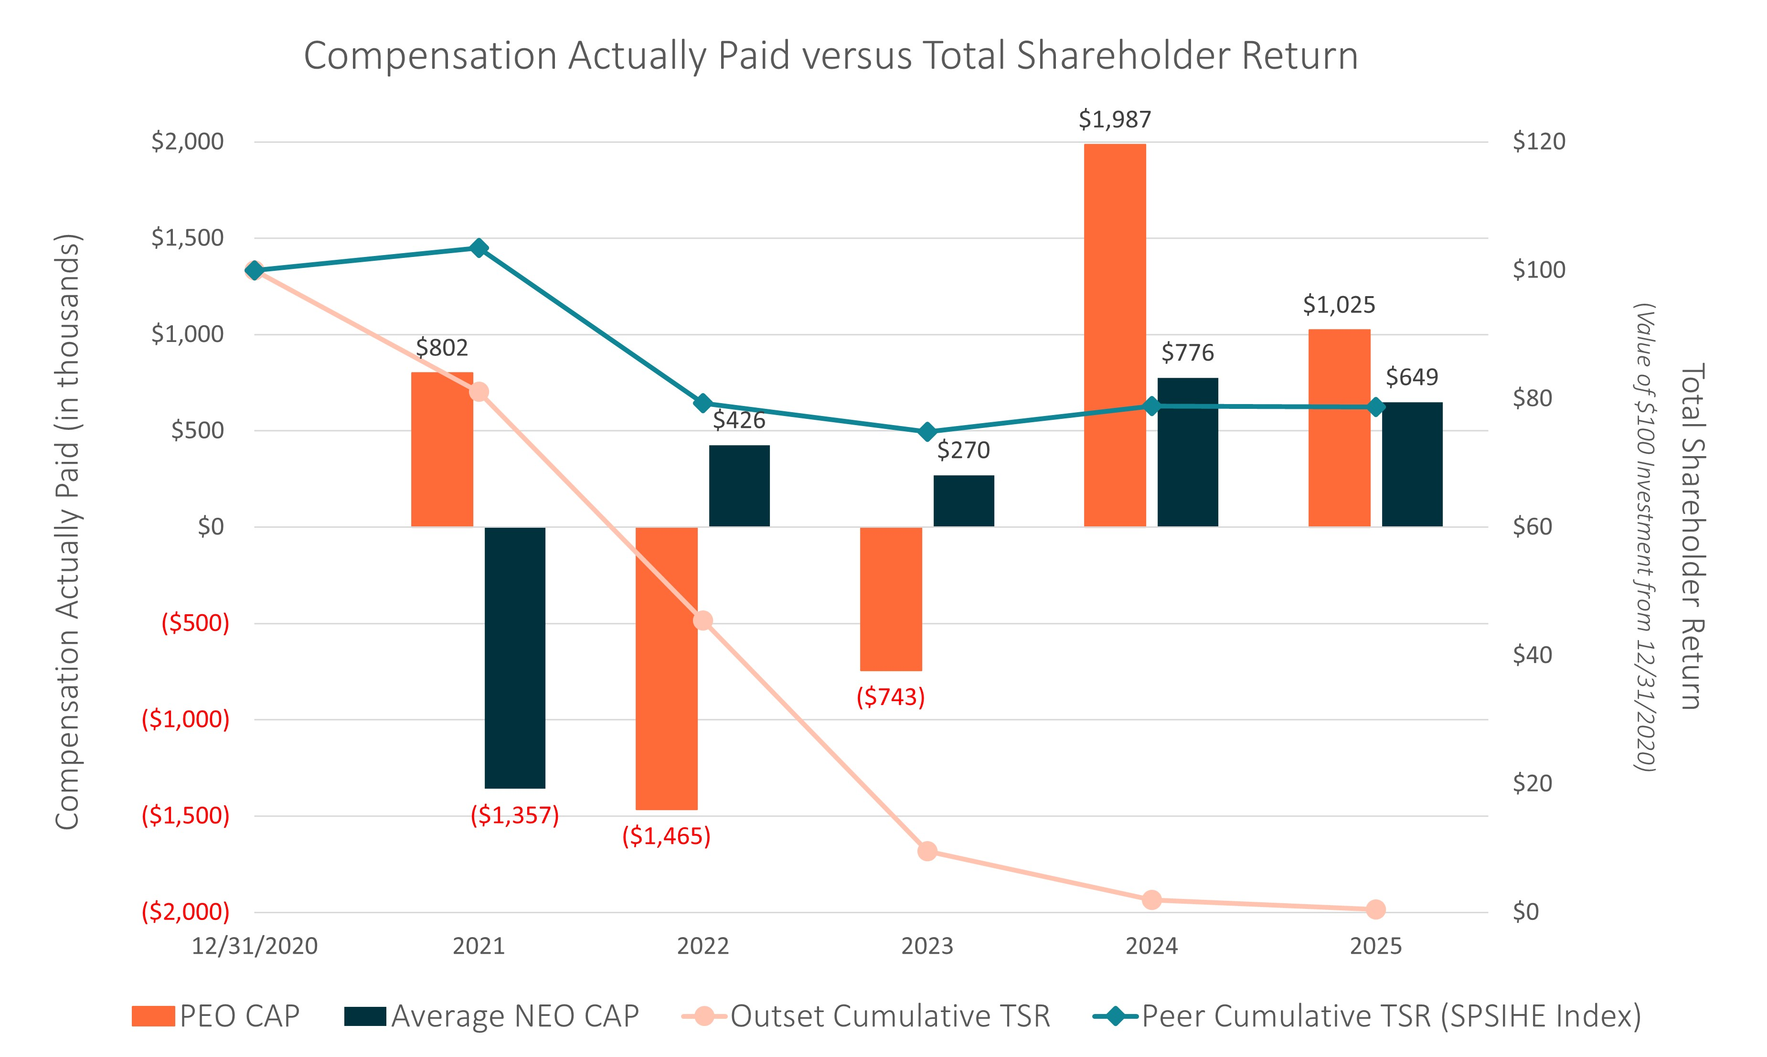
Compensation Actually Paid versus Total Stockholder Return Compensation Actually Paid (in thousands) Total shareholder return (value of $100 investment from 12/31/2020) PEO CAP Average NEO CAP Outset Cumulative TSR Peer Cumulative TSR (SPSIHE Index) ($2,000) ($1,500) ($1,000) ($500) $0 $500 $1,000 $1,500, $2,000 12/31/2020 2021 2022 2023 2024 2025 $802 ($1357) ($1465) ($743) $802 $426 $270 $1,987 $776 $1,025 $649 $0 $20 $40 $60 $80 $100 $120

2026 Proxy Statement | 62

Table of Contents

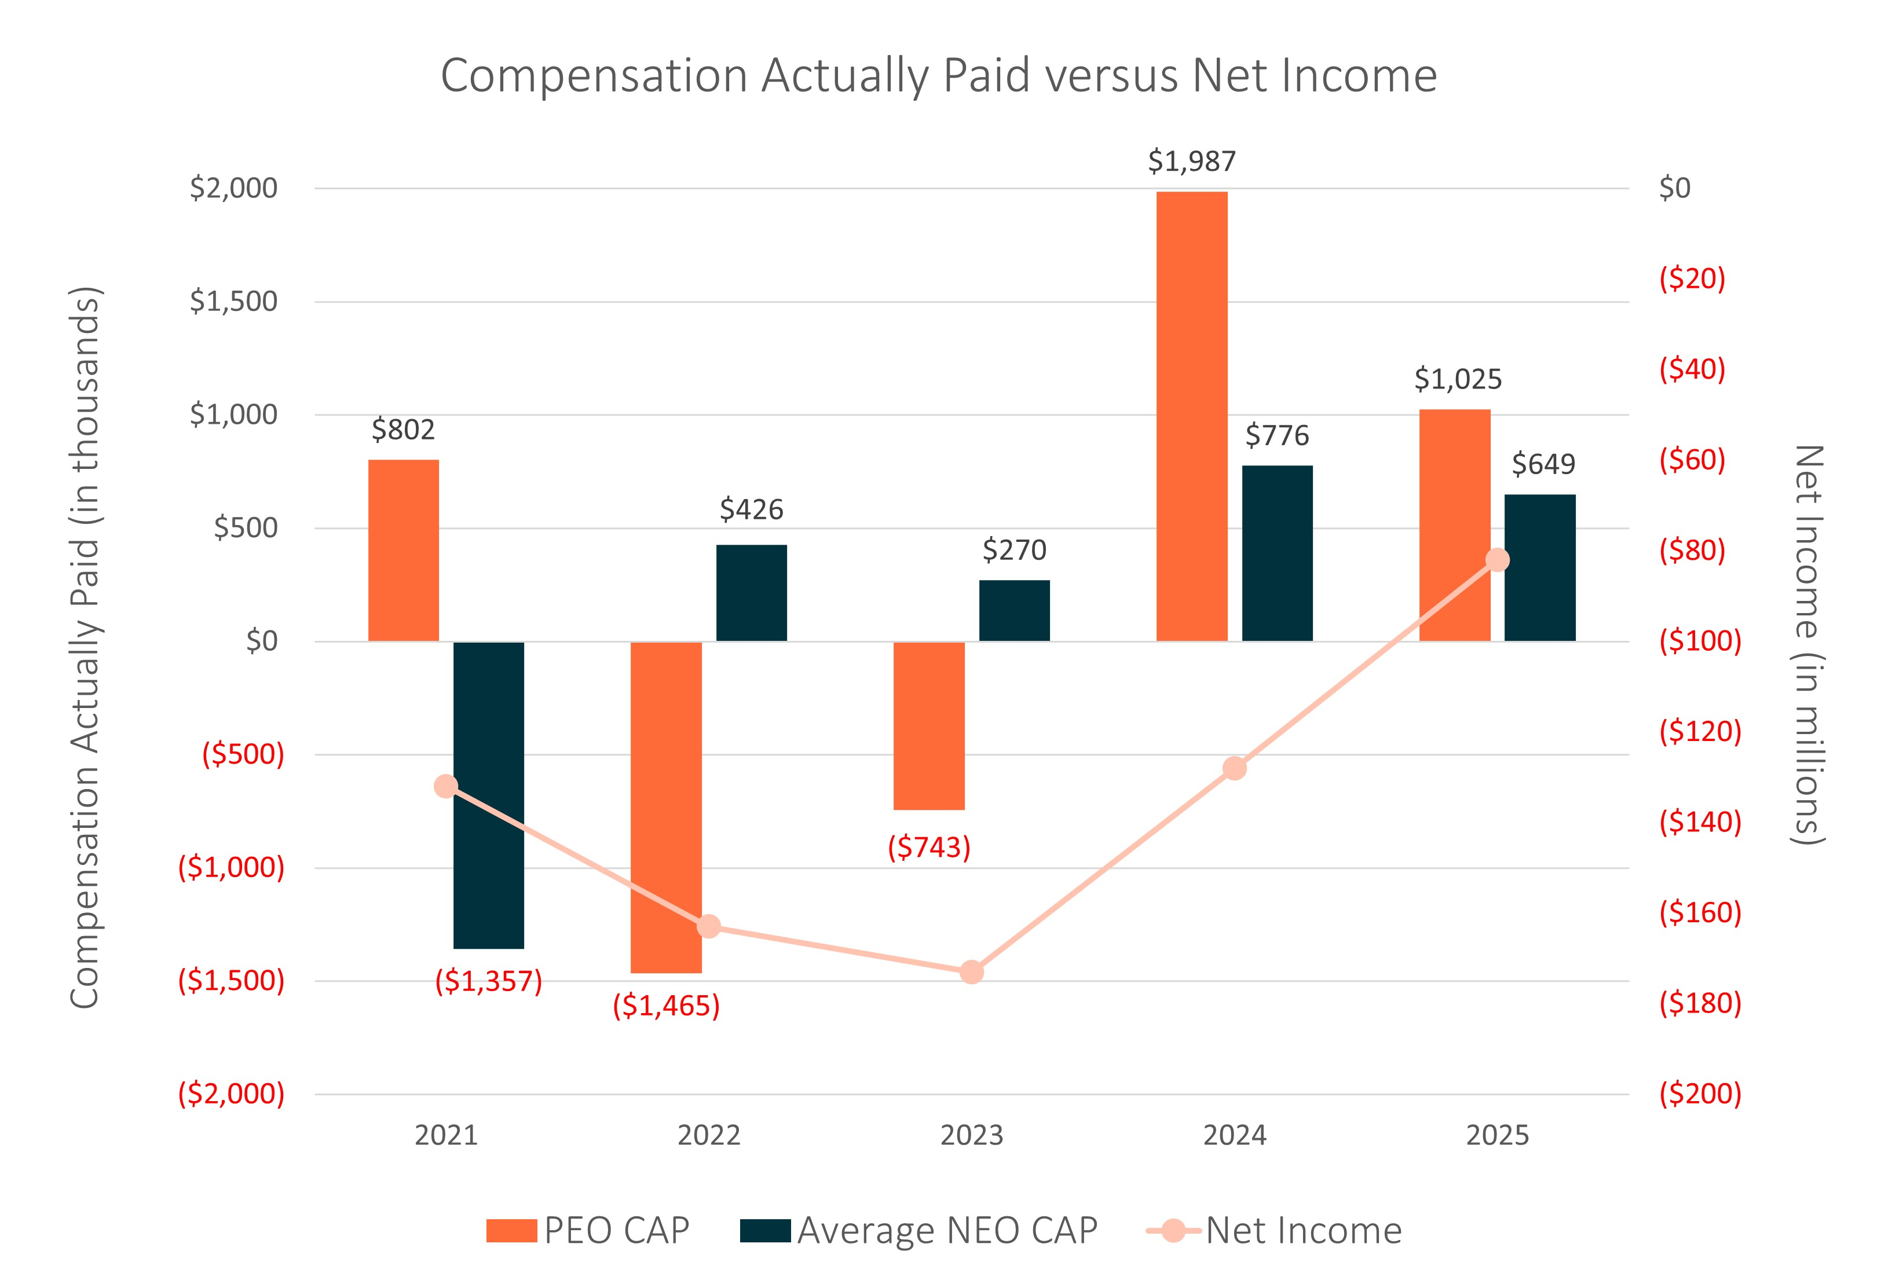
Compensation Actually Paid versus Net Income Compensation Actually Paid (in thousands) Net Income (in millions) 2021 2022 2023 2024 2025 PEO CAP Average NEO CAP Net Income ($2,000) ($1,500) ($1,000) ($500) $0 $500 $1,000 $1,500, $2,000 $802 ($1,357) ($1,465) $426 ($743) $270 $1,987 $776 $1,025 $649 ($200) ($180) ($160) ($140) ($120) ($100) ($80) ($60) ($40) ($20) $0

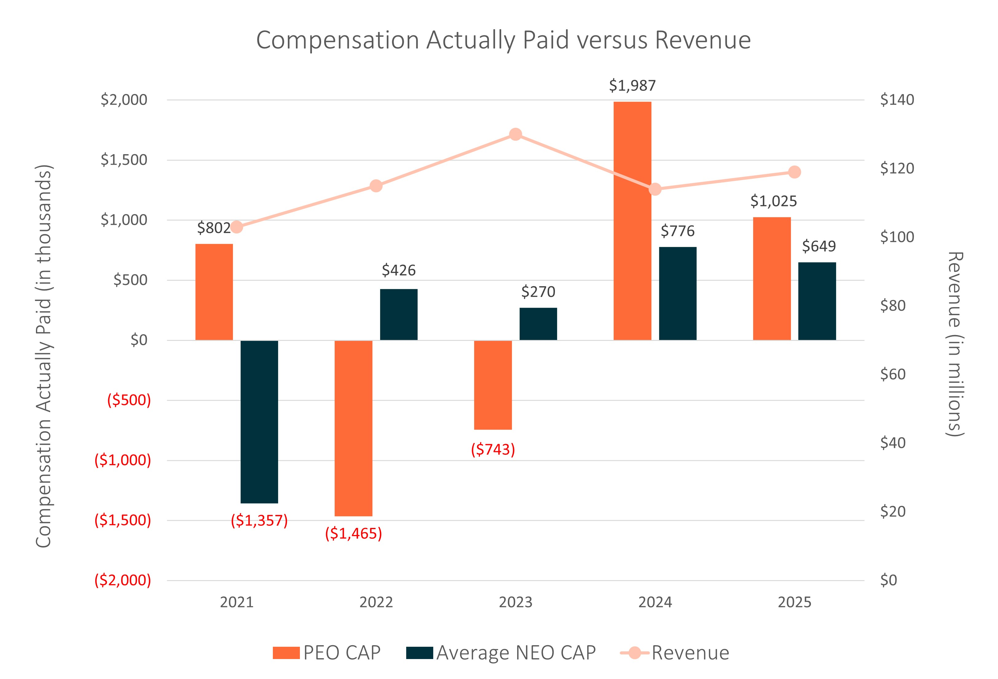
Compensation Actually Paid versus Revenue Compensation Actually Paid (in thousands) PEO CAP Average NEO CAP Revenue 2021 2022 2023 2024 2025 Revenue (in millions) ($2,000) ($1,500) ($1,000) ($500) $0 $500 $1,000 $1,500, $2,000 ($140) ($120) ($100) ($80) ($60) ($40) ($20) $0 $802 ($1,357) ($1,465) $426 ($743) $270 $1,987 $776 $1,025 $649

2026 Proxy Statement | 63

Table of Contents
List of Performance Measures
The following table includes a list of financial performance measures which, in the Company’s assessment, represent the most important financial performance measures used by the Company to link compensation actually paid to the NEOs to Company performance for 2025. More information about the ways in which these measures were integrated into the Company’s annual cash bonus and long-term equity incentive programs is included in the Compensation Discussion and Analysis section of this proxy statement.

PERFORMANCE MEASURES:
✓
Revenue
✓
Operating income (non-GAAP)
✓
EBITDA (non-GAAP)
✓
Relative TSR compared to Russell 2000 Medical Device Index
✓
Stock price

2026 Proxy Statement | 64

Table of Contents

Equity Plan Information

Equity Compensation Plan Information
The following table provides certain information as of December 31, 2025 regarding our equity compensation plans.

 |  | Number of Securities to be Issued upon Exercise of Outstanding Options, Warrants and Rights |  |  |  |  | Weighted Average Exercise Price of Outstanding Options and Rights |  |  |  |  | Number of Securities Remaining Available for Future Issuance Under Equity Compensation Plans (Excluding Securities Reflected in Column (a))
Plan Category |  | (a) |  |  |  |  | (b) |  |  |  |  | (c)
Equity compensation plans approved by security holders(1) |  |  | 991,542 |  | (2) |  | $ | 183.26 |  | (3) |  |  | 1,906,497 |  | (4)
Equity compensation plans not approved by security holders |  |  | — |  |  |  |  | — |  |  |  |  | —
Total |  |  | 991,542 |  |  |  | $ | 183.26 |  |  |  |  | 1,906,497

(1)
Includes our 2020 Equity Incentive Plan, 2019 Equity Incentive Plan, 2010 Stock Incentive Plan and Employee Stock Purchase Plan.
(2)
Includes 80,679 shares issuable pursuant to outstanding stock options and 910,863 shares issuable pursuant to outstanding restricted stock units (including PSUs, assuming the underlying shares are earned and vest at the target number of shares) under our 2020 Equity Incentive Plan, 2019 Equity Incentive Plan and 2010 Stock Incentive Plan.
(3)
Excludes restricted stock units which have no exercise price.
(4)
Includes 1,658,276 shares available for issuance under our 2020 Equity Incentive Plan and 248,221 shares available for issuance under our Employee Stock Purchase Plan. Our 2020 Equity Incentive Plan provides that the number of shares of our common stock reserved for issuance under the plan will automatically increase on the first day of each fiscal year, beginning with 2021 and continuing until (and including) 2030, by an amount equal to the lesser of 4% of the shares of our common stock issued and outstanding on December 31 of the immediately preceding calendar year or such other amount determined by our Board. Our Employee Stock Purchase Plan provides that the number of shares of our common stock available for future issuance under the plan will automatically increase on the first day of each fiscal year, beginning with 2021 and continuing until (and including) 2030, by an amount equal to the lesser of 1% of the shares of our common stock issued and outstanding on December 31 of the immediately preceding fiscal year, 45,814 shares or such other amount determined by our Board.

2026 Proxy Statement | 65

Table of Contents

Stock Ownership

Security Ownership of Certain Beneficial Owners and Management
The following table sets forth certain information with respect to the beneficial ownership of our common stock as of March 2, 2026 for: (i) each director and nominee for director, (ii) each of our NEOs, and (iii) each person, or group of affiliated persons, known by us to beneficially own more than 5% of our common stock.
Beneficial ownership is determined in accordance with the rules of the SEC. Under such rules, beneficial ownership includes any shares over which the individual has sole or shared voting power or investment power as well as any shares that the individual has the right to acquire within 60 days of March 2, 2026, through the exercise of any options, warrants or other rights. In computing the percentage beneficial ownership of a person, common stock not outstanding and subject to options, warrants or other rights held by that person that are currently exercisable or exercisable within 60 days of March 2, 2026 are deemed outstanding for purposes of calculating the percentage ownership of that person, but are not deemed outstanding for computing the percentage ownership of any other person. Subject to the foregoing, percentage of beneficial ownership is based on 18,463,417 shares of our common stock outstanding as of March 2, 2026.
To our knowledge, except as set forth in the footnotes to this table and subject to applicable community property laws, each person named in the table has sole voting and investment power with respect to the shares set forth opposite such person’s name. Except as otherwise indicated, the address of each of the persons in this table is c/o Outset Medical, Inc., 3052 Orchard Drive, San Jose, California 95134.

 |  | Beneficial Ownership
Name of Beneficial Owner |  | Number of Shares |  |  |  | Percentage of Total
Directors and Named Executive Officers:
Leslie Trigg(1) |  |  | 156,863 |  |  | *
John Brottem(2) |  |  | 17,003 |  |  | *
Karen Drexler(3) |  |  | 3,749 |  |  | *
Renee Gaeta |  |  | — |  |  | *
D. Keith Grossman(4) |  |  | 27,821 |  |  | *
Patrick T. Hackett(5) |  |  | 213,718 |  |  |  | 1.2 | %
Brent D. Lang(6) |  |  | 23,132 |  |  | *
Kevin O'Boyle |  |  | 3,786 |  |  | *
Karen Prange |  |  | — |  |  | *
Marc Nash(7) |  |  | 21,966 |  |  | *
All current executive officers and directors as a group (11 persons)(8) |  |  | 468,038 |  |  |  | 2.5 | %
5% Stockholders:(9)
FMR LLC(10) |  |  | 2,596,861 |  |  |  | 14.1 | %
BML Investment Partners, L.P.(11) |  |  | 1,902,201 |  |  |  | 10.3 | %
Alyeska Master Fund, LP(12 ) |  |  | 1,703,083 |  |  |  | 9.2 | %
Woodline Master Fund LP(13) |  |  | 1,325,784 |  |  |  | 7.2 | %
BlackRock, Inc.(14) |  |  | 1,213,547 |  |  |  | 6.6 | %
Entities affiliated with Perceptive(15) |  |  | 1,208,334 |  |  |  | 6.4 | %
Bank of America Corporation(16) |  |  | 950,558 |  |  |  | 5.1 | %

* Indicates beneficial ownership of less than 1% of the outstanding shares of our common stock.
(1)
Consists of (i) 64,808 shares of common stock held directly by Ms. Trigg, (ii) 584 shares of common stock held by The Trigg Family Trust U/A DTD 01/01/2002, (iii) 41,666 shares of common stock held by the Trigg 2002 Revocable Trust UAD 12/30/02 and (iii) 49,805 shares of common stock issuable pursuant to stock options exercisable within 60 days of March 2, 2026.

2026 Proxy Statement | 66

Table of Contents
(2)
Consists of (i) 14,479 shares of common stock held by Mr. Brottem and (ii) 2,524 shares of common stock issuable pursuant to stock options exercisable within 60 days of March 2, 2026.
(3)
Consists of (i) 1,666 shares of common stock held directly by Ms. Drexler and (ii) 2,083 shares of common stock held by the Drexler Family Trust U/A DTD 5/23/1996.
(4)
Consists of (i) 4,935 shares held directly by Mr. Grossman, (ii) 12,845 shares of common stock held by The D. Keith and Hallie H. Grossman Family Living Trust and (iii) 10,041 shares of common stock issuable pursuant to stock options exercisable within 60 days of March 2, 2026.
(5)
Consists of (i) 86,188 shares of common stock held by Mr. Hackett, (ii) 41,666 shares of common stock held by the Hackett Family Fund, (iii) 83,333 shares of common stock held by the Patrick T. Hackett 2006 GST Trust and (ii) 2,531 shares of common stock issuable pursuant to stock options exercisable within 60 days of March 2, 2026. Mr. Hackett disclaims beneficial ownership of the shares held by the Hackett Family Fund.
(6)
Consists of (i) 5,866 shares of common stock held by Mr. Lang, (ii) 16,666 shares of common stock held by the Lang Van Schaack Family Revocable Trust and (iii) 600 shares of common stock issuable pursuant to the vesting of RSUs within 60 days of March 2, 2026.
(7)
Consists of (i) 19,263 shares of common stock held by Mr. Nash and (ii) 2,703 shares of common stock issuable pursuant to stock options exercisable within 60 days of March 2, 2026.
(8)
Consists of (i) 399,834 shares of common stock owned by our current executive officers and directors, (ii) 67,604 shares of common stock issuable pursuant to stock options held by our current executive officers and directors that are exercisable within 60 days of March 2, 2026 and (iii) 600 shares of common stock issuable pursuant to the vesting of RSUs held by our current executive officers and directors within 60 days of March 2, 2026.
(9)
Based on Amendment No. 1 to the Schedule 13G filed by The Vanguard Group (“Vanguard”) on March 27, 2026, we understand that Vanguard completed an internal realignment on January 12, 2026, and, in accordance with SEC Release No. 34-39538 (January 12, 1998), certain subsidiaries or business divisions of subsidiaries of Vanguard, that formerly had, or were deemed to have, beneficial ownership of our shares with Vanguard, will report beneficial ownership separately (on a disaggregated basis) from Vanguard in reliance on such release. These subsidiaries and/or business divisions pursue the same investment strategies as previously pursued by Vanguard prior to the realignment. Further, in accordance with SEC Release No. 34-39538 (January 12, 1998), Vanguard no longer has, or is deemed to have, beneficial ownership over securities beneficially owned by such subsidiaries and/or business divisions. Accordingly, we have removed Vanguard from the foregoing table purely as a result of the restructuring, as our understanding is that our shares continue to be beneficially owned by certain subsidiaries or business divisions of subsidiaries of Vanguard. “Prior to Amendment No. 1, Vanguard filed a Schedule 13G on July 29, 2025 reporting shared voting power with respect to 11,217 shares of common stock, sole dispositive power with respect to 972,310 shares of common stock and shared dispositive power with respect to 19,119 shares of common stock.
(10)
Based solely on a Schedule 13G/A filed with the SEC on April 7, 2025 by FMR LLC (“FMR”) and Abigail P. Johnson. FMR has sole voting power with respect to 2,595,865 shares of common stock and sole dispositive power with respect to 2,596,861 shares of common stock. Abigail P. Johnson has sole dispositive power with respect to 2,596,861 shares of common stock. The address for each of FMR and Abigail P. Johnson is 245 Summer Street, Boston, Massachusetts 02210.
(11)
Based solely on a Schedule 13G/A filed with the SEC on February 13, 2026 by BML Investment Partners, L.P. (“BML Investment”). BML Investment has shared voting and shared dispositive power with respect to 1,902,201 shares of common stock. BML Investment’s sole general partner is BML Capital Management, LLC (“BML Capital”), whose managing member is Braden M. Leonard. As a result, BML Capital and Mr. Leonard may be deemed to indirectly beneficially own the shares held by BML Investment. The address of BML Investment is 65 E Cedar, Suite 2, Zionsville, Indiana 46077.
(12)
Based solely on a Schedule 13G filed with the SEC on May 15, 2025 by Alyeska Investment Group, L.P., Alyeska Fund GP, LLC and Anand Parekh. Each of the reporting persons has shared voting and shared dispositive power with respect to 1,703,083 shares of common stock. The address of each of the reporting persons is 77 West Wacker Drive, 7th Floor, Chicago, Illinois 60601.
(13)
Based solely on a Schedule 13G filed with the SEC on May 15, 2025 by Woodline Partners LP (“Woodline Partners”), the investment adviser to Woodline Master Fund LP (“Woodline Fund”), with respect to 1,325,784 shares of common stock held directly by Woodline Fund. Woodline Partners has shared voting and shared dispositive power with respect to such shares of common stock. The address of Woodline Partners is 4 Embarcadero Center, Suite 3450, San Francisco, California 94111.
(14)
Based solely on a Schedule 13G/A filed with the SEC on October 17, 2025 by BlackRock, Inc. (“BlackRock”). BlackRock has sole voting power with respect to 1,188,631 shares of common stock and sole dispositive power with respect to 1,213,547 shares of common stock. The address of BlackRock is 50 Hudson Yards, New York, New York, 10001.
(15)
Based solely on a Schedule 13G/A filed with the SEC on May 15, 2025 by the reporting persons. Perceptive Advisors LLC, Joseph Edelman, Perceptive Credit Advisors LLC and Perceptive Credit Holdings IV, LP (together, the “Perceptive entities”) each have shared voting and shared dispositive power with respect to 1,208,334 shares of common stock, as a result of ownership of 833,334 shares of common stock and warrants to purchase 375,000 shares of common stock that are subject to a 9.99% beneficial ownership limitation. The address of each of the Perceptive entities is 51 Astor Place, 10th Floor, New York, New York 10003.

2026 Proxy Statement | 67

Table of Contents
(16)
Based solely on a Schedule 13G filed with the SEC on February 11, 2026 by Bank of America Corporation (“Bank of America”) on behalf of itself and its wholly owned subsidiaries BofA Securities, Inc., Bank of America N.A., Merrill Lynch International, and Merrill Lynch Pierce Fenner & Smith, Inc. Bank of America has shared voting power with respect to 950,501 shares of common stock and shared dispositive power with respect to 950,549 shares of common stock. The address of Bank of America is 100 N. Tryon Street, Charlotte, North Carolina 28255.

Delinquent Section 16(a) Reports
Section 16(a) of the Exchange Act requires our executive officers, directors and holders of more than 10% of our common stock to file with the SEC initial reports of ownership of our common stock on a Form 4 and reports of changes in such ownership on a Form 4 or Form 5. Executive officers, directors and holders of more than 10% of our common stock are required by SEC regulations to furnish us with copies of all Section 16(a) forms they file. We submit all applicable Section 16(a) filing requirements on behalf of our executive officers and directors. To our knowledge, based solely on the reports filed by us, copies of such reports furnished to us and written representations made by our executive officers and directors regarding their filing obligations, all Section 16(a) filing requirements applicable to our executive officers and directors were satisfied with respect to the fiscal year ended December 31, 2025.

2026 Proxy Statement | 68

Table of Contents

Audit Matters

Proposal Three: Ratification of Appointment of Independent Registered Public Accounting Firm
Our Audit Committee has appointed KPMG LLP as our independent registered public accounting firm for the fiscal year ending December 31, 2026. Although stockholder ratification of the appointment of KPMG LLP is not required by our bylaws, other governing documents or the law, our Board considers the appointment of our independent registered public accounting firm to be an important matter of stockholder concern and is submitting the appointment of KPMG LLP for ratification by our stockholders as a matter of good corporate practice. If our stockholders fail to ratify the appointment, our Audit Committee will review its future selection of KPMG LLP as its independent registered public accounting firm. Even if the appointment is ratified, our Audit Committee, in its discretion, may direct the appointment of a different independent registered public accounting firm at any time during the year if they determine that such a change would be in the best interests of the Company and our stockholders.
Our Board considers the appointment of KPMG LLP as our independent registered public accounting firm for 2026 to be in the best interests of the Company and our stockholders. We expect representatives of KPMG LLP to attend the Annual Meeting. They will have an opportunity to make a statement if they wish and will be available to respond to appropriate questions from stockholders.
KPMG LLP has served as our independent registered public accounting firm since 2011.
Principal Accountant Fees and Services
The following is a summary of the fees and services provided by KPMG LLP to us for fiscal years 2025 and 2024.

 |  | Year Ended December 31,
 |  | 2025 |  |  |  | 2024
Audit Fees(1) |  | $ | 1,203,799 |  |  | $ | 1,401,900
Audit-Related Fees |  | $ | — |  |  | $ | —
Tax Fees |  | $ | — |  |  | $ | —
All Other Fees |  | $ | — |  |  | $ | —
Total |  | $ | 1,203,799 |  |  | $ | 1,401,900

(1)
Audit Fees consist of fees for professional services related to audits of our annual financial statements, reviews of our quarterly financial statements, audit of our internal control over financial reporting, and audit services that are normally rendered by KPMG LLP in connection with regulatory filings. The audit fees for fiscal years 2025 and 2024 also include reimbursement for direct out-of-pocket expenses.
Pre-Approval Policies and Procedures
Our Audit Committee is responsible for appointing, setting compensation for, and overseeing the work of our independent registered public accounting firm. Our Audit Committee’s charter establishes a policy that all audit and permitted not-audit and tax services to be provided by our independent registered public accounting firm must be pre-approved by our Audit Committee. Our Audit Committee has pre-approved all such audit and permitted non-audit services in accordance with this policy for the years ended December 31, 2025 and 2024. As part of this review, our Audit Committee considers whether the provision of any such non-audit or tax services by KPMG LLP is compatible with maintaining the independence of our independent registered public accounting firm.

2026 Proxy Statement | 69

Table of Contents
Our Audit Committee may delegate authority to pre-approve services to one or more of its members, provided any decisions made by such member or members to grant pre-approvals must be presented to the full Audit Committee at its next scheduled meeting.

Vote Required: | Ratification of the appointment of KPMG LLP as our independent registered public accounting firm for 2026 requires the affirmative vote of a majority of the shares of common stock cast at the Annual Meeting. Abstentions will have no effect on the outcome of this vote. Brokers have discretion to vote on this proposal.
Board Recommendation: | Our board and the audit committee of our board each Unanimously recommends a vote “For” the RatifiCation of the appointment of KPMG LLP as our independent registered public accounting firm for 2026.

Report of the Audit Committee
The Audit Committee oversees our independent registered public accounting firm and assists our Board in fulfilling its oversight responsibilities on matters relating to the integrity of our financial statements, our compliance with legal and regulatory requirements and the independent registered public accounting firm’s qualifications and independence by meeting regularly with the independent registered public accounting firm and financial management personnel. Management is responsible for the preparation, presentation and integrity of our financial statements.
In fulfilling its oversight responsibilities, the Audit Committee:
•
reviewed and discussed our financial statements as of and for the fiscal year ended December 31, 2025 with management and KPMG LLP;
•
discussed with KPMG LLP the matters required to be discussed by the applicable requirements of the Public Company Accounting Oversight Board and the SEC;
•
received the written disclosures and the letter from KPMG LLP required by the applicable requirements of the Public Company Accounting Oversight Board regarding KPMG LLP’s communications with the Audit Committee concerning independence; and
•
discussed the independence of KPMG LLP with that firm.
Based on the Audit Committee’s review and discussions noted above, the Audit Committee recommended to our Board that the audited financial statements be included in our Annual Report on Form 10-K for the fiscal year ended December 31, 2025 for filing with the SEC. The Audit Committee also appointed KPMG LLP as our independent registered public accounting firm for the fiscal year ending December 31, 2026.

Submitted by the Audit Committee of our Board:
Kevin O’Boyle, Chair
Patrick T. Hackett
Brent D. Lang

2026 Proxy Statement | 70

Table of Contents

Additional Information

Other Matters
Our Board is not aware of any other matters that will be presented for consideration at the Annual Meeting. However, if any other matters are properly brought before the Annual Meeting, the persons named in the accompanying proxy intend to vote on those matters in accordance with their best judgment.

Stockholder Proposals and Nominations for Next Year’s Annual Meeting of Stockholders
In order to be considered for inclusion in the proxy materials for our 2027 annual meeting of stockholders, proposals submitted by stockholders pursuant to Rule 14a-8 under the Exchange Act must be received by our Corporate Secretary at Outset Medical, Inc., 3052 Orchard Drive, San Jose, California 95134 on or before December 25, 2026, and also must otherwise comply with the procedures and requirements set forth in Rule 14a-8.
Alternatively, stockholders intending to present a proposal (outside of the process established in Rule 14a-8) or nominate a director for election at our 2027 annual meeting of stockholders without having the proposal or nomination included in the proxy materials for the meeting must comply with the requirements set forth in our bylaws. Our bylaws require, among other things, that our Corporate Secretary receive the proposal or nomination no earlier than the close of business on the 120th day, and no later than the close of business on the 90th day, prior to the first anniversary of the preceding year’s annual meeting of stockholders. Accordingly, for our 2027 annual meeting of stockholders, our Corporate Secretary must receive the proposal or nomination no earlier than February 4, 2027 and no later than 5:00 p.m. Eastern Time on March 6, 2027. The proposal or nomination must contain the information required by our bylaws and otherwise comply with the requirements set forth in our bylaws.
In addition to satisfying the foregoing requirements under our bylaws, to comply with the universal proxy rules, stockholders who intend to solicit proxies in support of director nominees other than the Company’s nominees must provide notice to our principal executive offices at Outset Medical, Inc., 3052 Orchard Drive, San Jose, California 95134, Attn: Corporate Secretary that sets forth the information required by Rule 14a-19 under the Exchange Act no later than April 5, 2027.

Availability of Annual Report on Form 10-K
A copy of our annual report on Form 10-K for the fiscal year ended December 31, 2025 as filed with the SEC is available free of charge on our website at www.outsetmedical.com or on the SEC’s website at www.sec.gov. Stockholders may also obtain a copy of our 2025 annual report, including financial statements but excluding exhibits, without charge by sending a written request to: Outset Medical, Inc., Attention: Corporate Secretary, 3052 Orchard Drive, San Jose, California 95134.

By order of the Board of Directors,

/s/ John L. Brottem

John L. Brottem
General Counsel and Secretary
April 24, 2026

2026 Proxy Statement | 71

Table of Contents

APPENDIX A:

NON-GAAP RECONCILIATIONS

The following table shows our GAAP gross margin and operating income reconciled to our non-GAAP gross margin and operating income included in this proxy statement. These non-GAAP financial measures are in addition to, and not a substitute for, or superior to, financial measures calculated in accordance with GAAP. As listed in the table below, GAAP financial measures include stock-based compensation expense, severance and related charges net of the reversal of compensation accruals for impacted employee, as well as litigation charges incurred outside of the ordinary course of business in connection with the stockholder class action and relative derivative lawsuits as disclosed in our latest annual and quarterly reports. Stock-based compensation is a non-cash expense, and severance and related charges arise outside the ordinary course of continuing operations and are not reflective of the Company's current operating performance. In addition, litigation charges related to the above-described matters are excluded because they constitute non-routine litigation costs, arise outside of the ordinary course of the Company’s business, and are not indicative of its recurring operating results or underlying performance trends. As such, management has excluded the effects of these items in non‐GAAP measures to assist investors in analyzing and assessing past and future operating performance and period-to-period comparisons. There are limitations related to the use of non-GAAP financial measures because they are not prepared in accordance with GAAP, may exclude significant expenses required by GAAP to be recognized in our financial statements, and may not be comparable to non-GAAP financial measures used by other companies. We encourage investors to carefully consider our results under GAAP, as well as our supplemental non‐GAAP information and the reconciliation between these presentations, to more fully understand our business.

Reconciliation Between GAAP and Non-GAAP Gross Margin and Operating Income

Year Ended
December 31, 2025
GAAP gross margin |  |  | 39.1 |  | %
Stock-based compensation expense |  |  | 0.5
Non-GAAP gross margin |  |  | 39.6 |  | %
($ in million)
GAAP operating income |  | $ | (66.7 | )
Stock-based compensation expense |  |  | 15.6
Severance and related charges, net |  |  | 0.0
Litigation charges |  |  | 0.6
Non-GAAP operating income |  | $ | (50.5 | )

2026 Proxy Statement | A-1

Table of Contents

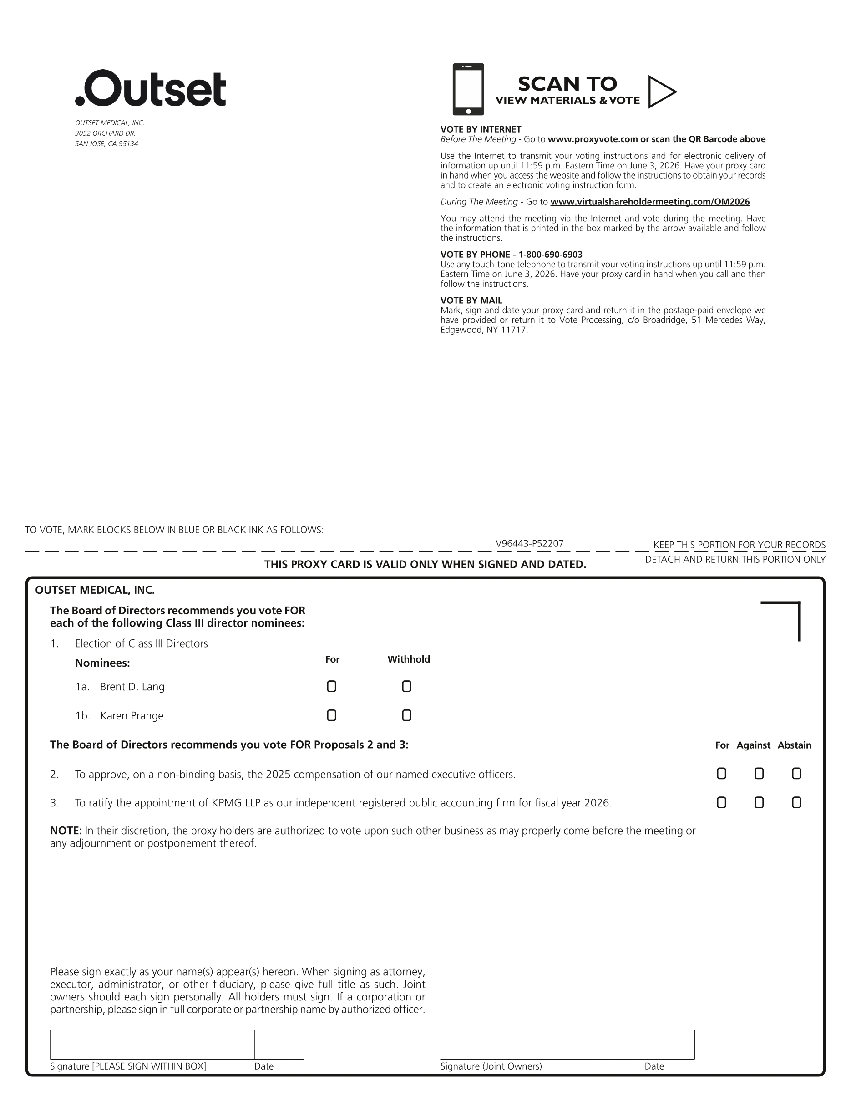

SCAN TO VIEW MATERIALS & VOTE OUTSET MEDICAL, INC. 3052 ORCHARD DR. SAN JOSE, CA 95134 VOTE BY INTERNET Before The Meeting - Go to www.proxyvote.com or scan the QR Barcode above Use the Internet to transmit your voting instructions and for electronic delivery of information up until 11:59 p.m. Eastern Time on June 3, 2026. Have your proxy card in hand when you access the website and follow the instructions to obtain your records and to create an electronic voting instruction form. During The Meeting - Go to www.virtualshareholdermeeting.com/OM2026 You may attend the meeting via the Internet and vote during the meeting. Have the information that is printed in the box marked by the arrow available and follow the instructions. VOTE BY PHONE - 1-800-690-6903 Use any touch-tone telephone to transmit your voting instructions up until 11:59 p.m. Eastern Time on June 3, 2026. Have your proxy card in hand when you call and then follow the instructions. VOTE BY MAIL Mark, sign and date your proxy card and return it in the postage-paid envelope we have provided or return it to Vote Processing, c/o Broadridge, 51 Mercedes Way, Edgewood, NY 11717. TO VOTE, MARK BLOCKS BELOW IN BLUE OR BLACK INK AS FOLLOWS: V96443-P52207 KEEP THIS PORTION FOR YOUR RECORDS THIS PROXY CARD IS VALID ONLY WHEN SIGNED AND DATED. DETACH AND RETURN THIS PORTION ONLY OUTSET MEDICAL, INC. The Board of Directors recommends you vote FOR each of the following Class III director nominees: 1. Election of Class III Directors Nominees: For Withhold 1a. Brent D. Lang 1b. Karen Prange The Board of Directors recommends you vote FOR Proposals 2 and 3: For Against Abstain 2. To approve, on a non-binding basis, the 2025 compensation of our named executive officers. 3. To ratify the appointment of KPMG LLP as our independent registered public accounting firm for fiscal year 2026. NOTE: In their discretion, the proxy holders are authorized to vote upon such other business as may properly come before the meeting or any adjournment or postponement thereof. Please sign exactly as your name(s) appear(s) hereon. When signing as attorney, executor, administrator, or other fiduciary, please give full title as such. Joint owners should each sign personally. All holders must sign. If a corporation or partnership, please sign in full corporate or partnership name by authorized officer. Signature [PLEASE SIGN WITHIN BOX] Date Signature (Joint Owners) Date

Table of Contents

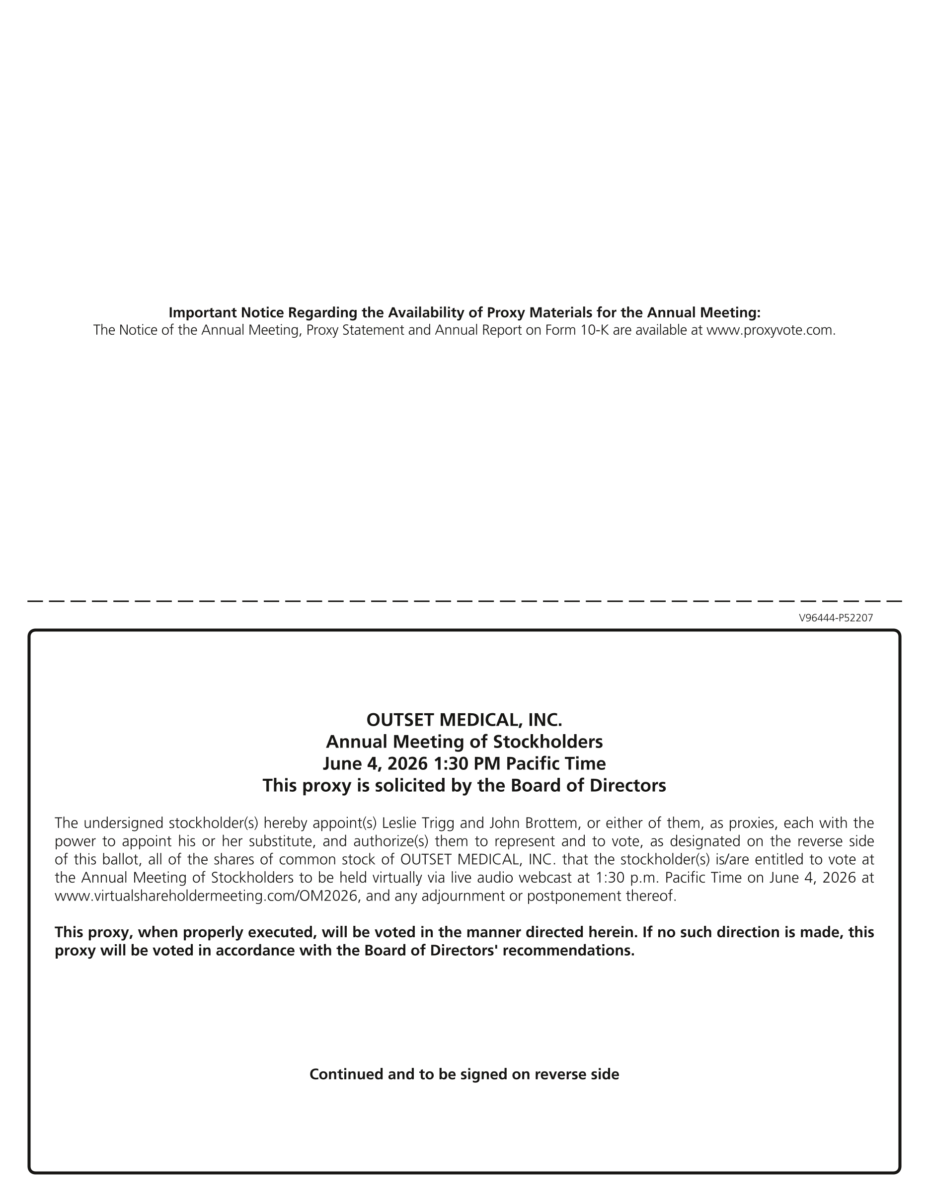

Important Notice Regarding the Availability of Proxy Materials for the Annual Meeting: The Notice of the Annual Meeting, Proxy Statement and Annual Report on Form 10-K are available at www.proxyvote.com. V96444-P52207 OUTSET MEDICAL, INC. Annual Meeting of Stockholders June 4, 2026 1:30 PM Pacific Time This proxy is solicited by the Board of Directors The undersigned stockholder(s) hereby appoint(s) Leslie Trigg and John Brottem, or either of them, as proxies, each with the power to appoint his or her substitute, and authorize(s) them to represent and to vote, as designated on the reverse side of this ballot, all of the shares of common stock of OUTSET MEDICAL, INC. that the stockholder(s) is/are entitled to vote at the Annual Meeting of Stockholders to be held virtually via live audio webcast at 1:30 p.m. Pacific Time on June 4, 2026 at www.virtualshareholdermeeting.com/OM2026, and any adjournment or postponement thereof. This proxy, when properly executed, will be voted in the manner directed herein. If no such direction is made, this proxy will be voted in accordance with the Board of Directors' recommendations. Continued and to be signed on reverse side

